**Refresh the World.** Make a Difference.

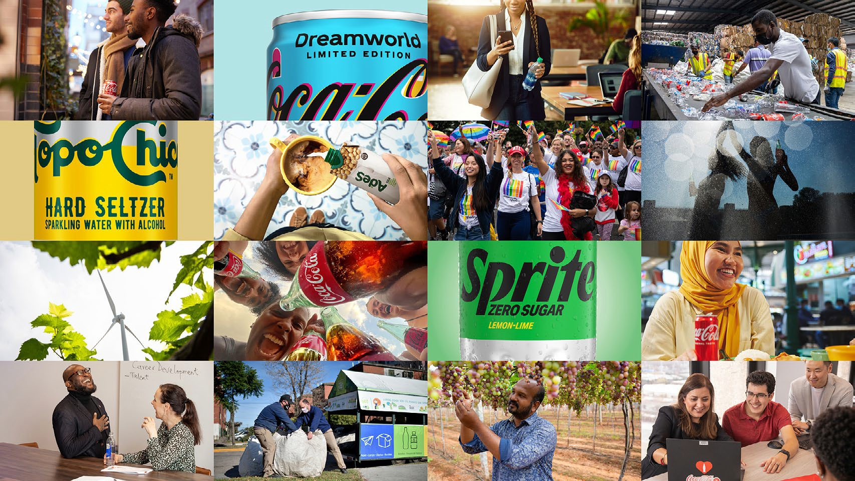

2022 BUSINESS & SUSTAINABILITY REPORT

CONTENTS

CEO MESSAGE EXECUTIVE SUMMARY

OUR COMPANY

WATER

PORTFOLIO

PACKAGING

CLIMATE

AGRICULTURE

PEOPLE

OPERATIONS

DATA APPENDIX

FRAMEWORKS

###### We build loved brands that bring joy to our consumers’ lives with beverage choices for all occasions, tastes and lifestyles. Our growth strategy is grounded in our core values and commitment to social and environmental responsibility.

CONTENTS

BOARD OF DIRECTORS EXECUTIVE SUMMARY



CHAIRMAN & CEO MESSAGE

3



WATER LEADERSHIP

24

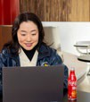

PEOPLE & COMMUNITIES

51



CLIMATE

43

OUR COMPANY **12**

At a Glance **13**

How We Operate **14**

Innovation **15**

Financial Highlights **17**

Governance & Management **18**

Priority Topics **21**

Stakeholder Engagement & Partnerships **22**

Giving Back to Our Communities **60**

Economic Empowerment **62**

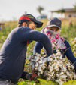

47

OPERATIONS HIGHLIGHTS **63**

Asia Pacific **64**

Europe, Middle East & Africa **65**

Latin America **66**

North America **67**

Global Ventures/Bottling

Investments Group **68**

ABOUT THIS REPORT **69**

DATA APPENDIX **70**

Financial and Portfolio Data **71**

Packaging **76**

Water 77

Greenhouse Gas Emissions

|  |  |  |  |  |  |  |  |  |  |  |
| --- | --- | --- | --- | --- | --- | --- | --- | --- | --- | --- |
| **5** |  | PORTFOLIO: |  |  | SUSTAINABLE |  | Human Rights  Safety & Health | **52**  **55** | & Waste  Workplace, Safety & Giving Back | **78**  **80** |
| **6** |  | BEVERAGES FOR ALL |  |  | AGRICULTURE |  | Diversity, Equity & Inclusion | **56** | Human Rights & Agriculture | **83** |

Definitions of Priority Topics **84**

Assurance Statements **86**

REPORTING FRAMEWORKS & SDGs **87**

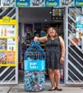

PACKAGING: WORLD WITHOUT WASTE

36

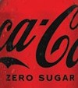

31

**SCOPE OF THIS REPORT**

This 2022 Business & Sustainability Report is The Coca-Cola Company’s fifth report to integrate overall business and sustainability performance, data and context, reflecting our continued journey toward driving sustainable business practices into our core strategy.

Except as otherwise noted, this report covers the 2022 performance of The Coca-Cola Company and the Coca-Cola system (our company and our bottling partners), as applicable.

As used in this report, the terms “material,” “materiality,” “immaterial,” “substantive,” “significant” and other similar terminology are not used, or intended to be construed, as they have been defined by or construed in accordance with the securities laws or any other laws of the United States or any other jurisdiction or as they are used in the context of financial statements and financial reporting.

For detailed information on the scope of this report, please see About This Report on page 69.

CONTENTS

CEO MESSAGE EXECUTIVE SUMMARY

OUR COMPANY

WATER

PORTFOLIO

PACKAGING

CLIMATE

AGRICULTURE

PEOPLE

OPERATIONS

DATA APPENDIX

FRAMEWORKS

The Coca-Cola Company’s

CHAIRMAN & CEO MESSAGE

purpose is to refresh the world and make a difference.

We have remained true to that purpose for 137 years, and I am as encouraged today about the future of our business as I have ever been.

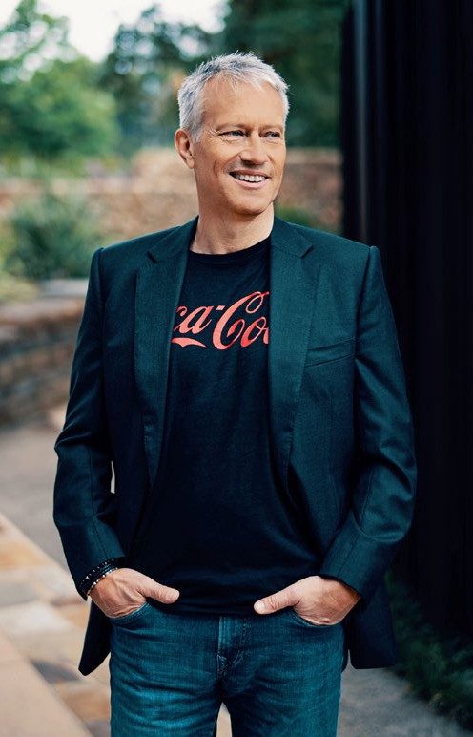

**James Quincey**

Chairman and CEO

Our strategy is clear. It’s centered around people—

our consumers and employees—and driving sustainable solutions that build resilience into our business to respond to current and future challenges, while creating positive change for the planet.

GREAT BRANDS, BOLD EXPERIMENTATION

As a total beverage company, we are committed to offering people more of the drinks they want across a range of categories and in a variety of sizes. In 2022, we launched

246 low- or no-sugar beverages and continued to see double- digit growth for Coca-Cola Zero Sugar, which is now available in more than 170 markets. This helped to drive our volume of low- and no-calorie beverage sales to 29% of total volume.

We’re driving the most significant marketing transformation in our history, focused on digital-first engagement with

consumers. We’re combining partnerships, technology and our consumers’ passions to create unforgettable experiences in music, gaming and sports, including:

* **Coca-Cola Creations:** This global innovation platform lends the iconic Coca-Cola brand to new expressions, driven by collaboration, creativity and cultural connection. Launched in 2022, we introduced five limited-edition drinks that drew inspiration from music, gaming and culture. These were complemented with experimental packaging designs and various digital experiences.
* **Sprite Limelight:** A music and cultural extension of the brand’s global platform “Heat Happens,” Sprite Limelight aims to unite fans from different cultures and lifestyles by bringing together different artists from around the world.

We’re also experimenting with new drinks. We’ve launched Jack Daniel’s & Coca-Cola as a ready-to-drink cocktail through a relationship with Brown-Forman. This is one example of

our ongoing journey to bring Coke to consumers in new and dynamic ways. We take the new responsibilities that come with our entry in this space very seriously. As a result, we’ve embedded our Global Policy on Alcohol Responsibility into our business processes to ensure we grow our alcohol brands in a responsible and sustainable way.

SUSTAINABILITY IS CORE TO OUR BUSINESS STRATEGY

**Water:** Water is a priority for our company because it is the first ingredient in all our beverages and is essential to the communities we serve. As a local business operating in more than 200 countries and territories, we have a responsibility to help protect critical resources.

Our 2030 Water Security Strategy focuses on increasing water security. We work with partners to provide access to a

steady supply of clean water for people and ecosystems in the areas where we operate and source ingredients. We recently announced a more focused effort to prioritize the most water- stressed regions. As we’ve done since 2015, we’ll continue to replenish the water we use in our finished beverages to nature and communities. In 2022, we replenished 159%.

CONTENTS

CEO MESSAGE EXECUTIVE SUMMARY

OUR COMPANY

WATER

PORTFOLIO

PACKAGING

CLIMATE

AGRICULTURE

PEOPLE

OPERATIONS

DATA APPENDIX

FRAMEWORKS

Our strategy is clear. It’s centered around people—our consumers and employees—and driving sustainable solutions that build resilience into our business to respond

to current and future challenges, while creating positive change for

the planet.”

**Packaging:** We seek to drive a circular economy for our packaging because this helps to reduce waste and carbon emissions. We’re working to use more recycled content in our packaging, to expand our use of refillable bottles, and to collect packaging for recycling through our World Without Waste initiative. We also partner to design new solutions for

packaging. For example, we licensed our technology for a 100% plant-based plastic bottle to a company building a commercial- scale facility in Germany. This bio-based plastic packaging

has a lower carbon footprint than other plastics. While we’re making progress, we know there is more work to be done. In 2022, we collected 61% of the equivalent bottles and cans that we introduced into the market and used 15% rPET

in our bottles.

To galvanize collective action, we invest in solutions and partnerships across industry, governments and society.

In 2022, we became a Strategic Partner of the Ellen MacArthur Foundation. This group includes companies within key industry sectors that can help drive the transition to a circular economy.

**Climate:** Our water, packaging and climate goals are interconnected. For example, by creating a circular economy for packaging, we can lower our carbon footprint.

By approaching water stewardship from a basin perspective, we participate in initiatives that increase communities’ resilience to extreme weather events, alongside our partners.

Our approach to climate is rooted in science, and we’ve set a science-based target to reduce absolute greenhouse gas emissions by 25% by 2030, against a 2015 baseline.

As of 2022, we have reduced our emissions by 7% against this baseline.

A COMPANY FOR FUTURE GENERATIONS

We’re committed to creating a culture of inclusion and belonging and to driving meaningful change in our communities. By 2030, we aspire to be 50% led by women globally. Today, 39% of our senior leaders are women.

The Coca-Cola Foundation, the philanthropic arm of

The Coca-Cola Company, contributed $94.8 million to 301 organizations around the world in 2022 to help create a better shared future for the communities our business serves.

Our continued success would not be possible without our people. I am grateful for the company and system employees who live our purpose every day. Their collective passion

and focus to build loved brands and make a difference in the world is how our business will continue to thrive for generations to come.



**James Quincey**

Chairman and Chief Executive Officer April 26, 2023

CONTENTS

CEO MESSAGE EXECUTIVE SUMMARY

OUR COMPANY

WATER

PORTFOLIO

PACKAGING

CLIMATE

AGRICULTURE

PEOPLE

OPERATIONS

DATA APPENDIX

FRAMEWORKS



Our Board of Directors is proud of our company’s ongoing success. As the business continues to grow and evolve, our Board also continues to evolve. Through our Board refreshment efforts, we strive to maintain a balance of skills, tenure and diversity among our Directors. I am extremely proud that in 2022 we achieved gender parity in the composition of our Board. And as this report demonstrates, our actions and our business success remain grounded in our strong values and purpose: to refresh the world and make a difference.”

MARIA ELENA LAGOMASINO

BOARD OF DIRECTORS

Lead Independent Director

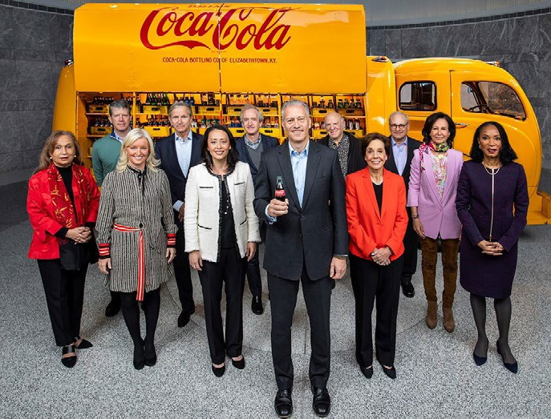From left to right:

ALEXIS M. HERMAN 

Chair and Chief Executive Officer, New Ventures LLC

HERB ALLEN 

President,

Allen & Company LLC

CAROLYN EVERSON 

Senior Advisor, Permira

MARC BOLLAND 

Chairman, Blackstone Europe

CAROLINE J. TSAY 

Technology Company Advisor/ Limited Partner of

Venture Capital Funds

CHRISTOPHER C. DAVIS 

Chairman,

Davis Selected Advisers, L.P.

JAMES QUINCEY 

Chairman and

Chief Executive Officer, The Coca-Cola Company

BARRY DILLER



Chairman and Senior Executive, IAC Inc. and Expedia Group, Inc.

MARIA ELENA LAGOMASINO



*Lead Independent Director*

Chief Executive Officer and Managing Partner, WE Family Offices

DAVID B. WEINBERG

Chairman and Chief Executive Officer, Judd Enterprises, Inc.



A

ANA BOTÍN 

Executive Chair, Banco Santander, S.A.

HELENE D. GAYLE 

President, Spelman College

AMITY MILLHISER* 

Vice Chair, PricewaterhouseCoopers LLP (Not pictured)

 Audit Committee

 Corporate Governance and Sustainability Committee  Executive Committee

 Finance Committee

Talent and Compensation Committee  Chair



Member

Note: Board composition and committee positions reflected as of April 25, 2023.

* Ms. Millhiser will join the Board on July 1, 2023 after her retirement from her current role, at which time she will join the Audit Committee.

CONTENTS

CEO MESSAGE EXECUTIVE SUMMARY

OUR COMPANY

WATER

PORTFOLIO

PACKAGING

CLIMATE

AGRICULTURE

PEOPLE

OPERATIONS

DATA APPENDIX

FRAMEWORKS

# Executive

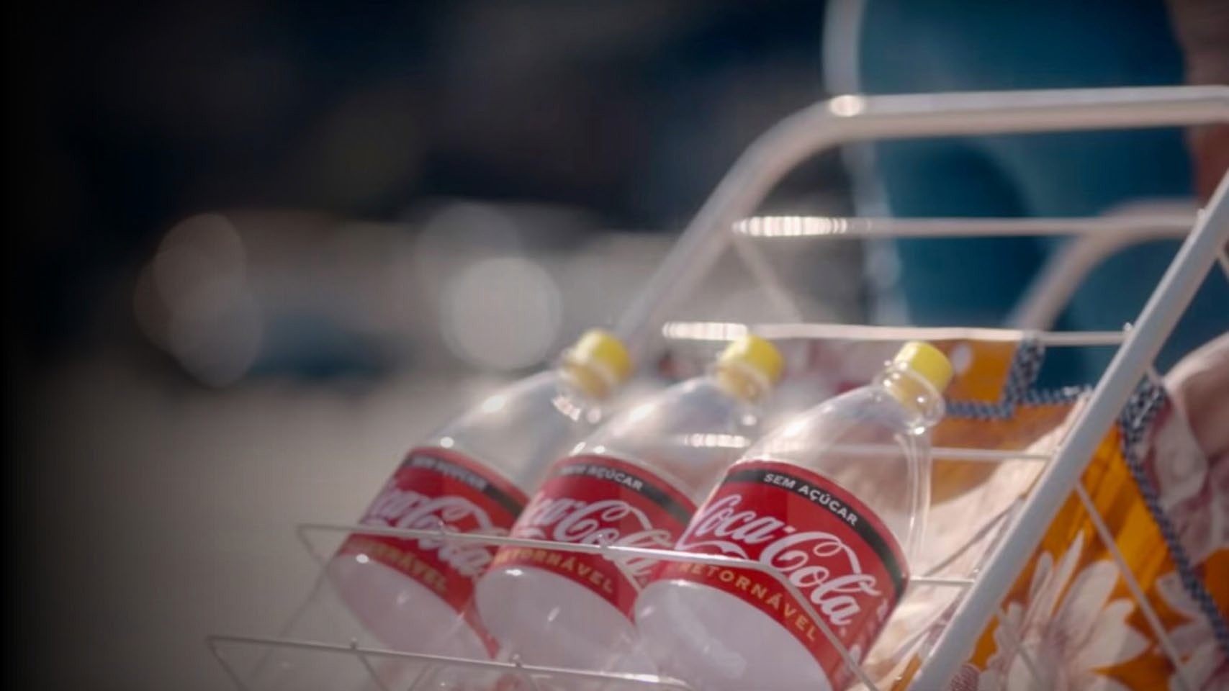

## Summary

OUR PRIORITIES & PROGRESS

We focus on the highest-priority sustainability issues facing our company, stakeholders and communities, with the goal of maximizing collective impact.

These issues, which we review on a regular basis in collaboration with leading NGO partners, are

integrated into both our business strategy and system- wide operations to simultaneously build resilience

and drive growth. They also inform our ambitious sustainability goals and how we report on progress against these interconnected goals.

**THE COCA-COLA COMPANY** 2022 BUSINESS & SUSTAINABILITY REPORT 6

CONTENTS

CEO MESSAGE EXECUTIVE SUMMARY

OUR COMPANY

WATER

PORTFOLIO

PACKAGING

CLIMATE

AGRICULTURE

PEOPLE

OPERATIONS

DATA APPENDIX

FRAMEWORKS

##### OUR SUSTAINABILITY GOALS

|  |  |  |  |  |  |  |  |
| --- | --- | --- | --- | --- | --- | --- | --- |
|  | | WATER LEADERSHIP | PORTFOLIO | PACKAGING | CLIMATE | SUSTAINABLE AGRICULTURE | PEOPLE & COMMUNITIES |
| **OUR KEY GOALS** |  | Achieve **100%** regenerative water use across **175 facilities** identified as facing high levels of water stress by 2030  Work with partners to help improve the health of  **60 watersheds** identified as most critical for the system’s operations and agricultural supply chains by 2030  Aim to return a cumulative total of **2 trillion liters** of water to nature and communities globally, between 2021–2030 | Offering drinks with **reduced added sugar**  Offering more drinks with  **nutrition and wellness benefits**  Providing **clear nutrition information** on packaging and in our communications  Marketing our drinks  **responsibly** | Make **100%** of our packaging recyclable globally by 2025  Use at least **50%** recycled content in our packaging by 2030  **Collect** and **recycle** a bottle or can for each one we sell by 2030  Reduce our use of virgin plastic derived from non-renewable sources by a cumulative **3 million metric tons** between 2020–20251  By 2030, we aim to have at least **25%** of our beverages worldwide by volume sold in refillable/ returnable glass or plastic bottles or in fountain dispensers with reusable packaging | Reduce absolute emissions by **25%** by 2030 against a 2015 baseline  Ambition to achieve **net zero emissions by 2050** | Sustainably source **100%** of priority agricultural ingredients over time | Mirror the markets we serve by 2030   * Aspire to be **50%** led by women globally * **Align** U.S. race/ethnicity representation to U.S. census data across all job levels |
| **2022 PROGRESS** | Replenished **159%** of the water we use in our finished beverages  **291 billion liters** of  water returned to nature and communities in 2022 | **~68%** of the products in our beverage portfolio have less than 100 calories per 12-ounce serving  **29%** of our volume sold in 2022 was low- or no-calorie | **90%** of our packaging is recyclable  **15%** of PET used is recycled PET (rPET)  **61%** of our packaging collected for recycling2 | **7% decline** in absolute emissions since 2015 toward a 25% science- based reduction target by 2030  Renewable electricity usage increased from **12%** in 2021 to  **21%** in 2022 | **64%** of priority ingredients sustainably sourced to Leader standard in line with our Principles for Sustainable Agriculture | **39%** of senior leadership positions held by women4 |
| **COMMITTED TO INDUSTRY LEADERSHIP** | CDP Water Security Score: **A–**  **Replenished 100% of the water used** in our finished beverages globally every year since 2015 | We support more than **50** calorie and sugar reduction pledges globally, in collaboration with industry peers  Coca-Cola Zero Sugar has delivered double-digit **volume growth** in five of the last six years | Investing in **refillable** and  **dispensed** solutions  More than **40 markets** currently offer at least one brand in 100% rPET3 packaging, excluding caps and labels | Target **aligned** to Science-Based Targets initiative (SBTi)  CDP Climate Change Score: **A–** | **Engagement** with suppliers to implement Principles  for Sustainable Agriculture framework and drive progress on other key sustainability issues such as water | As part of our efforts to create a diverse, equitable and inclusive workplace, we are **partnering** with the Valuable 500’s Generation Valuable initiative, a mentoring program designed to promote inclusion in the workplace for people with disabilities |

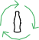

 The Coca-Cola Company

 The Coca-Cola System



1. Reduction measured from historical usage modeled with 2018–2020 data.
2. The collection rate represents the average collection rate for select primary consumer packaging, which is the percentage of our packaging that was collected for recycling (or refill).

**THE COCA-COLA COMPANY** 2022 BUSINESS & SUSTAINABILITY REPORT

1. Except where otherwise indicated, where reference is made in this report to 100% recycled PET, 100% rPET, or 100% recycled plastic beverage packaging, we are referring to the material from which the plastic bottle is made, not the cap and label.
2. Data as of December 31, 2022, for salaried and hourly employees. Race/ethnicity data is for U.S. workforce only. This data excludes Bottling Investments Group (BIG), Global Ventures, fairlife and BODYARMOR.

7

CONTENTS

CEO MESSAGE EXECUTIVE SUMMARY

OUR COMPANY

WATER

PORTFOLIO

PACKAGING

CLIMATE

AGRICULTURE

PEOPLE

OPERATIONS

DATA APPENDIX

FRAMEWORKS

##### WATER LEADERSHIP PORTFOLIO: BEVERAGES FOR ALL

159%

OF THE WATER USED IN OUR FINISHED

BEVERAGES RETURNED TO NATURE AND COMMUNITIES IN 20221

Water is a priority for The Coca-Cola Company because it is essential to life, our beverages and the communities we serve. We have operations nearly everywhere in the world—in more than 200 countries and territories. That means we have a responsibility to help those who face water scarcity and to protect local water resources where we operate, especially in places with the

biggest challenges.

Our 2030 Water Security Strategy is focused on accelerating the actions needed to increase water security where we operate, source ingredients and touch people’s lives. We do that by contributing toward sustainable, clean water access that improves livelihoods and wellbeing while protecting against water-related disasters. We understand water challenges are

10%

WATER EFFICIENCY IMPROVEMENT

ACROSS ALL SYSTEM OPERATIONS COMPARED TO 2015

291B LITERS

OF WATER RETURNED TO NATURE AND COMMUNITIES IN 2022

different in each region, so we are focused on doing what matters most locally, where the challenges are greatest.

**We have set three key goals designed to achieve our vision:**

* Achieve 100% regenerative water use across **175 of our facilities**, identified as facing high levels of water stress by 2030.
* Improve the health of **60 watersheds** identified as most critical for our operations and agricultural supply chain by 2030.
* Return a cumulative total of **2 trillion liters** of water to nature and communities globally over the life of our strategy, between 2021–2030.

READ MORE WATER LEADERSHIP 

We have exceeded our 100% replenishment goal every year since 2015.

1 Substantially all replenish data is internally validated and verified; the equivalent volume for 100% Replenish rate (182.9 Billion litres BL) is externally assured. Peer-reviewed methodologies were used to calculate volumetric benefits per project and operating unit for all externally assured data; one exception was approved for internally validated and verified data. The replenish benefit is typically estimated as a long-term, average annual volume, but for some project activities it varies annually. Replenish benefits fall under three categories: Watershed Protection and Restoration (233.5 BL), Water for Productive Use (40.9 BL) and Water Access and Sanitation (17.4 BL). Due to joint venture or merger and acquisition activities between 2019–2022, certain brands may not be accounted for in this metric. Unless otherwise stated, in this report finished beverages is

based on global sales volume. Approximately 13.5 BL (approx. 7%) of the water used in our beverages that we returned to nature and communities is from 7 projects located in Ukraine and Belarus where since May 2019 we have not been able to monitor projects on intervals aligned with internal guidelines due to COVID and the ongoing war.

As a total beverage company, we are committed to offering people more of the drink choices they want across a range of categories and in a variety of packages. Evolving consumer tastes and preferences help steer our business strategy and shape the lineup of beverages we bring to market.

We take a disciplined approach to product innovation and portfolio management, ensuring we develop and deliver preferred, great-tasting beverages for all occasions and lifestyles. This includes offering drinks with reduced added sugar and more brands with nutrition and wellness benefits; providing small package options and clear nutrition information on packaging and in our communications; and marketing our drinks responsibly.

|  |
| --- |
| 900,000+ TONS  OF ADDED SUGAR REMOVED  FROM OUR GLOBAL PORTFOLIO CUMULATIVELY THROUGH EFFORTS TO REFORMULATE MORE THAN 1,000 BEVERAGES FROM 2017–2022 |
| 19 OF TOP 20 BRANDS  ARE REDUCED-SUGAR OR ZERO-SUGAR, OR HAVE A REDUCED-SUGAR OR  ZERO-SUGAR OPTION |
| 29% OF OUR VOLUME SOLD  IN 2022 WAS LOW- OR NO-CALORIE |
| ~68% OF THE PRODUCTS  IN OUR BEVERAGE PORTFOLIO  HAVE LESS THAN 100 CALORIES PER 12-OUNCE SERVING |

READ MORE PORTFOLIO: BEVERAGES FOR ALL 

**THE COCA-COLA COMPANY** 2022 BUSINESS & SUSTAINABILITY REPORT 8

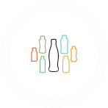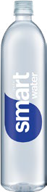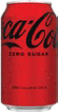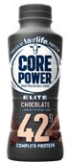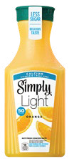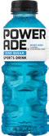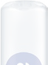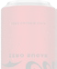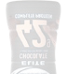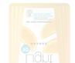

**Portfolio Marketing**

We continue to use our marketing to drive growth of our low- and no-calorie portfolio. Coca-Cola Zero Sugar has experienced double-digit growth in five of the last six years. In 2022, several leading low- and no-calorie brands in North America launched consumer campaigns with celebrity partners

and sponsorship assets.

CONTENTS

CEO MESSAGE EXECUTIVE SUMMARY

OUR COMPANY

WATER

PORTFOLIO

PACKAGING

CLIMATE

AGRICULTURE

PEOPLE

OPERATIONS

DATA APPENDIX

FRAMEWORKS

##### PACKAGING CLIMATE

We recognize our responsibility to help solve complex plastic waste challenges facing our planet and society. Our ambitious strategy to drive change through a circular economy for our packaging is called World Without Waste. This strategy is

a global sustainable packaging platform focused on these fundamental goals: Making 100% of our packaging recyclable globally by 2025—and using at least 50% recycled material in our packaging by 2030 (**Design**); collecting and recycling a bottle or can for each one we sell by 2030 (**Collect**); and bringing people together to support a healthy, debris-free environment (**Partner**).

|  |  |  |
| --- | --- | --- |
| DESIGN: GOALS | 2022 STATUS | |
| Make 100% of our packaging recyclable globally by 2025 | **90%** globally1 | 90% |
| Use at least 50% recycled content in our packaging by 2030 | **25%**2 recycled material in our packaging globally; **15%**  of PET used is recycled PET | 25% |
|  |  | 15% |
| Reduce our use of virgin plastic derived from  non-renewable sources by a cumulative 3 million metric tons from 2020–20253 | In 2022, we avoided around half a million metric tons of virgin plastic usage through our efforts on lightweighting and use of recycled content with an incremental avoidance of over 50,000 metric  tons compared to 2021. However, growth of plastic packaging has outpaced these efforts, so we did not reduce virgin plastic usage overall in 2022 | |
| By 2030, we aim to have at least 25% of our beverages worldwide by volume sold in refillable/returnable glass or plastic bottles or in fountain dispensers with reusable packaging | Approximately **14%** of total beverage volume was served in reusable packaging in 2022 | 14% |

We are making progress against each of these objectives, which are embedded in how we operate as a business, and we take a transparent approach to reporting our actions, results and learnings. Local teams are executing in ways appropriate for their markets, and we are using a networked approach to deliver impact at scale.

READ MORE PACKAGING 

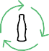

Taking well-informed, decisive action to help address climate change is a priority for our company. Climate change poses risks to our business and our stakeholders. By implementing an

interconnected approach across our priority sustainability issues, we are reducing the Coca-Cola system’s greenhouse gas (GHG) emissions and building resilience in our business, value chain and local communities.

We are working to reduce our carbon footprint in line with science to help avoid the worst impacts of climate change. We do this by analyzing and prioritizing the sources of GHG emissions across our value chain and by partnering with stakeholders to drive down emissions.



21%

RENEWABLE ELECTRICITY USAGE

IN OUR SYSTEM—AN INCREASE FROM 12% IN 2021

As of 2022, we reduced our absolute emissions by 7% against a 2015 baseline, making progress toward our science-based reduction target of 25% by 2030 against the baseline. Our ambition also includes achieving net zero emissions by 2050.

Several of our bottling partners and suppliers have set or committed to setting their own science-based reduction targets to drive climate action across our value chain.

READ MORE CLIMATE 

|  |  |  |
| --- | --- | --- |
| GOAL | 2022 STATUS | |
| Reduce absolute | **7%** decline in absolute |  |
| greenhouse gas (GHG) emissions by **25%** by | emissions since 20151 | 7% |
| 2030, against a 2015 |  |  |
| baseline |  |  |

|  |
| --- |
| AMBITION |
| To achieve **net zero emissions** by 2050 |



|  |  |  |
| --- | --- | --- |
| COLLECT: GOAL | 2022 STATUS | |
| Collect and recycle a bottle or can for each one we sell by 2030 | **61%**4 | 61% |

1 Only recyclable where infrastructure exists.

The Coca-Cola Company applies the recommendations of the Task Force on Climate-related Financial Disclosures (TCFD) in this report and in a TCFD Index and provides comprehensive disclosures to CDP on Climate Change.

378 OF OUR SUPPLIERS

(OUT OF 495 REQUESTED) PROVIDED CLIMATE DATA TO CDP IN 2022

(A 12% INCREASE FROM 2021)

|  |  |
| --- | --- |
| PARTNER: GOAL  We bring people together to support a healthy, debris-free environment. | 2022 STATUS |
| See our 2022 partnership highlights here |

2 Includes select primary consumer packaging materials.

3 Reduction measured from historical usage modeled with 2018–2020 data.

4 The collection rate represents a weighted average of national collection rates, collected for recycling rates or refillable rates by packaging type to TCCS’s sales in units to express the percent of equivalent bottles and cans introduced into the market that were collected and refilled or collected for recycling for the year.

1 This figure is calculated using the market-based emissions method and therefore includes purchased renewable electricity as part of the system’s overall emissions reduction.

CONTENTS

CEO MESSAGE EXECUTIVE SUMMARY

OUR COMPANY

WATER

PORTFOLIO

PACKAGING

CLIMATE

AGRICULTURE

PEOPLE

OPERATIONS

DATA APPENDIX

FRAMEWORKS

##### SUSTAINABLE AGRICULTURE HUMAN RIGHTS

Our products and some of our packaging are made from a wide variety of agricultural ingredients, which we source from around the world. This complex global supply chain includes many kinds of suppliers, from multinational companies to smallholder farmers. Our Principles for Sustainable Agriculture (PSA) communicate our expectations for environmental, social and economic performance to our agricultural suppliers at

the farm level. The PSA, introduced in 2021, take a long-term perspective and reflect the most recent science, our total beverage company portfolio, and our increasingly diverse supply chain. The PSA are designed to encourage continuous improvement in farming practices and lead to more ethical and sustainable sourcing.

Our goal is to sustainably source all our ingredients over time—such as sugar cane, corn, fruit, coffee, tea and soybeans. Sustainably sourcing our ingredients increases the resilience of our supply chain, helps to conserve nature, and empowers producers and farm workers. In practice, we encourage

and support our ingredient suppliers to drive continuous improvement in sustainable farming practices, based

on our PSA.

READ MORE SUSTAINABLE AGRICULTURE 

**2022 Progress on Sustainable Sourcing2**

0 20 40 60 80 100

36%

MANGOES

GRAPES 37%

SUGAR CANE 40%

APPLES 55%

CORN 70%

TEA 74%

80%

SUGAR BEETS

PULP AND PAPER 86%

ORANGES 89%

LEMONS 96%

Respecting human rights is one of our core values.

The Coca-Cola Company was among the first companies to commit to the United Nations Guiding Principles on Business and Human Rights, and we have strived to inspire and drive responsible business practices ever since.



2,770 AUDITS

CONDUCTED IN 2022

READ MORE HUMAN RIGHTS 

COFFEE 99%

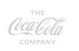

IMPACT

**Innovation**

Developing transformative due diligence and remediation programs through emerging technologies and creative partnerships with stakeholders and experts.

IMPACT

**Agriculture**

Driving meaningful and enduring change in the lives of everyone touched by the commodities

at the heart of our products — from smallholder farmers and their families to the communities we serve.

**Real**

**IMPACT**

**Toward a Better Tomorrow**

IMPACT

**Work**

Empowering workers across our value chain — from upstream supply chain workers and

our 700,000+ system employees to down- stream informal waste collection workers supporting recycling around the world.

We are proud to introduce Real Impact, a new vision for the company’s human rights program. Our mission is to take actions that lead toward a better tomorrow. We will take the lessons learned from existing programs and partnerships and seek to scale and adapt best practices across more geographies to deliver real impact to more people across our value chain.

We will work to drive progress across our company, our industry and beyond through rigorous analysis, creative partnerships and constant innovation to turn commitment into action.



IN 2022, 64%

OF OUR GLOBAL PRIORITY INGREDIENT VOLUMES

WERE SUSTAINABLY SOURCED TO OUR LEADER STANDARD1, IN LINE WITH OUR PRINCIPLES FOR SUSTAINABLE AGRICULTURE.

100%

SOYBEANS

**Percentage of company operations that achieved compliance with our Supplier Guiding Principles**

**Percentage of bottling partners that achieved compliance with our Supplier Guiding Principles**

**Percentage of direct suppliers that achieved compliance with our Supplier Guiding Principles**

100

80

100

80

93% 93%

95%

99%

92%

90%

93%

93%

100

91%

87%

92% 91%

80

60 60 60

40 40 40

20 20 20

1 Leader standard represents supply volume verified to a company-approved, third-party validation, that is aligned with our PSA.

2 Data is based on supplier reporting according to our PSA governance requirements.

0

2019

2020

2021

2022

0

2019

2020

2021

2022

0

2019

2020

2021

2022

CONTENTS

CEO MESSAGE EXECUTIVE SUMMARY

OUR COMPANY

WATER

PORTFOLIO

PACKAGING

CLIMATE

AGRICULTURE

PEOPLE

OPERATIONS

DATA APPENDIX

FRAMEWORKS

##### DIVERSITY, EQUITY & INCLUSION GIVING BACK TO OUR COMMUNITIES



**We approach our DEI strategy through the lens of three core ambitions:**

ASPIRE TO CREATE a workforce that mirrors the markets we serve.

ENABLE an inclusive culture where our employees thrive.

ADVANCE equity within our business, communities, and the marketplace.

We help create a better shared future for everyone our brands and business system touches by working to provide access to equal opportunity and fostering

belonging both in our workplaces and the communities we serve. We partner with global, national and local organizations—plus our network of bottling partners— to improve people’s lives. While we continued to make meaningful progress in 2022, our work is an ongoing journey in an ever-changing landscape. That’s why we continue to prioritize listening and learning; executing our strategy consistently; and holding ourselves accountable for continuous progress.

READ MORE DIVERSITY, EQUITY & INCLUSION 

**2022 Gender Representation by Level (global)1**

The Coca-Cola Foundation’s mission is to make a difference in communities where our company operates and where our employees live and work. As the independent philanthropic arm of The

Coca-Cola Company, The Coca-Cola Foundation supports transformative ideas and institutions that address pressing and complex global challenges. Our goal

is to leave a measurable and lasting impact in local communities through a focus on the environment and society. In 2022, The Coca-Cola Foundation

contributed $94.8 million to 301 organizations globally.

READ MORE GIVING BACK TO OUR COMMUNITIES 

**Our Refreshed Giving Approach**

As of 2022, our giving is focused on impacting these areas:

ENVIRONMENTAL

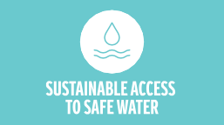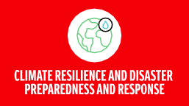



SOCIAL

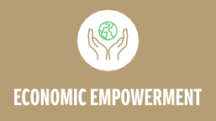



|  |  |  |  |  |
| --- | --- | --- | --- | --- |
|  | **SENIOR LEADERSHIP** | **MIDDLE MANAGEMENT** | **PROFESSIONALS** | **TOTAL** |
| Female | 39.0% | 51.3% | 36.0% | **44.0%** |
| Male | 61.0% | 48.7% | 64.0% | **56.0%** |

**2022 Race/Ethnicity Representation by Level (U.S. only)1**

**SENIOR LEADERSHIP**

**MIDDLE**



Recycling

**13%**

$14.1M

$13.0M

Matching Gifts

**7%**

Education &

Youth Development

**14%**

$12.0M

Women’s Empowerment

**7%**

Disaster Relief & Humanitarian Aid

**15%**

$94.8M

2022 Contributions

$10.1M

$31.8M

Community Well-Being

**11%**

Water & Environment

**33%**

$7.0M

$6.8M

**The Coca-Cola Foundation: 2022 Contributions**

**MANAGEMENT PROFESSIONALS TOTAL**

|  |  |  |  |  |
| --- | --- | --- | --- | --- |
| American Indian/Alaskan Native | 0.0% | 0.3% | 0.4% | **0.3%** |
| Asian | 10.0% | 10.4% | 5.4% | **8.1%** |
| Black/African American | 8.6% | 16.1% | 30.3% | **22.0%** |
| Hispanic/Latino | 9.9% | 8.7% | 21.2% | **14.6%** |
| Native Hawaiian/Other Pacific Islander | 0.1% | 0.1% | 0.5% | **0.3%** |
| Not specified | 9.1% | 5.2% | 2.4% | **4.3%** |
| Two or more races | 0.9% | 2.2% | 3.0% | **2.5%** |
| White | 61.4% | 57.1% | 36.7% | **48.1%** |

1 Data as of December 31, 2022, for salaried and hourly employees. Race/ethnicity data is for U.S. workforce only. This data excludes Bottling Investments Group (BIG), Global Ventures, fairlife and BODYARMOR. For exclusions, please view the criteria statement in the Independent Accountants’ Review Report.

Note: The percentages in each column in these charts may not sum to 100% due to rounding.

CONTENTS

CEO MESSAGE EXECUTIVE SUMMARY

OUR COMPANY

WATER

PORTFOLIO

PACKAGING

CLIMATE

AGRICULTURE

PEOPLE

OPERATIONS

DATA APPENDIX

FRAMEWORKS

OVERVIEW

AT A GLANCE

HOW WE OPERATE

INNOVATION FINANCIAL HIGHLIGHTS GOVERNANCE & MANAGEMENT PRIORITY TOPICS STAKEHOLDER ENGAGEMENT & PARTNERSHIPS

# Our

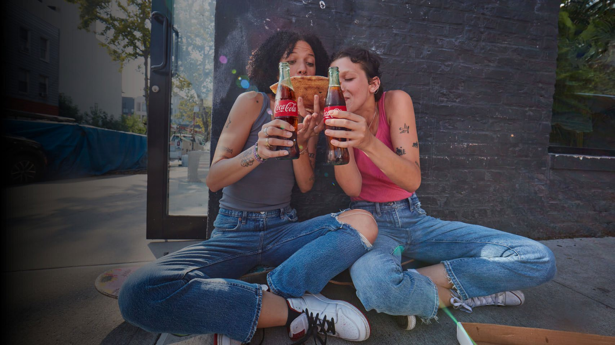

## Company

We are a total beverage company with products sold in more than 200 countries and territories. We are constantly transforming our portfolio, from reducing added sugar in our drinks to bringing innovative

new products to market. We seek to positively impact people’s lives, communities and the planet through water replenishment, packaging recycling, sustainable sourcing practices and carbon emissions reductions across our value chain. Together with our bottling partners, we employ more than 700,000 people, helping bring economic opportunity to local communities worldwide.

**THE COCA-COLA COMPANY** 2022 BUSINESS & SUSTAINABILITY REPORT 12

CONTENTS

CEO MESSAGE EXECUTIVE SUMMARY

OUR COMPANY

WATER

PORTFOLIO

PACKAGING

CLIMATE

AGRICULTURE

PEOPLE

OPERATIONS

DATA APPENDIX

FRAMEWORKS

OVERVIEW

AT A GLANCE

HOW WE OPERATE

INNOVATION FINANCIAL HIGHLIGHTS GOVERNANCE & MANAGEMENT PRIORITY TOPICS STAKEHOLDER ENGAGEMENT & PARTNERSHIPS

COMPANY FACTS OUR SUSTAINABILITY BUSINESS PRIORITIES

AT A GLANCE

137 YEARS

of refreshing the world and making a difference

ATLANTA, GEORGIA

Global headquarters

200+

Countries and territories where our products

are sold

~200

Master brands

**Water Leadership**

**Reducing Added Sugar**

**Packaging**

**Climate**

**Sustainable Agriculture**

**People & Communities**

THE COCA-COLA SYSTEM

2022 PERFORMANCE

2022 GLOBAL UNIT CASE VOLUME MIX BY OPERATING SEGMENT

~200

Bottling partners worldwide

~950

Production facilities

700K+

System employees

~30M

Retail customer outlets

$43.0B

2022 Net Operating Revenues

11%

2022 Net Operating Revenue Growth

17%

North America

28%

Europe, Middle East & Africa

24%

RETAIL VALUE UNIT CASE VOLUME

**Total Company Unit Cases**

27%

Latin America

Asia Pacific

Trademark Coca-Cola

(in billions) 4%

Sparkling Flavors

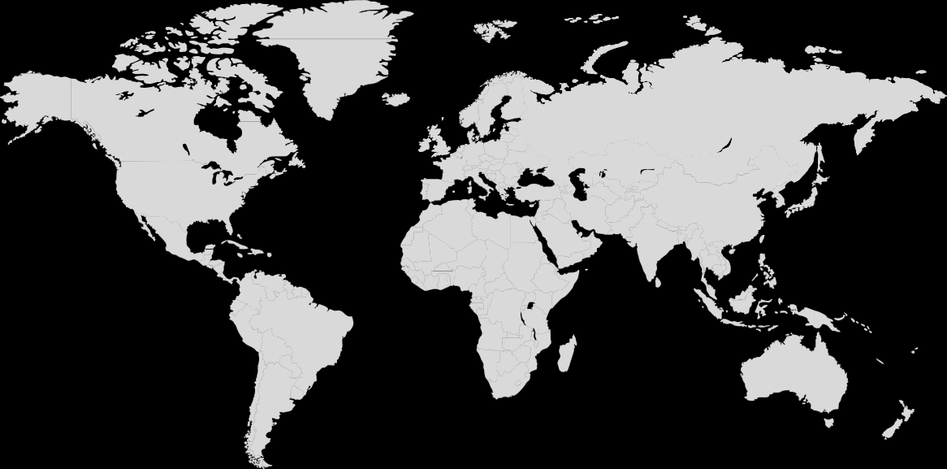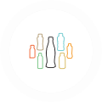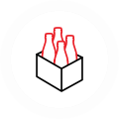

Water, Sports, Coffee & Tea

Juice, Value-Added Dairy & Plant-Based Beverages

Emerging & Other

30 28.2

20

10

0

2013

28.6

2014

29.2

2015

29.3

2016

29.2

2017

29.6

2018

30.3

2019

29.0

2020

31.3

2021

32.7

2022

Global Ventures

CONTENTS

CEO MESSAGE EXECUTIVE SUMMARY

OUR COMPANY

WATER

PORTFOLIO

PACKAGING

CLIMATE

AGRICULTURE

PEOPLE

OPERATIONS

DATA APPENDIX

FRAMEWORKS

OVERVIEW

AT A GLANCE

HOW WE OPERATE

INNOVATION FINANCIAL HIGHLIGHTS GOVERNANCE & MANAGEMENT PRIORITY TOPICS STAKEHOLDER ENGAGEMENT & PARTNERSHIPS

The Coca-Cola Company markets, manufactures and sells:

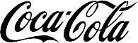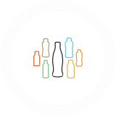

The Coca-Cola System1

**THE**

**COMPANY**

INNOVATION / CREATION / MARKETING

**Concentrates and Syrups**

**Finished Products**

BOTTLERS

DISTRIBUTION

**CUSTOMERS & CONSUMERS**

~200

BOTTLING PARTNERS WORLDWIDE

~950

PRODUCTION FACILITIES WORLDWIDE

2.2B SERVINGS PER DAY

HOW WE OPERATE

* Beverage concentrates and syrups
* Finished beverages (including sparkling soft drinks; water, sports, coffee & tea; juice, value- added dairy & plant-based beverages; and emerging beverages).

In our concentrate operations, The Coca-Cola Company typically generates net operating revenues by selling concentrates and syrups to authorized bottling partners.

Our bottling partners combine the concentrates and syrups with still or sparkling water

and sweeteners (depending on the product), to prepare, package, distribute and sell finished beverages.

Our finished product operations consist primarily of company-owned bottling and distribution operations.

We also operate retail outlets through

Costa Limited (Costa), which has nearly 4,000 Costa coffee shops and over 14,000 Costa Express self-serve coffee bars worldwide. Costa’s portfolio also includes ready-to-drink and at- home coffee solutions.

1 The Coca-Cola Company and its bottling partners are collectively known as the Coca-Cola system. The Coca-Cola Company does not own, manage or control most local bottling companies.

CONTENTS

CEO MESSAGE EXECUTIVE SUMMARY

OUR COMPANY

WATER

PORTFOLIO

PACKAGING

CLIMATE

AGRICULTURE

PEOPLE

OPERATIONS

DATA APPENDIX

FRAMEWORKS

OVERVIEW

INNOVATION

INNOVATION

AT A GLANCE

HOW WE OPERATE

INNOVATION FINANCIAL HIGHLIGHTS GOVERNANCE & MANAGEMENT PRIORITY TOPICS STAKEHOLDER ENGAGEMENT & PARTNERSHIPS

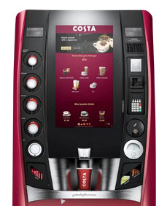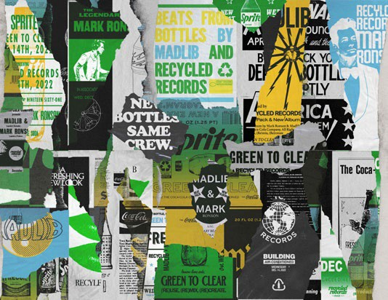

**“Recycled Records”**

|  |  |  |
| --- | --- | --- |
| BOLD BEVERAGES AND NEW EXPERIENCES  We’re taking global innovation to the next level. In 2022, we  combined partnerships, technology and our consumers’ passions to create unforgettable experiences in music, gaming and sports. | **Costa Coffee Smart Café**  Launched in the United States in 2022, the Costa Coffee Smart Café delivers a range of more than 200 drink options, from espresso to hot chocolate. These innovative touch-screen machines always use fresh milk and freshly ground Signature Blend beans. | |
| **Coke Studio**  [Coke Studio](https://www.coca-colacompany.com/news/coke-studio-goes-global) expanded into a global, digital-first platform.  Seven diverse artists from seven countries teamed up on a remake of Queen’s “A Kind of Magic” to kick off the platform. Coke Studio launched in 2008 in Pakistan as a TV series featuring live collaborations between  established and emerging musical artists before growing into an international music franchise with editions in India, the Philippines, Africa and the Middle East. | | **Coca-Cola Creations**  [Coca-Cola Creations](https://www.coca-colacompany.com/news/a-coca-cola-thats-out-of-this-world) is a new global innovation platform that lends the iconic Coca-Cola brand to new expressions, driven by collaboration, creativity and cultural connection. In 2022, we launched five limited-edition drinks:  Coca-Cola Starlight, Coca-Cola Byte, the artist Marshmello’s Limited Edition Coca-Cola, Coca-Cola Dreamworld, and Coca-Cola Soul Blast. Coca-Cola Creations draws inspiration from music, gaming and culture, and is complemented with experimental  packaging designs, digital experiences and more. |

Legendary music producers Mark Ronson and Madlib teamed up with Sprite, Fresca and Seagram’s to showcase the parallels between recycling sounds and beverage bottles. [“Recycled](https://www.coca-colacompany.com/news/sprite-fresca-seagrams-mark-ronson-madlib-music-connection) [Records”](https://www.coca-colacompany.com/news/sprite-fresca-seagrams-mark-ronson-madlib-music-connection) is an original EP created almost entirely from “recycled” sound samples captured during the PET bottle-to-bottle recycling process. The project is a creative, culturally relevant way

to celebrate the brands’ switch from green to clear PET packaging.

CONTENTS

CEO MESSAGE EXECUTIVE SUMMARY

OUR COMPANY

WATER

PORTFOLIO

PACKAGING

CLIMATE

AGRICULTURE

PEOPLE

OPERATIONS

DATA APPENDIX

FRAMEWORKS

OVERVIEW

AT A GLANCE

HOW WE OPERATE

INNOVATION FINANCIAL HIGHLIGHTS GOVERNANCE & MANAGEMENT PRIORITY TOPICS STAKEHOLDER ENGAGEMENT & PARTNERSHIPS

**A Metaverse Milestone**

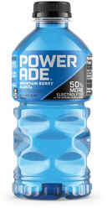

Coca-Cola thanked fans who participated in the brand’s journey into the metaverse with a special digital collectible drop on [International Friendship](https://www.coca-colacompany.com/news/coca-cola-marks-first-anniversary-in-the-metaverse-on-international-friendship-day) [Day 2022](https://www.coca-colacompany.com/news/coca-cola-marks-first-anniversary-in-the-metaverse-on-international-friendship-day). The collectible, featuring a design inspired by the bubbles inside a Coke bottle as well as themes of connection and unity, airdropped to the digital wallets of Coca-Cola collectible owners in July. Recipients could share a second International Friendship Day collectible with a friend to build Coke’s community of fans.

**Sprite Limelight**



[Sprite Limelight](https://www.coca-colacompany.com/news/sprite-and-james-blake-shine-limelight-on-diverse-artists) launched as the music and cultural extension of “Heat Happens,” the brand’s global platform unveiled in 2022. Grammy-winning producer James Blake crafted a lyrical hook rooted in keeping life’s “heat” at bay, and three distinctive global artists—American rapper Coi Leray, African singer-songwriter and social media sensation Omah Lay, and Chinese pop/rock singer Hua Chenyu—used the hook as inspiration for their own original songs.

**Lil Nas X and vitaminwater**

Global superstar Lil Nas X teamed up with [vitaminwater’s “Nourish Every](https://www.coca-colacompany.com/news/lil-nas-x-and-vitaminwater-team-up) [You” campaign](https://www.coca-colacompany.com/news/lil-nas-x-and-vitaminwater-team-up) to showcase six videos featuring his unreleased track, “Give Me One Chance.” Each featured a unique

vitaminwater flavor—focus, shine, energy, xxx zero, gutsy and ice—to create a fantasy world inspiring fans to nourish all of their “yous.” “Nourish Every You” was inspired by the insight that vitaminwater fans

want to take care of themselves, but are living with fluctuating physical, emotional and spiritual needs.

**POWERADE:**

**‘Pause is Power’**

POWERADE celebrated the [power of the pause](https://www.coca-colacompany.com/news/pause-is-power-powerade-challenges-win-at-all-costs-mindset)—prioritizing wellbeing over winning—with a global communications platform featuring USA gymnast Simone Biles and other accomplished athletes and coaches spanning a variety of sports. The campaign kicked off in March 2022

during NCAA March Madness.

CONTENTS

CEO MESSAGE EXECUTIVE SUMMARY

OUR COMPANY

WATER

PORTFOLIO

PACKAGING

CLIMATE

AGRICULTURE

PEOPLE

OPERATIONS

DATA APPENDIX

FRAMEWORKS

OVERVIEW

AT A GLANCE

HOW WE OPERATE

INNOVATION FINANCIAL HIGHLIGHTS GOVERNANCE & MANAGEMENT PRIORITY TOPICS STAKEHOLDER ENGAGEMENT & PARTNERSHIPS

**Organic Revenue Growth (Non-GAAP)1**

FINANCIAL HIGHLIGHTS

**Comparable Currency Neutral Operating Income Growth (Non-GAAP)2**

20

|  |  |  |  |  |
| --- | --- | --- | --- | --- |
| (in millions except per share data) | 2019 | 2020 | 2021 | 2022 |
| **Summary of Operations** |  |  |  | **$ 43,004** |
| Net operating revenues | $37,266 | $33,014 | $38,655 |
| Operating income | 10,086 | 8,997 | 10,308 | **10,909** |
| Net income attributable to shareowners of The Coca-Cola Company | 8,920 | 7,747 | 9,771 | **9,542** |
| **Per Share Data** |  |  |  | **$2.20** |
| Basic earnings per share | $2.09 | $1.80 | $2.26 |
| Diluted earnings per share | 2.07 | 1.79 | 2.25 | **2.19** |
| Cash dividends | 1.60 | 1.64 | 1.68 | **1.76** |
| **Balance Sheet Data** |  |  |  | **$ 92,763** |
| Total assets | $86,381 | $87,296 | $94,354 |
| Long-term debt | 27,516 | 40,125 | 38,116 | **36,377** |

15

10

5

0

-5

-10

(9%)

16%

16%

20

15

6%

2020

2019

2021

2022

10

5

0

2019

2020

2021

19%

2022

13%

12%

0%

**Comparable Currency Neutral Diluted Earnings Per Share Growth (Non-GAAP)3**

**Adjusted Free Cash Flow Conversion Ratio (Non-GAAP)4**

20

15

9%

2020

2019

2021

2022

10

5

0

-5 (2%)

17%

17%

120

100

80

60

40

20

0

2019

108%

116%

96%

89%

2020

2021

2022

Note: See pages 72–74 for reconciliations of non-GAAP financial measures to our results as reported under accounting principles generally accepted in the United States (U.S. GAAP).

1. Reported net operating revenues grew 9%, declined 11%, grew 17%

and grew 11% for the years ended December 31, 2019, 2020, 2021

and 2022, respectively.

1. Reported operating income grew 10%, declined 11%, grew 15% and

grew 6% for the years ended December 31, 2019, 2020, 2021 and

2022, respectively.

1. Reported diluted earnings per share grew 38%, declined 13%, grew 26% and declined 3% for the years ended December 31, 2019, 2020,

2021 and 2022, respectively.

1. Adjusted free cash flow conversion ratio = free cash flow adjusted for pension contributions divided by net income adjusted for noncash items impacting comparability.

CONTENTS

CEO MESSAGE EXECUTIVE SUMMARY

OUR COMPANY

WATER

PORTFOLIO

PACKAGING

CLIMATE

AGRICULTURE

PEOPLE

OPERATIONS

DATA APPENDIX

FRAMEWORKS

OVERVIEW

AT A GLANCE

HOW WE OPERATE

INNOVATION FINANCIAL HIGHLIGHTS GOVERNANCE & MANAGEMENT PRIORITY TOPICS STAKEHOLDER ENGAGEMENT & PARTNERSHIPS

CORPORATE GOVERNANCE

GOVERNANCE & MANAGEMENT

GOVERNANCE & MANAGEMENT THE COCA-COLA COMPANY

The Coca-Cola Company’s innovative and collaborative culture is underpinned by a robust framework of policies and processes to promote ethical behavior, accountability and transparency. Our Board of Directors is responsible for overseeing our governance framework as part

of its risk oversight function. Board Committee charters, our Code of Business Conduct, Corporate Governance Guidelines, Certificate of Incorporation and Corporate By-Laws can be viewed on our [website](https://investors.coca-colacompany.com/corporate-governance).

**Board Committees**

* Audit
* Corporate Governance and Sustainability
* Executive
* Finance
* Talent and Compensation

SUSTAINABILITY GOVERNANCE

The Board has delegated oversight of sustainability matters to its various committees in order to leverage each committee’s experience and subject-matter strengths in overseeing

the varied and technical matters encompassed by sustainability. The Corporate Governance and Sustainability Committee has primary responsibility for overseeing the company’s sustainability strategies and initiatives—and

related risks—that concern environmental, social, legislative, regulatory and public policy matters,

including progress toward the company’s sustainability goals. The Committee assesses a range of issues relevant to the company’s business, our shareowners, the broader stakeholder community or the general public.

This entails evaluating and reviewing information pertaining to social, political and environmental trends, in addition to oversight of the company’s sustainability goals and human rights practices.

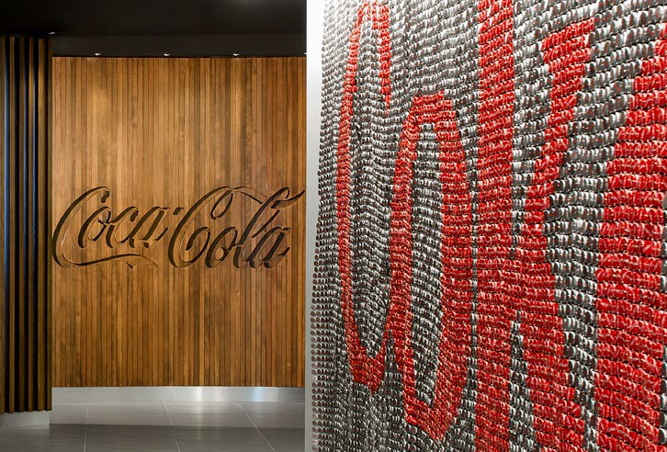

To reinforce the importance of meeting our sustainability goals, the Talent and Compensation Committee approved plans to link sustainability performance to our annual and long-term incentive programs for executives in 2022. In the annual incentive program, we have reinforced our commitment to DEI by incorporating quantitative and qualitative components tied to our 2030 aspirations to be 50% led by women globally and, in the United States, to align race and ethnicity representation to U.S. census data. Similarly, in the long-term incentive program, predefined goals related to our World Without Waste packaging strategy and our 2030 Water Security Strategy were incorporated into the 2022–2024 incentive awards.

**Driving Sustainability Performance through Executive Compensation**

Beginning in 2022, performance as it relates to diversity, packaging and water goals is reflected in our incentive programs for executives.

The Corporate Governance and Sustainability Committee oversees our plans and strategies on climate-related issues. For a deeper dive into

our climate governance, visit the Climate section. The Committee also oversees and reviews,

at least annually, the company’s public policy agenda, its position on significant public policy matters, political contributions and lobbying activities. The Committee reviews shareowner proposals on sustainability issues to be included in the company’s proxy statements and makes recommendations to the Board. In addition,

the Committee receives updates on priority sustainability issues, including actions and progress toward goals.

The Audit Committee oversees certain processes related to external sustainability disclosures and works jointly with the Corporate Governance and Sustainability Committee to oversee sustainability risks facing the company. Finally, the Talent

and Compensation Committee oversees the company’s human capital management policies and strategies. This includes talent management, leadership and company culture initiatives,

such as those promoting diversity, equity and inclusion (DEI). This Board-level commitment and alignment drives top-down accountability toward our DEI goals and helps support a positive company culture.

**SECTION SCOPE:** This section refers to governance, disclosure and policies of The Coca-Cola Company.

CONTENTS

CEO MESSAGE EXECUTIVE SUMMARY

OUR COMPANY

WATER

PORTFOLIO

PACKAGING

CLIMATE

AGRICULTURE

PEOPLE

OPERATIONS

DATA APPENDIX

FRAMEWORKS

OVERVIEW

AT A GLANCE

HOW WE OPERATE

INNOVATION FINANCIAL HIGHLIGHTS GOVERNANCE & MANAGEMENT PRIORITY TOPICS STAKEHOLDER ENGAGEMENT & PARTNERSHIPS

OUR APPROACH TO DISCLOSURE

We have a comprehensive sustainability reporting process that spans many years, and we aim to provide stakeholders with complete, transparent and candid information in all our public communications. This is our fifth annual

Business & Sustainability Report, which combines financial and sustainability performance in one publication. We also respond to the CDP [climate](https://www.coca-colacompany.com/content/dam/journey/us/en/policies/pdf/sustainability/2022-cdp-climate-response.pdf), [water](https://www.coca-colacompany.com/content/dam/journey/us/en/policies/pdf/sustainability/2022-cdp-water-response.pdf) and [forests](https://www.coca-colacompany.com/content/dam/journey/us/en/policies/pdf/sustainability/2022-cdp-forests-response.pdf) questionnaires and make those disclosures publicly available.

We recognize there is a desire for standardization across reporting frameworks, and we’re continually evaluating reporting options and listening to stakeholder feedback. This report

is prepared in accordance with the Global Reporting Initiative (GRI) Standards, a globally recognized framework. In addition, we provide indexes for the Sustainability Accounting Standards Board (SASB), the Task Force on Climate-related Financial Disclosures, the United Nations Sustainable Development Goals (SDGs), the United Nations Global Compact (UNGC) and the United Nations Guiding Principles Reporting Framework (UNGPRF). We also submit packaging data to the Ellen MacArthur Foundation/UN Environment Programme’s New Plastics Economy Global Commitment, the WWF ReSource Plastic disclosure platform and the U.S. Plastics Pact.

PUBLIC POLICY & POLITICAL ENGAGEMENT

Integrity, transparency and nonpartisanship underpin our approach to engagement in the public policy and political process. In the United States and Canada, we promote public policy solutions about key issues for our business that include [environmental sustainability](https://www.coca-colacompany.com/content/dam/journey/us/en/policies/public-policy/docs/TCCC-Sustainability-Report.pdf), [consumer](https://www.coca-colacompany.com/content/dam/journey/us/en/policies/public-policy/docs/TCCC-ConsumerPreference-Report-.pdf) [preference](https://www.coca-colacompany.com/content/dam/journey/us/en/policies/public-policy/docs/TCCC-ConsumerPreference-Report-.pdf), tax and trade, and [workplace and](https://www.coca-colacompany.com/content/dam/journey/us/en/policies/public-policy/docs/TCCC-DEI-Report-.pdf) [economic inclusion](https://www.coca-colacompany.com/content/dam/journey/us/en/policies/public-policy/docs/TCCC-DEI-Report-.pdf). Our advocacy often involves education, participation and thought leadership within industry, business and policy forums. When significant to our business interests, we share our policy positions through advocacy initiatives.

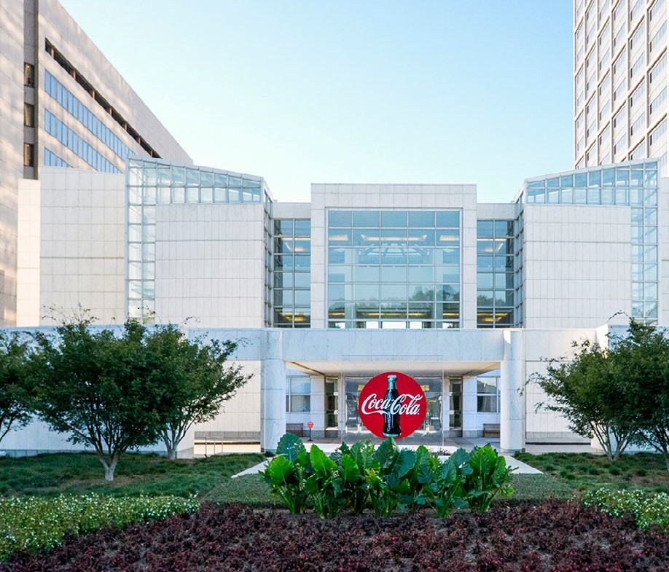

Learn about our transparent approach to stakeholder engagement  and [scientific research](https://www.coca-colacompany.com/policies-and-practices/transparency.html).

The company follows all national laws regarding political engagement and discloses political contributions according to each country’s legal framework and through the relevant national regulatory authorities. In early 2023, the company enhanced its disclosures to include links to our non-U.S. political contributions.

The Corporate Governance and Sustainability Committee of the Board of Directors annually reviews our public policy agenda and advocacy program. These reviews ensure that our activities align with our business interests and serve the needs of our shareowners and broader stakeholder community. The North America Operating Unit Vice President of Public Policy, Federal Government Relations & Political Engagement is responsible for management of our public policy agenda and political engagement, in consultation with the North America Operating Unit Senior Vice President & Chief of Public Affairs, Communications and Sustainability, and the Legal Department. Our political participation is conducted in an open and nonpartisan manner and in strict compliance with the [Code of Business](https://investors.coca-colacompany.com/corporate-governance/code-of-business-conduct) [Conduct](https://investors.coca-colacompany.com/corporate-governance/code-of-business-conduct), the [U.S. Political Engagement Policy](https://www.coca-colacompany.com/policies-and-practices/public-policy-and-political-engagement/us-political-engagement-policy), and applicable laws and regulations.

Consistent with U.S. federal law, the company does not use corporate funds to contribute to federal candidates, political parties or political committees, or otherwise employ its resources, including in-kind, even when permitted by

law. The company has a long-standing policy against use of corporate funds for independent expenditures or super PACS, including toward electioneering communications. Effective as

of January 1, 2021, the company does not use corporate funds to directly support state or local political candidates, even if permitted by law.

The Coca-Cola Company was recognized as a Trendsetter in the [2022 CPA-Zicklin](https://www.politicalaccountability.net/wp-content/uploads/2022/10/2022-Index-Text-File-for-Web-10.11.22.pdf) [Index of Corporate Political Disclosure](https://www.politicalaccountability.net/wp-content/uploads/2022/10/2022-Index-Text-File-for-Web-10.11.22.pdf) [and Accountability](https://www.politicalaccountability.net/wp-content/uploads/2022/10/2022-Index-Text-File-for-Web-10.11.22.pdf). The Center for Political Accountability (CPA) aims to encourage responsible corporate political activity, protect shareholders and strengthen the integrity of the political process.

CONTENTS

CEO MESSAGE EXECUTIVE SUMMARY

OUR COMPANY

WATER

PORTFOLIO

PACKAGING

CLIMATE

AGRICULTURE

PEOPLE

OPERATIONS

DATA APPENDIX

FRAMEWORKS

OVERVIEW

EXECUTIVE LEADERSHIP TEAM

Chairman and Chief Executive Officer

Chief Communications, Sustainability and Strategic

Partnerships Officer

Chief Technical

and Innovation Officer

President and Chief Financial Officer

AT A GLANCE

HOW WE OPERATE

INNOVATION FINANCIAL HIGHLIGHTS GOVERNANCE & MANAGEMENT PRIORITY TOPICS STAKEHOLDER ENGAGEMENT & PARTNERSHIPS

OUR SUSTAINABILITY APPROACH

The Coca-Cola Company works closely with approximately 200 bottling partners across more than 200 countries and territories to achieve our sustainability goals. We have established internal processes and an internal control environment that help us identify and manage risks. One hallmark of our approach is regular communication between the Board, our Chairman and CEO, and internal teams such

as the Enterprise Risk Management team, the Risk Steering Committee and the Networked Corporate Sustainability team, which includes Technical, Innovation and Supply Chain; Public Affairs, Communications and Sustainability; Global Human Rights; and Procurement. The company’s Compliance, Legal and Finance

functions serve in an advisory role. Our networked teams also collaborate with operating units, bottling partners, NGOs, governments, investors and people in communities all around the world to identify risks and make progress toward

our sustainability goals. For more about our

**Sustainability Governance at The Coca-Cola Company**

Enterprise Risk Management

Audit Committee

Board of Directors

Talent and Compensation Committee

Corporate Governance and Sustainability Committee

approach to risk management and priority issues, see Priority Topics.

STEERING COMMITTEES

Risk Steering Committee

Sustainability Steering Committee

NETWORKED CORPORATE SUSTAINABILITY TEAM

|  |  |  |  |  |  |  |  |
| --- | --- | --- | --- | --- | --- | --- | --- |
| Public Affairs, Communications & Sustainability | | Technical, Innovation & Supply Chain | | Global Human Rights | | Procurement | |
|  |  | |  | |  | |  |

CROSS-FUNCTIONAL STEERING GROUPS

ADVISORY ROLE

Compliance

Legal

Finance

|  |  |  |  |  |  |  |  |  |  |  |  |
| --- | --- | --- | --- | --- | --- | --- | --- | --- | --- | --- | --- |
| Global Environmental Council | | Sustainable Sourcing Committee | | Packaging Core Team | | Water Core Team | | Climate Core Team | | Global Health & Safety Council | |
|  |  | |  | |  | |  | |  | |  |

**OPERATING UNIT LOCAL SUSTAINABILITY TEAMS**

CONTENTS

CEO MESSAGE EXECUTIVE SUMMARY

OUR COMPANY

WATER

PORTFOLIO

PACKAGING

CLIMATE

AGRICULTURE

PEOPLE

OPERATIONS

DATA APPENDIX

FRAMEWORKS

OVERVIEW

AT A GLANCE

HOW WE OPERATE

INNOVATION FINANCIAL HIGHLIGHTS GOVERNANCE & MANAGEMENT PRIORITY TOPICS STAKEHOLDER ENGAGEMENT & PARTNERSHIPS

During 2022, we undertook a comprehensive review of the highest priority topics for our company, system and stakeholders.

PRIORITY TOPICS

Identifying and prioritizing our material topics, in collaboration with a cross-functional internal team and key external stakeholders, is a foundational step in how we develop our corporate

strategy, conduct and evolve our business, and report on progress.

Prior to 2022, our last comprehensive review was conducted in 2019, with refreshes being undertaken in 2020 and 2021 to establish closer alignment between priority topics and business- relevant issues and practices.

Our 2022 review included a robust analysis and broader engagement guided by ERM, a leading sustainability consultancy. This was followed by interviews with more than 30 internal and external stakeholders and an online survey that had 90 responses from across the globe.

Stakeholders we talked to represent a diversity of views and have deep expertise across a range of issues and sectors. The stakeholders included investors and financial institutions, NGOs,

bottling partners, trade and industry associations, business peers, customers and suppliers.

Our comprehensive 2022 review process resulted in an updated priority topics matrix, which reflects adjustments to several key issues in response to feedback from both internal and external stakeholders.

The updated matrix continues to demonstrate that our priority topics are Packaging & Circularity and Water Stewardship, followed by Health

& Nutrition and Climate Change. Responsible Sourcing and Talent Attraction, Retention and DEI increased in importance versus the prior year.



PACKAGING & CIRCULARITY

WATER STEWARDSHIP

HEALTH & NUTRITION

RESPONSIBLE SOURCING

SUSTAINABLE COMMUNITIES

ADVOCACY & REGULATORY ENGAGEMENT

CLIMATE CHANGE

LA

RESPONSIBLE MARKETING

TALENT ATTRACTION, RETENTION & DEI

UMAN RIGHTS

BIODIVERSITY & DEFORESTATION

PRODUCT QUALITY & SAFETY BUSINESS CONTINUITY & RESILIENCE

STAKEHOLDER, SYSTEM & BUSINESS PARTNER ENGAGEMENT

CORPORATE GOVERNANCE

IMPACT TO THE COCA-COLA COMPANY

We have implemented management initiatives to address these priority topics. We also continue to evolve our strategic approach to

effectively manage associated business risks and opportunities in light of the ongoing changes to both our business and the external context in which we operate. This is detailed in the individual sections of the report.

BOR & H

IMPORTANCE TO EXTERNAL STAKEHOLDERS

The horizonal axis represents impact to the company and the vertical axis

represents the importance to stakeholders. The quadrants help identify where the combined views of the priority topics fall.

FOR FURTHER DETAILS INCLUDING THE FULL DEFINITIONS OF EACH TOPIC, PLEASE SEE THE DATA APPENDIX 

CONTENTS

CEO MESSAGE EXECUTIVE SUMMARY

OUR COMPANY

WATER

PORTFOLIO

PACKAGING

CLIMATE

AGRICULTURE

PEOPLE

OPERATIONS

DATA APPENDIX

FRAMEWORKS

OVERVIEW

AT A GLANCE

HOW WE OPERATE

INNOVATION FINANCIAL HIGHLIGHTS GOVERNANCE & MANAGEMENT PRIORITY TOPICS STAKEHOLDER ENGAGEMENT & PARTNERSHIPS

##### PARTNERING FOR IMPACT

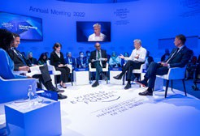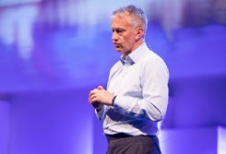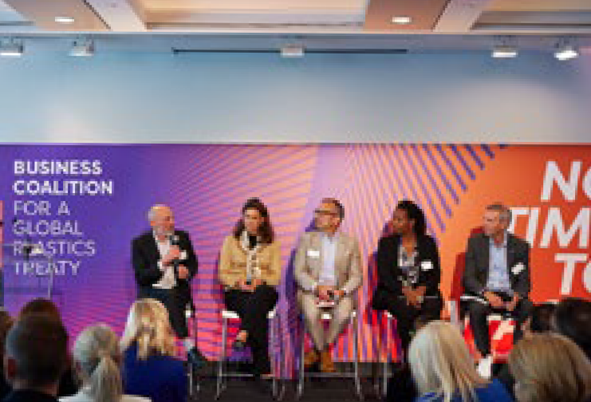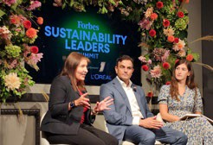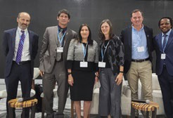

In 2022, as COVID-19 restrictions eased, we were able to attend several global events in person. We used these opportunities to engage with diverse stakeholders, to listen and to explore ways to drive collective action to positively impact people, communities and our environment.

**World Economic Forum**

Davos, Switzerland

**The Consumer Goods Forum Global Summit**

Dublin, Ireland

**World Water Week**

Stockholm, Sweden

**Business Coalition for a Global Plastics Treaty Launch**

New York, NY, U.S.

**Forbes Sustainability Summit**

New York, NY, U.S.

**UN Climate Change Conference**

Sharm El Sheikh, Egypt

**Global Leadership Events**

NOVEMBER

SEPTEMBER

SEPTEMBER

AUGUST

JUNE

MAY

**Partnership Highlights**

* Coca-Cola Philippines and Indorama Ventures partnered to establish PETValue Philippines, a full operation recycling facility that is the first of its kind in the country. The facility is helping to drive collective action toward a circular economy for PET plastic, by providing more than 800 collection points for PET bottles in the country. PETValue’s projected

capacity, or the amount of used plastic bottles it can process, is 30,000 metric tons per year, which requires around 2 billion PET bottles as input to be recycled.

* In partnership with WWF-Pakistan, we are working to address water scarcity and quality issues for approximately 360,000 people in Lahore, Pakistan who rely on the Ravi River as a freshwater source.
* We partnered with the CEO Water Mandate, denkstatt and others to help build the business case for Nature-Based Solutions (NBS) by developing a standardized methodology to quantify the co-benefits

of NBS projects and calculate the social return on investment.

* We joined the Supplier Leadership on Climate Transition initiative along with

18 other companies to mobilize collective climate action by providing suppliers with resources, tools and knowledge to accelerate their decarbonization. Ten suppliers that we sponsored, who completed the program, have set or committed to setting emissions reduction targets through the Science-Based Targets initiative.

* We joined with the [Business Coalition for a](https://www.businessforplasticstreaty.org/) [Global Plastics Treaty](https://www.businessforplasticstreaty.org/) and the International Council of Beverages Associations in support of a UN Global Plastics Treaty. The Business Coalition is supporting the treaty negotiations around the vision of a circular economy

in which plastic never becomes waste or pollution, and the value of products and materials is retained in the economy.

STAKEHOLDER ENGAGEMENT & PARTNERSHIPS

As one of the world’s largest and most recognized companies, we have an opportunity to

use our size and scale to help address global challenges.

While we strive to make progress on our own, we are committed to fostering partnerships that drive collective impact in areas including

water stewardship, packaging circularity, climate action and many more. As a global business

that operates locally, we can extend our impact and reach because of the strength of the

Coca-Cola system, which includes our approximately 200 bottling partners worldwide.

We engage with stakeholders, including governments, NGOs, communities, suppliers, investors, business partners, customers and consumers around the world and throughout our network, in many forums and formats.

Feedback from our stakeholders allows us to learn and improve, and informs our business and sustainability strategy.

In all our engagements with stakeholders, we are committed to upholding the principles of **transparency**, **consistency**, **accountability** and **integrity**.

**SECTION SCOPE:** In this section our stakeholder engagement and partnership work refers to actions by the company

as well as our owned and independent bottling partners and our independent suppliers and partners.

CONTENTS

CEO MESSAGE EXECUTIVE SUMMARY

OUR COMPANY

WATER

PORTFOLIO

PACKAGING

CLIMATE

AGRICULTURE

PEOPLE

OPERATIONS

DATA APPENDIX

FRAMEWORKS

OVERVIEW

AT A GLANCE

HOW WE OPERATE

INNOVATION FINANCIAL HIGHLIGHTS GOVERNANCE & MANAGEMENT PRIORITY TOPICS STAKEHOLDER ENGAGEMENT & PARTNERSHIPS

##### CONVENING MEANINGFUL CONVERSATIONS

###### KEY REGIONAL EVENTS IN 2022



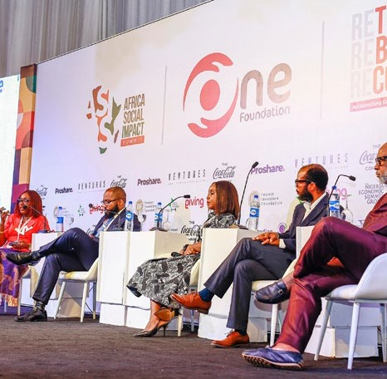

NIGERIA

**Africa Social Impact Summit**

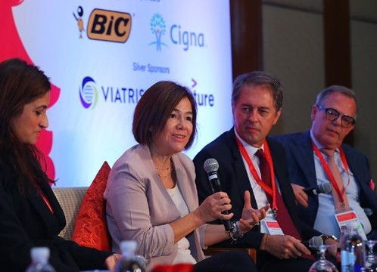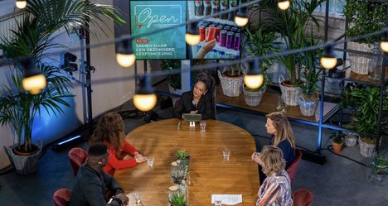

**OPEN Conversation**

Coca-Cola Netherlands held its fifth OPEN conversation in October involving our local bottling partner and key stakeholders to discuss topics such as packaging, water, climate, diversity, equity and inclusion

and how we can all contribute to a

healthier living environment.

**Break the Ceiling Touch the Sky**

Coca-Cola is a World Sponsor of House of Rose Professional’s Break the Ceiling Touch the Sky®, a global women's leadership platform. In September,

the 2022 Middle East edition brought together over 300 women from top companies across the region to Dubai to learn, network, share and apply best practices on leadership, success,

diversity and inclusion.

UNITED ARAB EMIRATES

THE NETHERLANDS

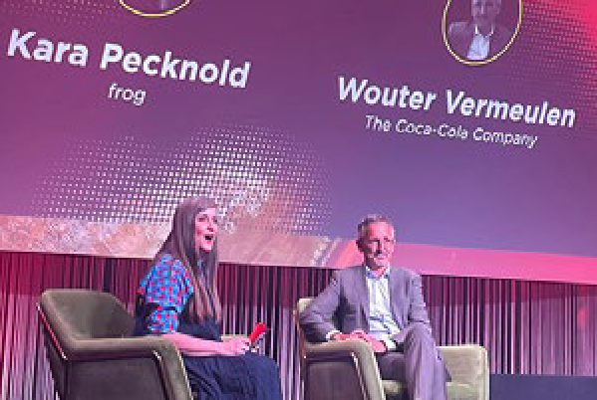

The Coca-Cola Company became a Strategic Partner of the **Ellen MacArthur Foundation** with the announcement shared during its annual Summit on July 5, 2022. The Foundation’s Strategic Partners include some of

the world’s largest and most influential organizations, with transformative potential to demonstrate what’s possible to accelerate the transition to a circular economy.

We partnered with Sterling One Foundation to hold the inaugural Africa Social Impact Summit under the theme “rethink, rebuild, recover— accelerating growth for the sustainable development goals (SDGs)” in Abuja, Nigeria in July. The summit provided a platform for dialogue on regional inclusive development aimed at stimulating the private sector and impact investors, to shape market-led solutions for the SDGs.

CONTENTS

CEO MESSAGE EXECUTIVE SUMMARY

OUR COMPANY

WATER

PORTFOLIO

PACKAGING

CLIMATE

AGRICULTURE

PEOPLE

OPERATIONS

DATA APPENDIX

FRAMEWORKS

# Water

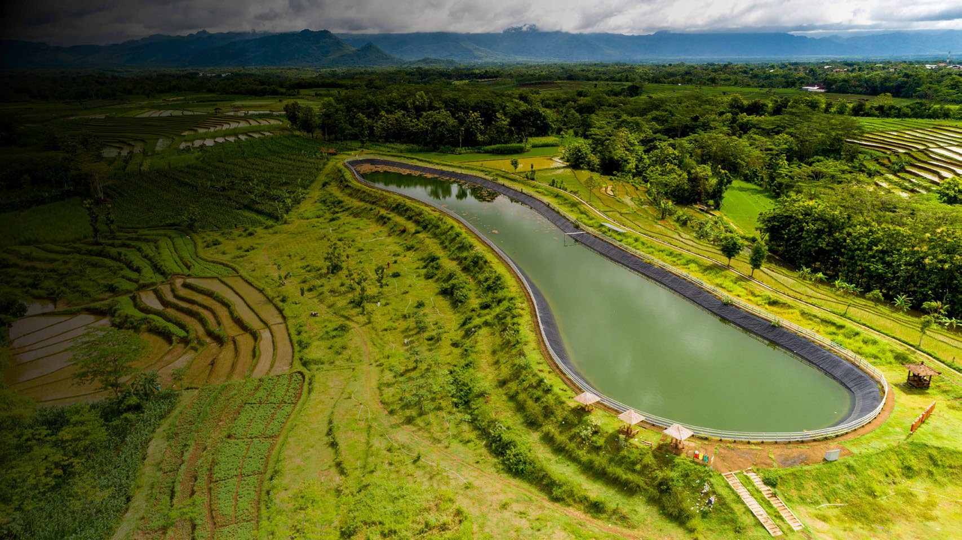

## Leadership

291B LITERS

OF WATER RETURNED TO NATURE AND COMMUNITIES IN 2022

159%

OF THE WATER USED IN OUR FINISHED BEVERAGES RETURNED TO NATURE AND COMMUNITIES IN 20222, 3

WE HAVE REPLENISHED MORE THAN 100% OF THE WATER USED IN OUR FINISHED BEVERAGES EVERY YEAR SINCE 2015

Water is a priority for The Coca-Cola Company because it is essential to life, our beverages and the

communities we serve. It is also critical to public health, food security, biodiversity and the climate crisis. The world is experiencing increased water insecurity, which is evident through water scarcity, with demands for safe, usable water exceeding supply in certain areas.

We have operations nearly everywhere in the world— in more than 200 countries and territories. That means we have a responsibility to accelerate our efforts to help address water stress, protect local water resources and help build community climate resilience—communities’ ability to adapt to these changing conditions. That’s why our 2030 Water Security Strategy is focused on accelerating the actions needed to increase water security where we operate, source ingredients and touch people’s lives.1

1. The previously reported figure of 18.5 million people provided access to safe drinking water, sanitation and hygiene since 2010, was through working collectively with The Coca-Cola Foundation, bottlers, implementing partners and other co-funders.

SECTION SCOPE: In this section our water leadership work refers to actions by the company, The Coca-Cola Foundation as well as our owned and independent bottling partners and our independent suppliers and partners.

1. Substantially all replenish data is internally validated and verified; the equivalent volume for 100% Replenish rate (182.9 Billion litres BL) is externally assured. Peer- reviewed methodologies were used to calculate volumetric benefits per project and operating unit for all externally assured data; one exception was approved for internally validated and verified data. The replenish benefit is typically estimated as a long-term, average annual volume, but for some project activities it varies annually. Replenish benefits fall under three categories: Watershed Protection and Restoration (233.5 BL), Water for Productive Use (40.9 BL) and Water Access and Sanitation (17.4 BL). Due to joint venture or merger and acquisition activities between 2019–2022, certain brands may not be accounted for in this metric. Unless otherwise stated, in this report finished beverages is based on global sales volume. Approximately 13.5 Billion liters (approx. 7%) of the water used in our beverages that we returned to nature and communities is from 7 projects located in Ukraine and Belarus where since May 2019 we have not been able to monitor projects on intervals aligned with internal guidelines due to COVID and the ongoing war.
2. Many of our water replenishment projects are funded by The Coca-Cola Foundation.

**THE COCA-COLA COMPANY** 2022 BUSINESS & SUSTAINABILITY REPORT 24

CONTENTS

CEO MESSAGE EXECUTIVE SUMMARY

OUR COMPANY

WATER

PORTFOLIO

PACKAGING

CLIMATE

AGRICULTURE

PEOPLE

OPERATIONS

DATA APPENDIX

FRAMEWORKS

##### 2030 WATER SECURITY STRATEGY

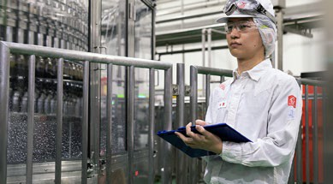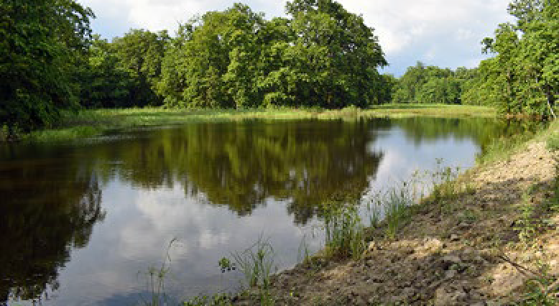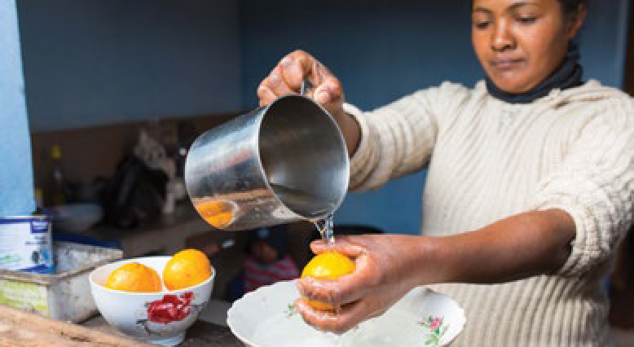

**Vision:** Our 2030 Water Security Strategy is focused on accelerating the actions needed

to increase water security where we operate, source ingredients and touch people’s lives. We

do that by contributing toward sustainable, clean water access that improves livelihoods and wellbeing while protecting against water-related disasters. We also work to preserve nature and biodiversity as well to promote advanced water management practices.

OUR OPERATIONS

**Our 2030 strategy is grounded in the fact that water is a shared resource. As such, our work is organized to address water security in:**

OUR WATERSHEDS

OUR COMMUNITIES

Over the last couple of years, we followed a process to segment and prioritize our operating facilities, commercial regions, sourcing regions for global priority ingredients, watersheds, and communities based on those with the highest water-related risks (read more on the following page). As a result of this work, we have set three key goals designed to achieve our vision:

**Open Call to Accelerate Action on Water**

The Coca-Cola Company and our bottling partners Coca-Cola FEMSA, Coca-Cola Europacific Partners and Arca Continental joined the “[Open Call to Accelerate Action](https://wateractionnow.org/) [on Water](https://wateractionnow.org/)”, an initiative of the UN Global Compact, the CEO Water Mandate, and others. This means we will partner to build water resilience across operations and supply chains, and we will work together to achieve collective positive water impact in at least 100 vulnerable water basins

by 2030.

|  |
| --- |
| GOAL 1 |
| Achieve 100% regenerative water use across **175 of our facilities** identified as facing high levels of water stress by 2030. |

|  |
| --- |
| GOAL 2 |
| Improve the health of  **60 watersheds** identified as most critical for our operations and agricultural supply chain by 2030. |

To achieve our goals, collective action is critical.

**We work collaboratively with partners across sectors to implement actions in our operations, watersheds (including agricultural ingredient sourcing regions) and communities:**

|  |
| --- |
| GOAL 3 |
| Return a total of **2 trillion liters** of water to nature and communities globally between 2021 and 2030. |

**Actions within Our Operations**

* + Use less water
  + Reuse and treat wastewater

**Actions in Our Watersheds & Our Communities**

* + Support nature-based solutions
  + Invest in landscape solutions (gray infrastructure)

**All three goals contribute to our commitment to maintain at least 100% global replenishment of the water used in our finished beverages.**

* + Help farmers use less water and implement sustainable agriculture practices
  + Help provide communities with access to safe water, sanitation and hygiene (WASH)
  + Advocate for good water governance and smart policies

CONTENTS

CEO MESSAGE EXECUTIVE SUMMARY

OUR COMPANY

WATER

PORTFOLIO

PACKAGING

CLIMATE

AGRICULTURE

PEOPLE

OPERATIONS

DATA APPENDIX

FRAMEWORKS



##### PRIORITIZING OPERATIONS, COMMUNITIES AND WATERSHEDS

In 2022, we completed our analysis of water- related risks in areas where we can make the greatest impact1. We prioritized our operating facilities, commercial regions,

sourcing regions for global priority ingredients, watersheds and communities.

**Watersheds**

Similarly, we undertook a comprehensive process to identify priority watersheds across our system.

These include our Leadership Locations and their water sources, where we source global priority ingredients, key growth markets and

**Making the Greatest Impact Where It Matters Most by Doing What Matters Most**

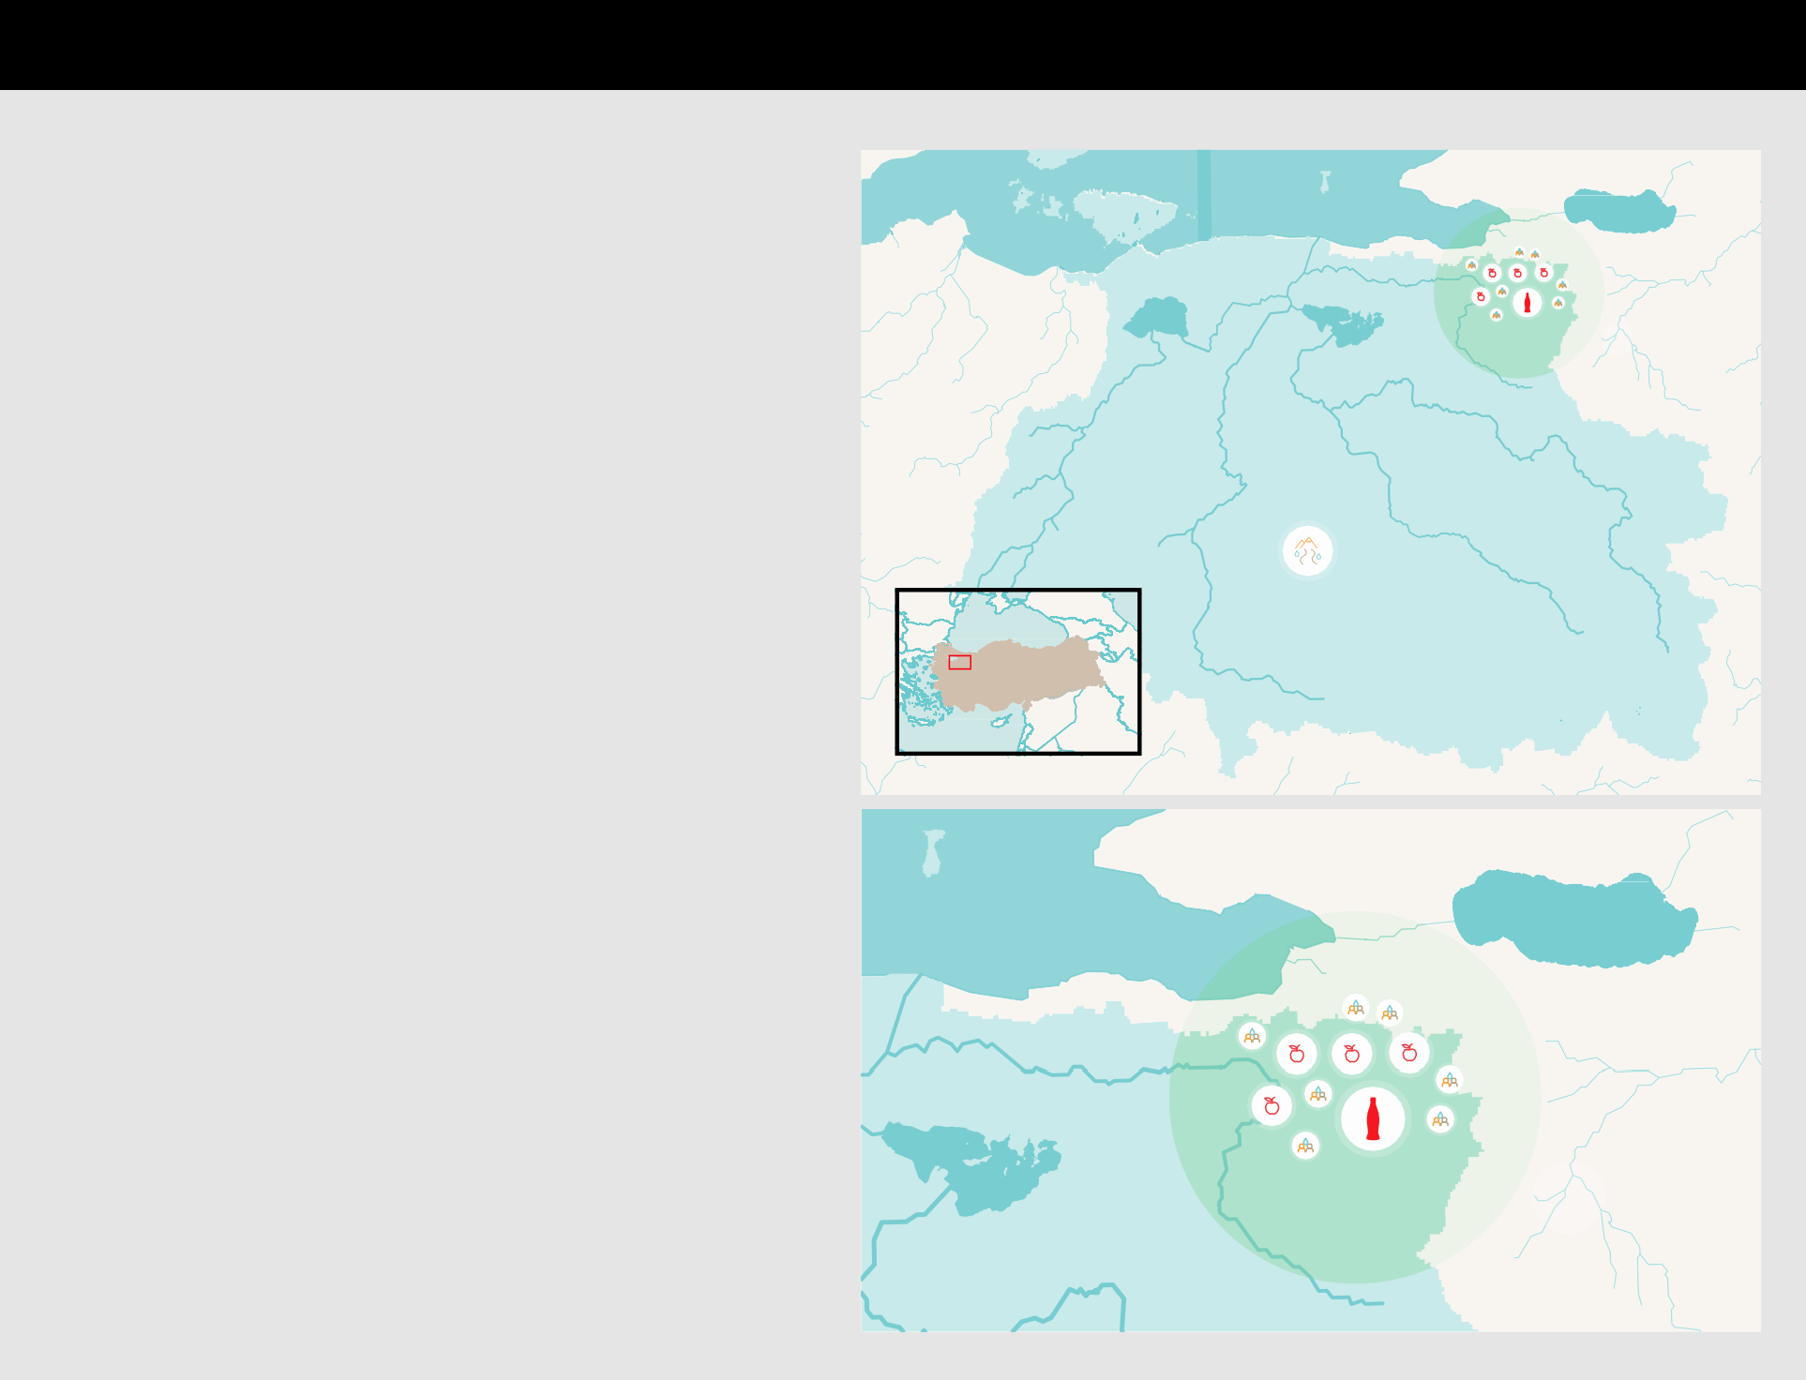Prioritizing operations, watersheds and

**Operations**

We analyzed water sourcing risks across approximately 700 operational locations (mainly concentrate plants and bottling facilities) and mapped the minor river basins and sourcing basins of these facilities. We catalogued these locations based on the detailed mapping

and results from an Enterprise Water Risk Assessment from the World Resources Institute’s Aqueduct 3.0 tool and from Facility Water Vulnerability Assessments—our site-level, internal proprietary tool.

priority communities.

**Communities**

We also began mapping priority communities, based on their lack of access to water, sanitation and hygiene (WASH) and resilience to water- related impacts of climate change (e.g., floods and droughts), with a focus on communities close to our facilities, and/or in urban growth centers where we sell our products, and/

or in rural farming communities where we source ingredients.

By mapping and overlaying our priority facilities,

communities in Türkiye

In Türkiye, we identified an operating facility located in a water- stressed area as a priority facility (Leadership Location) in the city of Bursa in the north-west of the country. The facility is owned and operated by our bottling partner Coca-Cola İçecek. Further, we identified the Bursa/Balikesir watershed as a priority because it not only serves as a water source for our facility but also because it supports the growing of apples, peaches and nectarines

that we source as ingredients in our products. In addition, we identified seven farming villages in the same province as priority communities, based on their location in ingredient sourcing and key market growth regions.

*Koca*

**SEA OF MARMARA**

*Lake Manyas*

*Simav*

*Nilüfer*

*Lake Ulubat*

*Emet*

Bursa

*Orhaneli*

*Lake Iznik*

As a result, each facility has been placed within one of three categories:

* **LEADERSHIP LOCATIONS:** Approximately 25% of our facilities face the highest level of water-related risks and are on a path to 100% regenerative water use by 2030.
* **ADVANCED EFFICIENCY LOCATIONS:** System

facility locations in a water-stressed context that will drive advanced water efficiency improvements in operations.

* **CONTRIBUTING LOCATIONS:** System facility locations in areas with low water-related risks. These will contribute to water security overall by implementing the Coca-Cola system's Water Resource Sustainability Standard, achieving industry benchmark water efficiency and 100% compliance with wastewater discharge standards.

watersheds and communities, we have developed a framework of prioritization and a deeper understanding of risks, which will help us

develop holistic, integrated and context-based approaches to help increase water security where it matters the most in our business, operations and supply chains.



**Defining Regenerative Water Use**

Regenerative water use means facilities must reduce, reuse, recycle and replenish the water used in operations in the local correlated watersheds for beneficial social, economic and/or environmental uses by other stakeholders and nature.

The watershed faces high levels of water scarcity and pollution of water sources from local industries, including textiles and agriculture (e.g., use of insecticides). Rural farming communities have relatively low levels of access to clean water.

The operating facility is driving water efficiency improvements by conducting a gap assessment against the Coca-Cola system’s Water Resource Sustainability Standard compliance process

and working with a third-party consultancy to screen options for improving water efficiency in our operations. We developed a watershed stewardship plan which includes supporting farmers to improve irrigation efficiency and reduce water contamination, reforestation efforts to help filter water pollution and regulate

precipitation and evaporation flows, and helping communities to install rainwater harvesting systems.

In this way we are working to help improve water security by focusing on actions we can take both within and outside our operations to help improve water efficiency and watershed health as well as support local communities and farmers through interventions that are relevant to the local context.

See the Sustainable Agriculture section for more details on how we are supporting farmers to improve water management in growing our ingredients in this region.

**TÜRKIYE**

*Nilüfer*

*Lake Ulubat*

BURSA/BALIKESIR WATERSHED

Bursa

*Lake Iznik*

1 Operating Facility

1. Orchards

7 Farming Villages

1. During the course of implementation of our 2030 Water Security Strategy we will review our prioritization periodically, as risks evolve and/or new data emerges. This may lead to changes in the prioritized facilities, watersheds and communities.

CONTENTS

CEO MESSAGE EXECUTIVE SUMMARY

OUR COMPANY

WATER

PORTFOLIO

PACKAGING

CLIMATE

AGRICULTURE

PEOPLE

OPERATIONS

DATA APPENDIX

FRAMEWORKS

##### REDUCING WATER CHALLENGES IN OUR OPERATIONS IMPROVING WATERSHED HEALTH

All our production operations will continue to implement the Coca-Cola system’s Water

Resource Sustainability Standard.

The purpose of this standard is to identify and reduce water quality- and quantity-related challenges for our operations.

To decrease water use in our operations, we use internal tools such as the Water Efficiency Catalogue, which assesses technical standards (e.g., on-line flow monitoring, water collection and reuse capabilities) and team culture (e.g.,

training and communication on the importance of water efficiency) regarding water efficiency in our production facilities and provides innovative best practices (e.g., water reuse for package rinsing and water-free lubrication of conveyor belts).

In the development of new plants, we leverage our Sustainability by Design Tool to ensure that water-efficient processes are implemented and that we achieve best-in-class water efficiency.

We have set an ambitious target to reduce our water use ratio by 20% by 2030 from a 2015 baseline for all operations across the system.

We are focused on water efficiency improvements in Leadership Locations and Advanced Efficiency Locations that operate in water-stressed contexts, which has resulted in a water use ratio of 1.79 liters of water used per liter of beverage in

2022. This is our highest achievement in water efficiency to date and significantly better than the industry average for carbonated soft drinks of

1.91 l/l of beverages.1

**Cost of Water**

We have partnered with denkstatt to develop a “Cost of Water” tool for our teams. This tool will help us get a better understanding of the

cost of water by evaluating the costs associated with potential water risks in addition to the

operational costs associated with water use. Better understanding of these costs will help strengthen decision making and the business case for investment in initiatives that respond to local challenges.

In 2022, we also worked with Bluerisk and Valuing Impact and a number of peer companies to better understand how projects returning water to communities and nature help create societal value. Across the 22 projects analyzed,

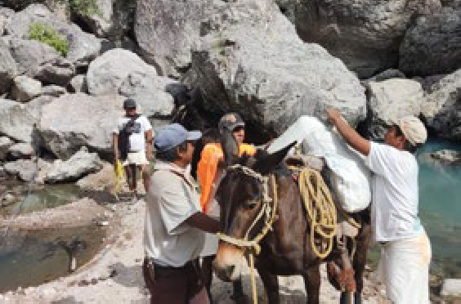

READ MORE ABOUT OUR WORK TO IMPROVE WATERSHED HEALTH IN PAKISTAN

Community members transport materials for

the construction of water storage tanks

Developing watershed stewardship plans at the catchment-scale is critical to helping

water users in a particular region identify and address the drivers of water risk. Working with partners to implement solutions, stakeholders can take an effective science- based approach to improve water resilience for both people and nature.”

**ALEJANDRA LÓPEZ RODRÍGUEZ**

Director, The Nature Conservancy Mexico Water Program

MEXICO

In Chihuahua, Mexico, we partnered with The Nature Conservancy, a global environmental nonprofit organization, to develop a watershed stewardship plan for the Lago Bustillo y de los Mexicanos watershed. It was identified as a priority watershed because it supplies water to

a manufacturing facility owned by our bottling partner Corporación del Fuerte, which is

a Leadership Location. In addition, the watershed includes orchards from which the system sources apples. The agricultural sector and the city of Cuauhtémoc are major water users.

The watershed is forecasted to face increasing water quality and quantity challenges in the coming years due to population growth and rising temperatures. With funding from Fundación Coca-Cola Mexico, our projects in this watershed have helped to improve rural communities’ access to water, mainly through rainwater harvesting systems and check dams. The watershed stewardship plan completed in 2022 helped identify key context-specific interventions to consider for future projects including, reforestation, rainwater harvesting, dams, plant nurseries, conservation of springs and community access to WASH, as well as the need to strengthen local partnerships. These plans will also help us to track improvements in watershed health and co- benefits of projects (e.g., enhanced biodiversity and carbon sequestration). One project currently in the pipeline is working with an agri-tech partner, Kilimo, to help local farmers save water by

adopting technology-enabled irrigation management tools.

**Watershed Stewardship Plans**

**Water Stewardship in Concentrate Plants**

Within our 18 concentrate production plants, which produce the concentrates used to make many of our sparkling beverages, the company has committed to driving water efficiency improvements. In 2022, we achieved a 7% average water efficiency improvement across all our concentrate plants compared to a 2015 baseline. These facilities have worked

as a network to review and assess the implementation of best practices and governance of water use, known as “Water Efficiency Maturity Assessments.”

As an example, in 2022, one of our concentrate plants in Ireland reduced its water consumption by more than 13,000 cubic meters compared to the previous year by implementing circular washing in its clean-in-place process. A monitor-to- improve mindset in our local team

is also key to achieving and sustaining this level of performance.

As a member of the Alliance for Water Stewardship (AWS), we are proud to be a part of a global movement to advance good water stewardship practices. The AWS certification confirms that the highest global standard for responsible water stewardship has been met in support of social, cultural, environmental and economic benefits at both the site and catchment level. We plan to certify all our 18 concentrate production sites

against the latest AWS Standard by 2025.

we learned that these projects not only generated 210 million cubic meters of volumetric water benefits, but also delivered $39 million in

societal value, with an average societal return on investment (SROI) of 3.9.

We have a goal to achieve 100% regenerative water use in all our 175 Leadership Locations globally by 2030. In 2022, we included progress against water replenishment in Leadership Locations as a metric for the Long-Term Incentive (LTI) plan for our executive leadership team. Over the past year, our Talent and Compensation Committee approved the inclusion of a metric related to water replenishment in Leadership Locations in line with the goals of our 2030 Water Security Strategy.

**We have continued to improve the efficiency of our water use.**

10% IMPROVEMENT in water efficiency across all system operations compared

to 2015.

1 [2021 BIER (Beverage Industry Environmental Roundtable)](https://www.bieroundtable.com/work/benchmarking/) [Benchmarking report](https://www.bieroundtable.com/work/benchmarking/)

In 2022, The Coca-Cola Foundation provided support to Ceres for the Valuing Water Finance Initiative to drive investor leadership on valuing water and to broaden investors’ perspective on the role that water plays in many industries’ value chains.

CONTENTS

CEO MESSAGE EXECUTIVE SUMMARY

OUR COMPANY

WATER

PORTFOLIO

PACKAGING

CLIMATE

AGRICULTURE

PEOPLE

OPERATIONS

DATA APPENDIX

FRAMEWORKS

IMPROVING WATERSHED HEALTH (continued)

Protecting watersheds and recognizing the unique challenges and characteristics of water sources around the world has long been

a focus of our work.

Watersheds supply water for drinking, agriculture and manufacturing; provide habitat for plants and animals; and offer opportunities for recreation.

Based on our 2030 Water Security Strategy, we are placing even greater emphasis on the holistic improvement of watershed health. We set a goal to improve watershed health in 60 watersheds identified as most critical for our operations and agricultural supply chain by 2030.

OUR AGRICULTURAL WATER FOOTPRINT

**Examples of Watershed Projects in Priority Watersheds**

The Coca-Cola Foundation and the Coca-Cola system have a long history of watershed projects. A selection of these projects is shown below.

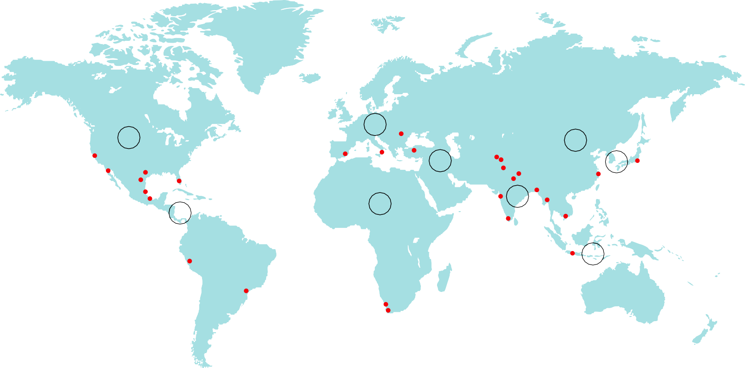

These projects include support for nature-based solutions such as reforestation, wetland and meadow restoration, as well as irrigation system improvements, invasive species removal and check dam construction. Many of the projects work in agricultural contexts to improve availability of water for irrigation and more efficiently use water in agriculture.

Many projects have multiple locations.

1. NORTH AMERICA

**USA:**

* Riparian habitat restoration
* Invasive species removal
* Wet meadow restoration
* Reforestation
* Floodplain reconnection
* Beaver dam analogs
* Community rain barrel distribution
* Native prairie protection
* Tallgrass prairie restoration
* Stream channel restoration

1. LATIN AMERICA

**Brazil:** Ecological restoration

**Mexico:**

* Reforestation
* Inﬁltration trenches for groundwater replenishment

**Peru:** Forest protection

1. EUROPE
2. EURASIA & MIDDLE EAST

**Türkiye:** Sustainable agricultural practices

**Pakistan:** Community water treatment

1. INDIA & SOUTHWEST ASIA

**India:** Check dams for groundwater recharge

Producing the ingredients used in our beverages accounts for an estimated 92% of our total blue water1 footprint, which is the volume of surface water and groundwater consumed in producing our finished products (evaporated or embedded in the product). That’s why, in 2022, we expanded our analysis and prioritization to include watersheds that support our priority ingredient sourcing, in addition to our operating facilities and those necessary for key market growth.

**Austria:** Soda lake protection

**Bulgaria:** Wetland restoration and protection

**Croatia/Serbia:**

* Oxbow restoration
* Wetland restoration and ﬂoodplain reconnection

**Hungary:**

* Oxbow restoration
* Floodplain restoration

**Italy:** Irrigation efficiency improvement

**Romania:** Floodplain wetland

**3** restoration

**1 7 Spain:**

– Wetland restoration

1. **8** – Irrigation system improvements

**Water Quality**

We’re working with several partners, including the World Resources Institute (WRI) and The Nature Conservancy, to develop a Water Quality Benefit Accounting (WQBA) methodology that seeks to provide guidance on identifying shared water quality challenges, activity selection, and recommended water quality indicators and benefit calculation methods.

**India/Nepal:** Rainwater harvesting and aquifer recharge

1. GREATER CHINA & MONGOLIA

**China:** Wetland water level management

1. JAPAN & SOUTH KOREA

**Japan:** Forest protection

1. ASEAN & SOUTH PACIFIC

**4 6 4**

**2**

AFRICA

**Indonesia:** Inﬁltration wells for aquifer recharge

**Egypt:** Soil improvement to reduce irrigation demand

**9 South Africa:** Invasive species

removal

**Thailand:** Check dams and water supply for agriculture

**Vietnam:** Floodwater retention

1 Source: Water Footprint Network.

CONTENTS

CEO MESSAGE EXECUTIVE SUMMARY

OUR COMPANY

WATER

PORTFOLIO

PACKAGING

CLIMATE

AGRICULTURE

PEOPLE

OPERATIONS

DATA APPENDIX

FRAMEWORKS

##### BUILDING COMMUNITIES’ WATER RESILIENCE

We adopt a human-rights based approach to water and communities.

We recognize the connection between our social license to operate and functional, resilient water infrastructure. Insufficient access to water, sanitation and hygiene (WASH) infrastructure and poor water quality are key challenges

faced by communities around the world. These challenges are being exacerbated by population growth, climate change, political conflict

and forced migration.

For more than a decade, The Coca-Cola Company has established strong leadership in community water programs with the support of The Coca-Cola Foundation and many nonprofits, governments, customers and other partners.

We are updating our reporting methodology for our community water programming data to

align with our 2030 Water Security Strategy and upcoming external frameworks, and we will apply it to future data reporting when ready.

In 2022, our operating units began the identification of priority communities based on communities’ access to WASH and/or their

resilience to the impacts of climate change (e.g., floods and droughts). We aim to support our priority communities in addressing shared water challenges by identifying and implementing interventions focused on:

1. Improving access to safe drinking water, sanitation and hygiene.
2. Enabling adaptation to water-related climate change impacts.
3. Ensuring rapid recovery from crises.

INTEGRATING GENDER INTO WASH PROGRAMS

Gender has always been a core focus for our WASH programs because we know that women and girls suffer disproportionately from poor access to clean water, sanitation and hygiene.

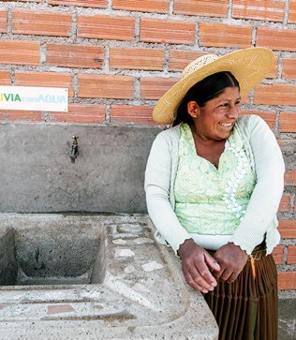

**Aliados por el Agua (Allies for Water)**

In Latin America and the Caribbean, 25% of the population lack access to safely managed drinking water services.1 Climate change, urbanization, accelerated water usage, and inadequate infrastructure are among the leading causes. In response to this, Coca-Cola Latin America, in alliance with the Global Environment Technology Foundation (GETF) and local civil society organizations, designed and launched a platform called Aliados por el Agua (Aliados) to help improve access to water, sanitation and hygiene (WASH) for 2 million people across 18 countries by 2030.

In 2022, Aliados implemented more than 30 projects across 12 countries, in partnership with

26 civil society organizations, as well as local municipalities, utility providers and communities, and funding from The Coca-Cola Foundation.

In addition, Coca-Cola Latin America partnered with Global Water Challenge and its women for water platform to develop the **Women for Water Framework for Action**—which is based on the [Ripple Effect Study](https://www.ipsos.com/sites/default/files/ct/publication/documents/2018-08/women_and_water-factsheet_0.pdf)—and helps to integrate gender and women’s empowerment into the Aliados por el Agua platform by focusing projects on three key areas: income generation, health and wellbeing, and resilience.

With our partners and support from The Coca-Cola Foundation, we are piloting the framework across four projects in Mexico, Bolivia and Brazil to empower women through water-related programming.

In 2018, The Coca-Cola Foundation partnered with Global Water Challenge (GWC), USAID and Ipsos through the Water and Development

Alliance (WADA) on a study across three countries in Africa—Nigeria, Rwanda, and Eswatini—of

the impact of improved WASH on women’s empowerment. This “Ripple Effect” study found that improved WASH had positive impacts on

a number of important facets of women’s lives including time savings. The research established that of women who utilized time savings for economic activities, 91% saw an increase in income. Providing women with greater economic opportunity helps build resilience in their families and communities.

In 2022, we were pleased to build on this work and help develop, along with WaterAid and Diageo, [practical guidance](https://washmatters.wateraid.org/publications/integrating-gender-equality-into-community-water-sanitation-and-hygiene-projects) to help companies and their implementing partners turn strategic commitments on community WASH and gender equality into integrated projects that result in better, more sustainable outcomes which are critical parts of the pathway to gender equality and women’s empowerment.



**Recognition**

In 2022 the Company scored an “A–” on Water, which indicates a strong

water security strategy and best-in-class governance, including tying executive compensation to our water replenish targets. For details, read our [2022 CDP](https://www.coca-colacompany.com/content/dam/journey/us/en/policies/pdf/sustainability/2022-cdp-water-response.pdf) [Water Response](https://www.coca-colacompany.com/content/dam/journey/us/en/policies/pdf/sustainability/2022-cdp-water-response.pdf). Our bottling partner Coca-Cola Europacific Partners (CCEP) was recognized with the highest score of A, while Swire Coca-Cola Limited, Coca-Cola HBC and Coca-Cola Bottlers Japan Inc. (CCBJI) received a score of A–.

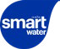

Our smartwater brand, in partnership with Global Water Challenge and

its women for water platform, launched **smart solutions: global water challenge**, a grant program in 2022 to support non-profits to improve communities’ access to WASH, improve watershed health and empower women through water-based activities. [Read more](https://www.coca-colacompany.com/news/zendaya-keeps-it-smart-smartwater).

**Collective Action**

The shared nature of water resources requires collective action to help solve water challenges. Some of our key partnerships are with:

* 2030 Water Resources Group, hosted by the World Bank
* Alliance for Water Stewardship (AWS)
* CEO Water Mandate, a partnership between the UN Global Compact and the Pacific Institute
* denkstatt
* Global Water Challenge
* Science Based Targets Network (SBTN)
* The Nature Conservancy
* The Water Resilience Coalition, an initiative of the CEO Water Mandate
* WASH4Work, an initiative hosted by the CEO Water Mandate
* WaterAid
* World Wildlife Fund (WWF)

**The Co-Benefits of WASH Access**

We’re working with WASH4Work, an initiative hosted by the CEO Water Mandate, to develop a standardized methodology of accounting for the co-benefits of WASH projects (e.g., health, income, nutrition, safety and security, and

education) and strengthen the business case for investments in WASH programs.

1 Source: [https://www.unwater.org/sites/default/files/app/](https://www.unwater.org/sites/default/files/app/uploads/2021/07/jmp-2021-wash-households-LAUNCH-VERSION.pdf) [uploads/2021/07/jmp-2021-wash-households-LAUNCH-](https://www.unwater.org/sites/default/files/app/uploads/2021/07/jmp-2021-wash-households-LAUNCH-VERSION.pdf) [VERSION.pdf](https://www.unwater.org/sites/default/files/app/uploads/2021/07/jmp-2021-wash-households-LAUNCH-VERSION.pdf)

READ MORE ABOUT OUR APPROACH TO STAKEHOLDER ENGAGEMENT AND PARTNERSHIPS 

CONTENTS

CEO MESSAGE EXECUTIVE SUMMARY

OUR COMPANY

WATER

PORTFOLIO

PACKAGING

CLIMATE

AGRICULTURE

PEOPLE

OPERATIONS

DATA APPENDIX

FRAMEWORKS

##### SPOTLIGHT: INVESTING IN NATURE-BASED SOLUTIONS

Recognizing that nature itself often offers the best mechanisms for restoring

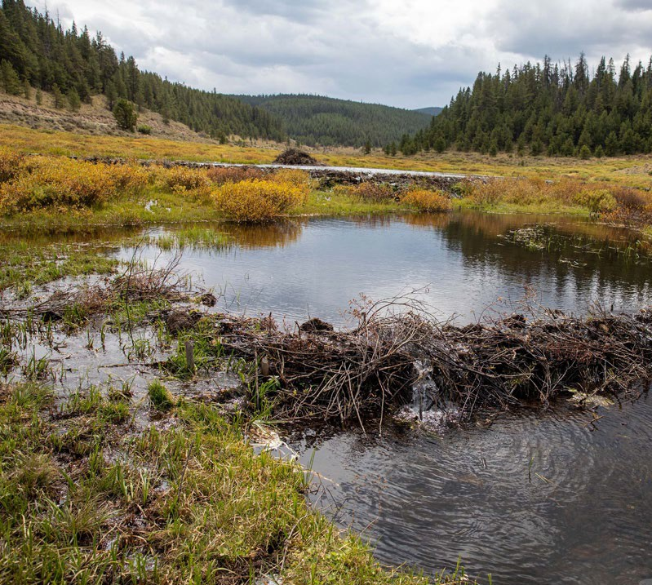

In order to achieve large-scale impact globally, we partner with governments, NGOs, communities and other companies. We share resources to increase all our efforts and to generate a bigger impact. We encourage others to join us.”

**MADHU RAJESH**

Senior Director–Water & Agriculture, The Coca-Cola Company

**Reforestation Helps Restore Watershed Health in the Philippines**

The Ipo Watershed in Bulacan in the Philippines supplies water to Metro Manila, the second most populous region of the country. Forest cover within the watershed has dramatically dropped from 85% to just 40% in recent years1 due to illegal logging and unsustainable forest practices, which has resulted in a reduction in the natural water storage capacity of the basin. Malnutrition is also a pervasive challenge in local communities. Since 2016, The Coca-Cola Foundation and Coca-Cola Foundation Philippines have worked in partnership with WWF-Philippines to protect rainforests of the area, replant trees and provide livelihood opportunities. The project has reforested 165 hectares of degraded land in the watershed and supported local communities to start household gardens to grow food.

In 2022 the project was assessed using the NBS valuation methodology. Overall, the project provided a very positive return on social investment and its specific co-benefits included:

* **WATER QUANTITY:** The replenishment of approximately 400 million liters of water per year due to decreased runoff and improved water access for local communities.
* **CARBON SEQUESTRATION:** Approximately 2,500 metric tons of CO2e per year from reforestation.
* **FOOD SUPPLY:** Household gardens helped to tackle food insecurity and some of the trees planted have edible fruits (e.g., rambutan, coffee).

watershed health, the company, The Coca-Cola Foundation and our bottling partners invest in nature-based solutions (NBS), such as forest protection and floodplain management, which build on natural processes to manage water systems.

Through our work, we have learned that NBS projects often have multiple co-benefits, such as better water quality, carbon sequestration, increased climate resilience, and enhanced richness and variety of life of natural

habitats (biodiversity).

We worked with [denkstatt](https://denkstatt.eu/success-stories/) to develop a methodology to help us quantify and test the co- benefits of NBS projects. In 2022, we partnered with the CEO Water Mandate, denkstatt and others to help build the business case for NBS by developing a standardized methodology to measure benefit accrual and a means to value social return on investment. The methodology has been tested across several of our water replenishment projects in key geographies.

This valuation methodology supports the broader [Benefit Accounting of Nature-Based Solutions for](https://ceowatermandate.org/nbs/) [Watersheds project](https://ceowatermandate.org/nbs/), including [The NBS Benefits](https://nbsbenefitsexplorer.net/) [Explorer tool](https://nbsbenefitsexplorer.net/), led by the Pacific Institute and

CEO Water Mandate, in partnership with The Nature Conservancy and LimnoTech. Our aim is to support public, private and non-profit sectors in developing effective policies and programs

to incentivize greater implementation of and investment in NBS because water is at the nexus of many goals, including protecting habitats, increasing biodiversity, sequestering carbon and promoting community resilience in the face of changing weather patterns.

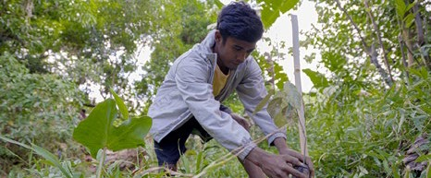

1 Source: [WWF-Philippines | Ipo Watershed](https://wwf.org.ph/what-we-do/water/ipo-watershed/)

CONTENTS

CEO MESSAGE EXECUTIVE SUMMARY

OUR COMPANY

WATER

PORTFOLIO

PACKAGING

CLIMATE

AGRICULTURE

PEOPLE

OPERATIONS

DATA APPENDIX

FRAMEWORKS

**Portfolio:** Beverages for All

We currently offer ~200 master brands worldwide in five beverage categories:

As a total beverage company, we are committed to offering people more of the drink choices they want across a range of categories and in a variety of packages. Ever-evolving consumer tastes and preferences help steer our business strategy and shape the lineup of beverages we bring to market.

We take a disciplined approach to product innovation and portfolio management, ensuring we develop and deliver preferred, great-tasting beverages for all occasions and lifestyles. This includes offering drinks with reduced added sugar and more brands with nutrition and wellness benefits; providing small package options

**Major Milestone for fairlife**

In 2022, fairlife became our first-ever

$1 billion dairy brand. Over the last decade, fairlife—now available in the United States and Canada—has focused on innovation and providing consumers with high-quality nutrition through a growing portfolio of value-added dairy products, including ultra-filtered, lactose- free milks; protein shakes; and sports recovery drinks. This builds on beverages available in other markets in the juice, value-added dairy and plant-based beverages category, such as AdeS, Chi, Santa Clara, Toni and Nutriboost.

and clear nutrition information on packaging and in our communications; and marketing our drinks responsibly.

**SECTION SCOPE:** In this section our Portfolio work refers to actions by the company as well as our owned and independent bottling partners and our independent suppliers and partners.

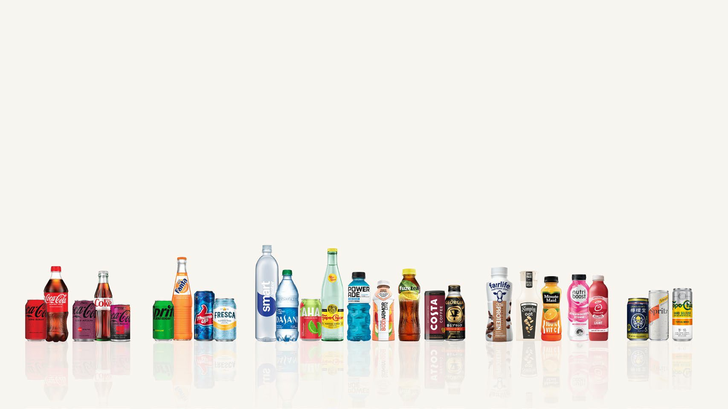

TRADEMARK COCA-COLA SPARKLING FLAVORS WATER, SPORTS, COFFEE AND TEA JUICE, VALUE-ADDED DAIRY AND PLANT-BASED BEVERAGES EMERGING

**THE COCA-COLA COMPANY** 2022 BUSINESS & SUSTAINABILITY REPORT 31

CONTENTS

CEO MESSAGE EXECUTIVE SUMMARY

OUR COMPANY

WATER

PORTFOLIO

PACKAGING

CLIMATE

AGRICULTURE

PEOPLE

OPERATIONS

DATA APPENDIX

FRAMEWORKS

##### LESS SUGAR, MORE CHOICES

We support the recommendations of leading health authorities that individuals should consume less than 10% of their total calories from added sugar. That’s why, from 2017–2022, we removed more than 900,000 tons of added sugar from our global portfolio through more than 1,000 beverage reformulations.

EUROPE

By 2025, we aim for 50% of the drinks we sell in Europe to be low- and no-calorie drinks (we’re

currently at 45%) in support of the EU Commission’s Farm-to-Fork strategy to accelerate the transition to sustainable food systems.

We support more than 50 calorie and sugar reduction pledges globally, in collaboration with industry peers. In 2022, we joined an updated industry-wide pledge in Australia to reduce the sugar content in our portfolio by 25% by 2025.

In Kazakhstan, we are among nine members of the national beverage association to sign an

industry pledge to reduce average added sugar in our drinks by 10% by the end of 2026. And we support guidelines released by the Health Ministry of Türkiye and Federation of Food and Drink Industry Associations of Türkiye to reduce

sugar in nonalcoholic beverages and certain food categories by 10% by 2025.

In Europe, we are leading the soft drinks industry in voluntarily committing to sugar reduction.

Together with peers through the industry association UNESDA Soft Drinks Europe, we have [reduced average added sugars in soft drinks by](http://www.unesda.eu/sugar-and-calorie-reduction) [28.6%](http://www.unesda.eu/sugar-and-calorie-reduction) across the European Union and United Kingdom since 2000. In June 2021, as part of

the [EU Code of Conduct for Responsible Food](https://www.europarl.europa.eu/doceo/document/E-9-2021-004615_EN.html) [Business and Marketing Practices](https://www.europarl.europa.eu/doceo/document/E-9-2021-004615_EN.html), we joined a UNESDA Soft Drinks Europe pledge to reduce the sugar in our drinks by an additional 10% by 2025, which will represent a 33% average sugar reduction when completed by 2025 compared to 2000. The European soft drinks sector is the only

UNITED STATES

We’re offering more low- and no- calorie options in more places. For example, 99.7% of U.S. outlets carry our low- and zero-sugar SKUs—and, on average, 24 zero-sugar sparkling soft drink SKUs are found per store.1

sector to have made an additional sugar reduction commitment under the EU Code of Conduct.

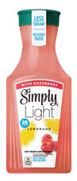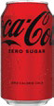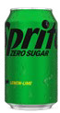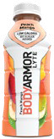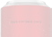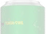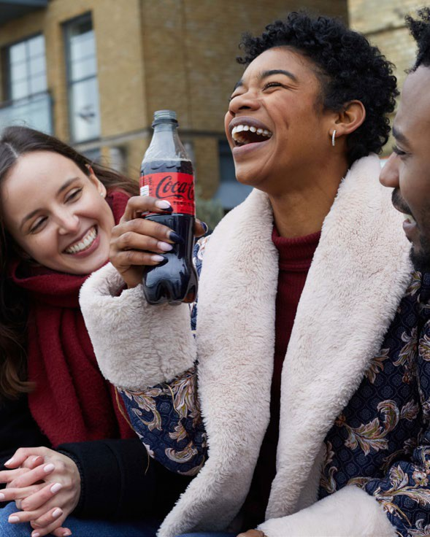

900,000+

tons of added sugar removed from our global portfolio cumulatively through efforts to reformulate more than 1,000 beverages from

2017–2022

19 OF TOP 20

brands are reduced-sugar or zero-sugar, or have a reduced-sugar or zero-sugar option

~1,400 ~68%

tons of added sugar of the products in our removed on an annualized beverage portfolio have basis through recipe less than 100 calories per changes in 2022 12-ounce serving

12

recipe changes to reduce added sugar in 2022

29%

of our volume sold in 2022 was low- or no-calorie

246

low- or no-sugar products launched in 2022

1 Source: Nielsen IQ, U.S. All Measured Channels, 2022 full year

**THE COCA-COLA COMPANY** 2022 BUSINESS & SUSTAINABILITY REPORT 32

CONTENTS

CEO MESSAGE EXECUTIVE SUMMARY

OUR COMPANY

WATER

PORTFOLIO

PACKAGING

CLIMATE

AGRICULTURE

PEOPLE

OPERATIONS

DATA APPENDIX

FRAMEWORKS

We continue to use our marketing to drive growth of our low- and no-calorie portfolio. Coca-Cola Zero Sugar has delivered double- digit volume growth in five of the last six years.

In 2022, several leading low- and no-calorie brands in North America launched consumer campaigns with celebrity partners and sponsorship assets:

**Sprite Zero Sugar** teamed up with *Marvel Studios’ Black Panther: Wakanda Forever* for the “Infinite Potential. Zero Limits” campaign. [Read more](https://www.coca-colacompany.com/news/sprite-zero-sugar-encourages-young-creators).

**Coca-Cola Zero Sugar** took center court during the 2022 Men’s and Women’s NCAA College Basketball Final Four tournaments in the United States with March Madness-themed “Best Coke Ever?” ads showcasing the brand’s reformulated taste. [Read more](https://www.coca-colacompany.com/news/ncaa-debate-the-goatness-campaign).

**smartwater** and global ambassador Zendaya, an acclaimed actor and performer, celebrated those who define “smart” on their own terms. Together, smartwater and Zendaya

are also helping address the water crisis in communities across the world by partnering with the Global Water Challenge’s women for water platform, which focuses on mobilizing clean water access for every woman and her community. [Read more](https://www.coca-colacompany.com/news/zendaya-keeps-it-smart-smartwater).

**vitaminwater** tapped global superstar Lil Nas X for the “Nourish Every You”

campaign encouraging self-expression and self-care. [Read more](https://www.coca-colacompany.com/news/lil-nas-x-and-vitaminwater-team-up).

**Simply** and actor/comedian Eugene Cordero invited consumers to “Say Yes to Simple” in a new campaign showcasing the brand’s fast- growing lineup of juices, ades, plant-based milk alternatives, smoothies and more. [Read more](https://www.coca-colacompany.com/news/Say-Yes-to-Simple-Simply-Brand-Refresh).

**Gold Peak** ready-to-drink tea collaborated with Grammy- and Oscar-winning artist Questlove on the “Tea is for Trying” campaign. [Read more](https://www.coca-colacompany.com/news/gold-peak-and-questlove-tea-is-for-trying).

SWEETENER INNOVATION

One of the ways we achieve great taste without sugar is by using low- and no-calorie sweeteners. We only use sugar alternatives that have been thoroughly tested through scientific studies and confirmed as safe by globally recognized food safety authorities, including the U.S. Food and Drug Administration (FDA), the European Food Safety Authority (EFSA) and Food Standards Australia and New Zealand (FSANZ). When used as part of a healthy diet and lifestyle, we believe the science shows that sugar alternatives can help meet public health recommendations to reduce added sugar. Additionally, food additives such as non-sugar sweeteners help make food systems more sustainable by both reducing sugar and lowering our carbon emissions.

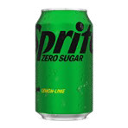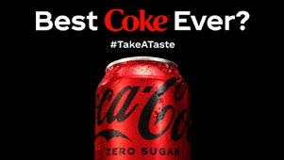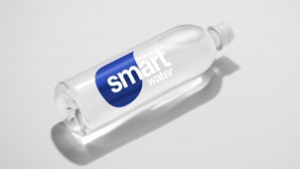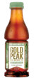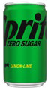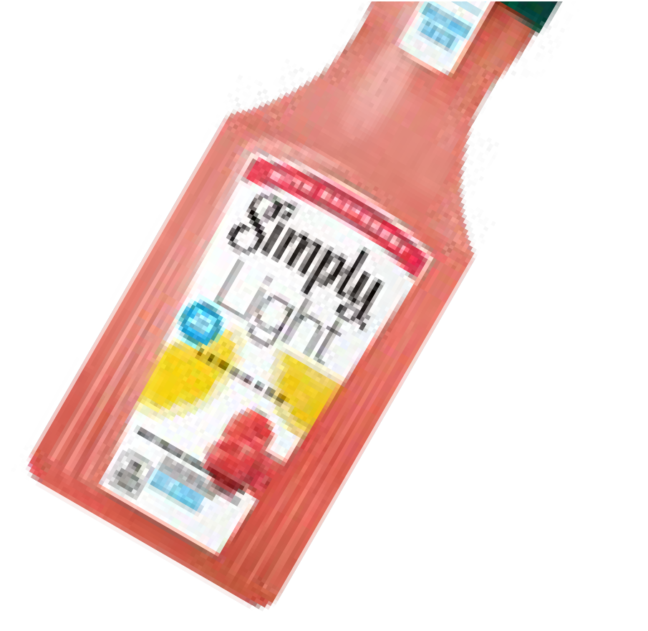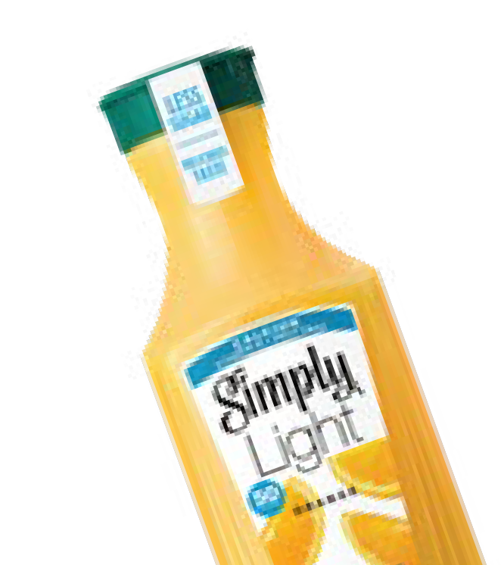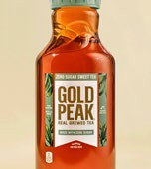

**Portfolio Marketing**

Our recent efforts have focused on collaborating with an ecosystem of suppliers and research organizations to develop, continuously improve and commercially scale stevia and other naturally derived sugar alternatives. A global list of more than 70 published journal articles dating back to 2008, reflecting research we have directly funded or authored, can be found on our [website](https://www.coca-colacompany.com/policies-and-practices/transparency.html).

FLAVOR BREAKTHROUGHS

Several of our core brands took creative approaches to promoting zero-calorie choices to younger consumers in 2022 through flavor innovations, packaging designs and digital experiences. The global Coca-Cola Creations platform introduced a series of limited-edition offerings inspired by consumer passion points of music, gaming and sports—starting with the outer space-inspired Coca-Cola Starlight, which offered fans a taste of outer space. In the United States, a limited-edition lineup of mysteriously flavored Fanta beverages was anchored by

a zero-sugar option.

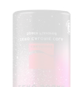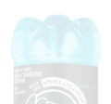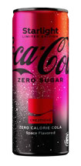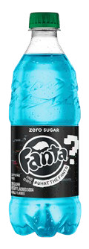

Since 2008, we have invested

more than $100 million in sweetener innovation and sugar reduction research.

**THE COCA-COLA COMPANY** 2022 BUSINESS & SUSTAINABILITY REPORT 33

CONTENTS

CEO MESSAGE EXECUTIVE SUMMARY

OUR COMPANY

WATER

PORTFOLIO

PACKAGING

CLIMATE

AGRICULTURE

PEOPLE

OPERATIONS

DATA APPENDIX

FRAMEWORKS

##### NUTRITION AND WELLNESS BENEFITS

We’re bringing teas, juices, waters, and dairy and plant-based

beverages to more people in more places. Some of these beverages are enhanced by fortifying them with vitamins and minerals.

**Cappy Immunity Support** is a wellness beverage in Europe powered by fruit multi-blends (orange, carrot and peach mix) along with vitamins

C and B12, and zinc.

**Minute Maid sparkling juice** gives consumers in China a zero-sugar option made with real fruit juice and refreshing bubbles, along with B3 vitamins and zinc to supplement nutritional needs.

**Fuze Tea** launched in Pakistan in two flavors— lemon and peach. The innovative brand is a fusion of reinvigorating tea extract from 100% sustainably sourced tea leaves and fruit flavors.

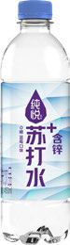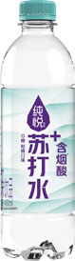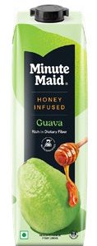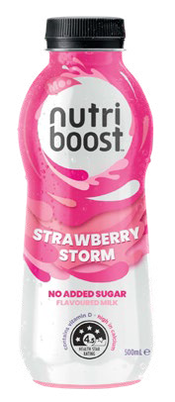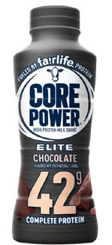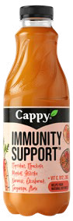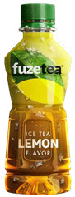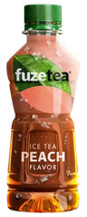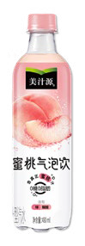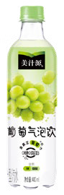

**Minute Maid Honey Infused** ready-to-drink fruit drinks in India contain added dietary fiber to support healthy digestion. The new preservative-free line is available in three delicious flavors: apple, mixed fruit and guava.

**Chun Yue** launched as first-ever functional soda

water in China, with added vitamins and minerals.

Two zero-sugar, zero- calorie options offer a slightly sweet, fruity taste. They are also fortified with niacin or zinc.

**Nutriboost** flavored milks have calcium, vitamin

D and no added sugar.

**fairlife Core Power Elite** contains 42g of high- quality protein to help build muscle and replenish, repair and rebuild. It is available in North America in three flavors: chocolate, strawberry and vanilla.

CONTENTS

CEO MESSAGE EXECUTIVE SUMMARY

OUR COMPANY

WATER

PORTFOLIO

PACKAGING

CLIMATE

AGRICULTURE

PEOPLE

OPERATIONS

DATA APPENDIX

FRAMEWORKS

**Responsible Growth Into Alcohol**

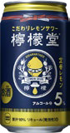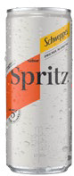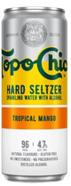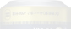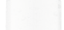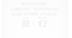

SMALLER PACKAGING

People can enjoy our drinks in sizes that help control portions and added sugar intake. These include 7.5-oz. mini cans and 8-oz. glass bottles in many markets. We continue to expand availability of these packages and introduce newer offerings, including 150-ml mini cans and 250-ml slim cans, so people can enjoy the same great tastes in sizes that are right for them.

In 2022, we kicked off a pilot of a Coca-Cola Freestyle compact fountain dispenser at on-the- go and at-work locations in France, Belgium, Great Britain and the Netherlands. In addition to giving consumers an expanded array of personalized,

on-demand beverage choices—including low- and no-calorie options—the innovation helps reduce our carbon and packaging footprints.

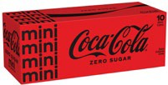

Today, about **44%** of our sparkling soft drink brands come in packages of 8.5 ounces or less.

In North America, 10-pack mini cans grew **39%** in 2022.

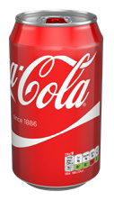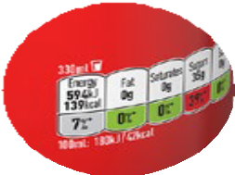

MORE INFORMATION FOR MORE INFORMED DECISIONS

We are committed to providing transparent nutrition information about all of our products, in line with local regulations, so consumers can make informed decisions. We were the first

beverage company to place calorie information on the front of nearly all our packaging worldwide.

Today, we provide nutrition information on product labels, with the exception of certain returnable bottles, fountain beverages

and waters (unsweetened, unflavored). For these beverage and packaging types, we offer nutrition information through websites and consumer hotlines.

RESPONSIBLE MARKETING

We respect the role of parents and caregivers as the primary decision-makers for what their children drink, and we do not market any of our

products directly to children under 13, regardless of nutritional profile. Effective January 1, 2022, we raised the age threshold from under 12 to under 13 and reduced the audience threshold from

35% to 30%. This means we will not place our marketing or advertising in any media, platform or event where more than 30% of the audience is under 13. Our policy goes beyond media and includes packaging, in-store and point of sale. Our approach is consistent with the International Chamber of Commerce Marketing & Advertising Code and its Framework for Responsible Food and Beverage Marketing Communication.

We hold everyone involved in our marketing and communications accountable to our [Global Responsible Marketing Policy](https://www.coca-colacompany.com/policies-and-practices/responsible-marketing-policy), from

employees and bottling partners to agency and media partners. We are a founding member of the International Food & Beverage Alliance (IFBA), a group of leading companies that self-regulate globally on responsible marketing to children.

Additionally, we collaborate with industry peers at regional and local levels to scale collective action in responsible marketing pledge programs.

Our commitment to offering more consumer choice includes our expansion into the fast- growing alcohol ready-to-drink (ARTD) market. In 2022, we launched Jack Daniel’s &

Coca-Cola in Mexico, with more markets to follow in 2023 through our relationship with Brown-Forman. Jack Daniel’s & Coca-Cola joins our growing portfolio of ARTD offerings including Lemon-Dou, Topo Chico Hard Seltzer and Schweppes Pre-Mixed Cocktails. In the United States, we authorize third parties to produce and sell Topo Chico Hard Seltzer, Simply Spiked Lemonade and Fresca Mixed.

We take the new responsibilities that come with our entry in this space very seriously. Recognizing the risks associated with alcohol consumption, we created guardrails outlined in our [Global Policy on Alcohol Responsibility](https://www.coca-colacompany.com/policies-and-practices/responsible-alcohol-marketing-policy#%3A~%3Atext%3DAlcohol%20consumption%20is%20not%20permitted%2Cproducts%20or%20at%20company%20events)) to ensure we grow our alcohol brands in a responsible and sustainable way. The policy articulates our commitment to:

1. Ensure the responsible marketing of our alcohol brands;
2. Support local responsible consumption partnerships and communications programs to help reduce the harmful use of alcohol;
3. Provide tools and information to enable people to make informed choices; and
4. Enable our employees and partners to be ambassadors for responsible consumption.

Our responsible alcohol marketing policy determines how we innovate and bring to market ARTD brands. This policy has

been reviewed by the World Federation of Advertisers and endorsed by the International Alliance for Responsible Drinking. At the heart of our approach is ensuring that our alcohol brands are only directed at adults over the legal purchasing age who choose to drink, and encouraging only drinking in moderation. This means our brands will never be directed

to minors below the legal purchasing age. We run regular trainings for our people and our partners, and always apply the appropriate safeguards across all channels of communications and sales.

In 2022, we joined the International Alliance for Responsible Drinking (IARD), a consortium of leading beer, wine and spirits producers committed to reducing harmful drinking

and promoting moderation through robust responsibility standards. In Brazil, we are working with three NGO partners on the Pega Leve (“Take it Easy”) program, which promotes moderation by communicating the risks of drinking and driving and excessive consumption, with a focus on

18- to 29-year-olds.

The Coca-Cola Company is also a member of Drinkwise in Australia and Drinkaware in the United Kingdom and the Republic of Ireland, which are independent not-for-

profit organizations that work with partners and members to reduce alcohol-related harm in those countries.

CONTENTS

CEO MESSAGE EXECUTIVE SUMMARY

OUR COMPANY

WATER

PORTFOLIO

PACKAGING

CLIMATE

AGRICULTURE

PEOPLE

OPERATIONS

DATA APPENDIX

FRAMEWORKS

# Packaging

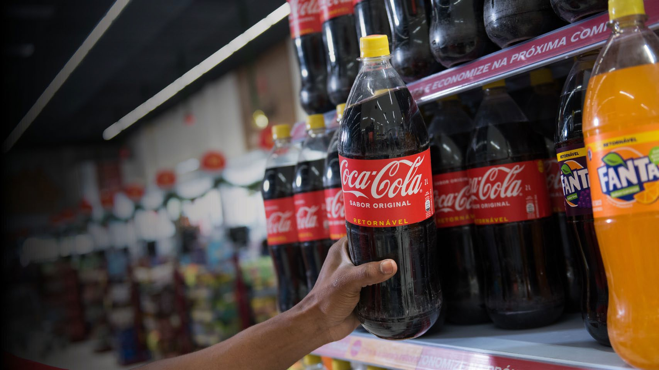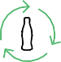

WORKING TOWARD A WORLD WITHOUT WASTE

IN 2022, WE ANNOUNCED A NEW GLOBAL REUSABLE PACKAGING GOAL.

BY 2030, WE AIM TO HAVE AT LEAST

25%

OF OUR BEVERAGES SOLD BY VOLUME

WORLDWIDE IN REFILLABLE/ RETURNABLE GLASS OR PLASTIC BOTTLES OR IN FOUNTAIN DISPENSERS WITH REUSABLE PACKAGING

ONE OF OUR PACKAGING

DESIGN GOALS IS TO REDUCE OUR USE OF VIRGIN PLASTIC DERIVED

FROM NON-RENEWABLE SOURCES BY A CUMULATIVE

3M METRIC TONS

BETWEEN 2020 AND 2025

We recognize our responsibility to help solve complex plastic waste challenges facing our planet and society. That’s why, in 2018, we launched an ambitious strategy called World Without Waste to drive systemic change through a circular economy for our packaging.

World Without Waste is a global sustainable packaging platform focused on measurable and interconnected goals, each of which are supported by additional targets:

* Making 100% of our packaging recyclable globally by 2025—and using at least 50% recycled material in our packaging by 2030 (**DESIGN**);
* Collecting and recycling a bottle or can for each one we sell by 2030 (**COLLECT**);
* Bringing people together to support a healthy, debris-free environment (**PARTNER**).

**SECTION SCOPE:** In this section, our packaging strategy refers to actions by the company as well as

our owned and independent bottling partners and our independent suppliers and partners.

**THE COCA-COLA COMPANY** 2022 BUSINESS & SUSTAINABILITY REPORT 36

CONTENTS

CEO MESSAGE EXECUTIVE SUMMARY

OUR COMPANY

WATER

PORTFOLIO

PACKAGING

CLIMATE

AGRICULTURE

PEOPLE

OPERATIONS

DATA APPENDIX

FRAMEWORKS

We are making progress against each of our objectives, which are embedded in how we operate as a business, and we are taking a transparent approach to reporting our actions, results and learnings.

Local teams are executing in ways appropriate for their markets, and we are using a networked approach to deliver impact at scale. Our work has also shown us where the major challenges are, and some of our markets will have challenges meeting goals as quickly as others.

Because packaging accounts for approximately 30% of our carbon footprint, nearly all of our World Without Waste efforts align with our 2030 science-based climate target and net zero ambition. When we lightweight our packaging, incorporate more recycled and bio-based material, invest in local recycling programs and increase our use of reusable packaging, we

can reduce both waste and our greenhouse gas (GHG) emissions.

##### WORLD WITHOUT WASTE: DESIGN

1. Only recyclable where infrastructure exists.

|  |  |  |
| --- | --- | --- |
| DESIGN: GOALS | 2022 STATUS | |
| Make 100% of our packaging recyclable globally by 2025 | **90%** globally1 | 90% |
| Use at least 50% recycled content in our packaging by 2030 | **25%**2 recycled material in our packaging globally and  **15%** of PET used is recycled PET (rPET) | 25%  15% |
| Reduce our use of virgin plastic derived from non-renewable sources by a cumulative 3 million metric tons from 2020–20253 | In 2022, we avoided around half a million metric tons of virgin plastic usage through our efforts on lightweighting and use of recycled content, with an incremental avoidance of over 50,000 metric tons since last year. However, growth of plastic packaging has outpaced efforts on lightweighting and use of recycled content, so that we have not reduced our use of virgin plastic overall | |
| By 2030, we aim to have at least 25% of our beverages worldwide by volume sold in refillable/ returnable glass or plastic bottles or in fountain dispensers with reusable packaging | Approximately **14%** of total beverage volume was served in reusable packaging in 2022 | 14% |

1. Includes select primary consumer packaging materials.
2. Reduction measured from historical usage modeled with 2018–2020 data.



Read more in the Data Appendix.

* In **France**, a 250-ml returnable glass bottle (RGB) launched in hotels, restaurants and cafes for Fuze Tea, Tropico, Sprite, Fanta and Minute Maid. Additionally, Coca-Cola and Coca-Cola Zero Sugar are now offered in RGBs nationwide, eliminating more than 15 million single-use glass bottles in 2022.
* In the **United States**, a 500-ml returnable glass bottle pilot program in approximately 100 retail and foodservice outlets in El Paso, Texas, generated a 75% return rate, and we are exploring expansion capabilities in 2023.

We also are working with Reuse Seattle to reduce single-use plastic waste by encouraging customers to transition to reusable cups for our dispensed products, as part of a broader multi- stakeholder effort on foodservice packaging across the metro region.

* In **South Africa**, we extended the rollout of refillable 2-liter and 1.5-liter PET plastic bottles.
* In **Sri Lanka**, we responded to the ongoing economic crisis by introducing the Large Returnable Glass Bottle (LRGB), nicknamed the “Big Buddy Pack,” to provide an affordable and returnable, mealtime-focused option for

families. Coca-Cola, Fanta and Sprite are offered in the 750-ml bottles, which feature paper labels and aluminum caps.

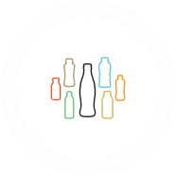

**Our Packaging Portfolio**

We deliver our beverages in a variety of packaging formats—from glass and PET bottles, to aluminum cans, to refillable packaging. Just as we offer drink choices for a range of occasions,

our packaging portfolio gives consumers multiple ways to enjoy our brands conveniently and safely.

Since glass, aluminum and PET plastic are all recyclable materials, they all can play a role in a circular economy. Refillable packages, both glass and plastic, can have the lowest carbon footprints of our packaging options. PET packages with recycled content can have a lower carbon footprint than aluminum and glass, which require more energy to produce, recycle and transport.

* In **Scotland**, Costa Limited (“Costa”) carried out a 14-store pilot of an on-the-go reusable cup

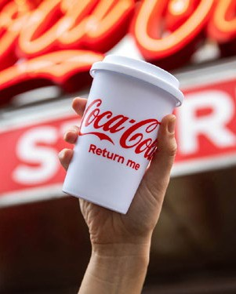Our Design goals establish a foundation for enabling a circular economy for our packaging materials. Creating a circular economy requires designing out waste by using, collecting and reusing recycled materials, which have inherent value. It also means embracing refillable and fountain/dispensed packaging solutions.

REFILLABLE PACKAGING

Reusable packaging can reduce single-use packaging waste. Expanding refillable packaging options helps ensure high levels of collection

of beverage containers. In 2022, we were proud to announce an industry-leading goal to have at least 25% of our beverage volume

worldwide sold in refillable/returnable glass or plastic bottles or in fountain dispensers with reusable packaging by 2030.

We continue to test and scale returnable glass bottle (RGB) and reusable PET pilot programs, including:

* In **Latin America**, the “Let’s Be Different” campaign kicked off on World Environment Day 2022, inviting consumers to trade any recyclable PET bottle for a refillable bottle of Coca-Cola Zero Sugar. In **Brazil**, returnable, refillable PET bottles of Coca-Cola, Fanta and Sprite can be returned, cleaned and refilled up to 25 times.

The package gives shoppers an affordable option and drives repurchase rates.

* In **Sweden**, we are collaborating with Reitan Convenience on a reusable packaging pilot in Stockholm. Shoppers who visit the sustainability- focused PDX store can choose from more than 60 fountain beverages, many of which are

not available in bottles or cans. Shoppers are encouraged to bring their own refillable vessels or purchase a reusable stainless steel tumbler.

* In **Hong Kong, China,** we have installed almost 100 Bonaqua Water Stations along hiking trails and in shopping malls and transportation hubs. Consumers pay a small fee to fill their own bottles with hot or cold Bonaqua water.

scheme, which invited consumers to rent a cup by scanning a QR code before enjoying their drink and then returning the cup for it to be washed and reused. The effort supports Costa’s global goal for 25% of its drinks to be served in reusable or refillable packaging by 2030.

We tailor our refillable packaging approach by market, based on local conditions. In 2023, we launched an end-to-end refillables operations guide to help local teams implement more effective strategies and plans.

CONTENTS

CEO MESSAGE EXECUTIVE SUMMARY

OUR COMPANY

WATER

PORTFOLIO

PACKAGING

CLIMATE

AGRICULTURE

PEOPLE

OPERATIONS

DATA APPENDIX

FRAMEWORKS

VIRGIN PET REDUCTION

In 2021, we set a goal to reduce our use of virgin plastic derived from nonrenewable sources by avoiding a cumulative 3 million metric tons by 2025 compared to 2020. We are pursuing this goal, which represents about 20% of our virgin plastic use, through more than 150 lightweighting projects and advancements on use of recycled and renewable materials.

In 2022, we avoided around half a million metric tons of virgin plastic usage through these efforts with an incremental avoidance of over 50,000 metric tons since last year. However, growth of plastic packaging has outpaced efforts on lightweighting and use of recycled content, so that we have not reduced our use of virgin plastic overall.

MOVING TOWARD 100% rPET1

Demand for recycled PET plastic for food-grade applications currently exceeds supply, so we need to help build a sustainable pipeline of high-quality material. We work with communities to boost PET recycling and collection; collaborate with recycling partners; and secure rPET to help ensure material for our bottles is used again and again.

In recent years, system partners and suppliers have announced significant investments, both individually and through joint ventures, to boost the global rPET infrastructure. Many investments are coming online in the next two years and will change the rPET landscape, particularly in Asia.

We continue to work with industry peers to advocate for government regulations permitting the use of rPET in food and beverage packaging. Notable countries with food-grade recycled plastics acceptance standards for use in

1 Except where otherwise indicated, where reference is made in this report to 100% Recycled PET, 100% rPET, or 100% Recycled Plastic Beverage Packaging, we are referring to the material from which the plastic bottle is made, not the cap and label.

beverages now include Bahrain, Bangladesh, Indonesia, Kuwait, Nigeria, Oman, Qatar, Saudi Arabia, South Korea, Thailand and Yemen.

Coca-Cola Beverages Philippines Inc. and Indorama Ventures—the world’s largest recycled PET flake producer—began operations at the new PETValue recycling facility. The country’s first bottle-to-bottle production site will process

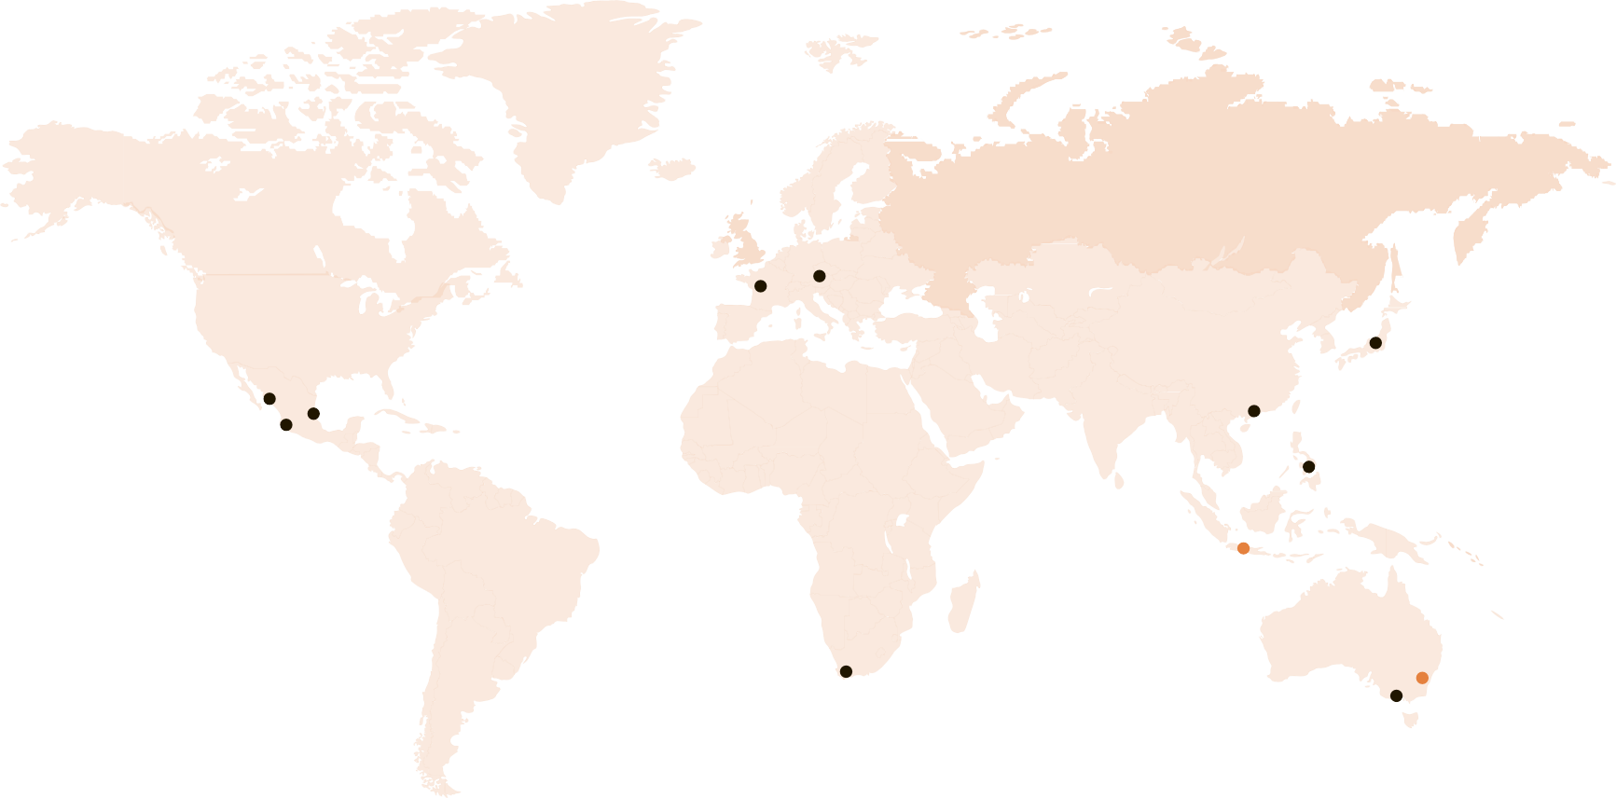

AUSTRALIA

A JV between Coca-Cola Europaciﬁc Partners, **Cleanaway Waste Management Ltd**, **Asahi Beverages** and **Pact Group**

SOUTH AFRICA

**PETCO**, a collaboration between Coca-Cola Africa, Coca-Cola Beverages Africa and several CPGs to ﬁnance PET collection

INDONESIA

**Amandina**, a JV between Coca-Cola Europaciﬁc Partners and Dynapack Asia

THE PHILIPPINES

**PETValue**, a JV between Coca-Cola Beverages Philippines and Indorama Ventures

MEXICO

**PetStar**, a JV between Coca-Cola Mexico and ARCA Continental

**IMER**, a JV between Coca-Cola Mexico, Coca-Cola FEMSA and Alpla

**Planeta**, a JV between Coca-Cola FEMSA and Alpla

JAPAN

**JAPAN FIGP**, a JV

between Ishizuka Glass Co., Ltd and Far Eastern New Century

HONG KONG, CHINA

**New Life Plastics**,

a JV between ALBA, Baguio and Swire Coca-Cola

FRANCE

**INFINEO**, a JV

between Coca-Cola Europaciﬁc Partners and PlastikPak

AUSTRIA

**PET2PET,** a JV

between Coca-Cola Hellenic and several Austrian partners

Active Planned

Through joint ventures and long-term supplier agreements, our system is making strategic investments to boost recycling capacity, unlock new supplies of recycled plastic and scale new technologies.

**Building a Global rPET Supply Chain**

1. billion clear PET plastic bottles into new bottles for Coca-Cola brands. Indorama Ventures will open a similar facility in Indonesia in 2023.

Around the world, many of our biggest brands are taking major steps to support a circular economy for plastic packaging. More than 40 markets currently offer at least one brand in 100% rPET packaging. A few highlights from 2022 include:

* In the **United States and Canada**, we recently began offering the majority of DASANI bottles— from 20-oz. and 1.5-liter singles to 10-oz. and

12-oz. multipacks—in 100% rPET plastic. The shift supports the DASANI brand's pledge to remove the equivalent of 2 billion virgin plastic bottles from production by 2027 compared to 2021 levels. The announcement followed the launch of 100% rPET bottles in New York, California

and Texas, which also included Coca-Cola 20- oz. bottles. Bold, on-pack labels drive consumer awareness with “100% Recycled Bottle” and “Recycle Me Again” calls to action.

* Eight markets in Europe (**Austria**, **Belgium**, **Iceland**, **Luxembourg**, **Netherlands**, **Norway**, **Sweden**, **Switzerland**) offer their entire locally produced portfolios in 100% rPET.
* In **Qatar**, Coca-Cola, Sprite, Fanta and Arwa water were sold in 100% rPET bottles in FIFA World

Cup 2022 stadiums and fan zones. This marked both the FIFA World Cup debut of the sustainable packaging format and the Middle East’s first 100% rPET rollout. Dedicated recycling bins and on-site communication ensured proper collection of all bottles to be recycled and converted locally back into new ones, closing the loop and leaving behind a green legacy.

CONTENTS

CEO MESSAGE EXECUTIVE SUMMARY

OUR COMPANY

WATER

PORTFOLIO

PACKAGING

CLIMATE

AGRICULTURE

PEOPLE

OPERATIONS

DATA APPENDIX

FRAMEWORKS

**Sustainable Innovation**

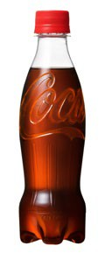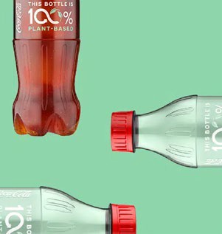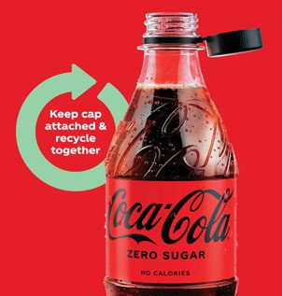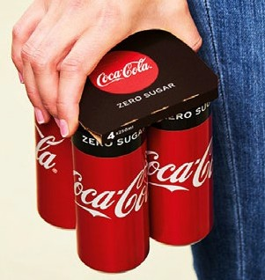

* In **Vietnam**, we launched 100% rPET Coca-Cola bottles, which is projected to avoid 2,000 metric tons of virgin plastic usage annually.
* In **Japan**, we achieved our World Without Waste goal of 50% recycled material use in Q1 2022. Four brands are now offered in 100%

recycled PET and supported by an educational marketing campaign.

SPRITE TRANSITIONS FROM GREEN TO CLEAR PET

We continued to transition Sprite plastic bottles from green to clear PET to help increase the efficiency of recycling systems. The move, which the brand has completed or is in process in over 100 countries, improves the efficiency of recycling systems and boosts availability of food-grade rPET. As one example, Coca-Cola North America’s entire green plastic portfolio—including packaging for Sprite, Fresca, Seagram’s and Mello Yello— made the transition to clear PET in 2022.

We continue to deliver breakthrough technologies to lightweight our plastic packaging:



As The Coca-Cola Company’s second-largest brand, Sprite is proud to demonstrate its commitment to circularity through our packaging by ensuring every bottle we make can be recycled and made into a new one. We can

only achieve our World Without Waste goals by creating closed-loop packaging streams, and that starts with clear PET.”

**SHRENIK DASANI**

Global Senior Director, Sprite Trademark

**Label-less bottles** are now available across a range of brands in Japan, South Korea and

China. Laser engraving technology used directly on the bottle helps improve recyclability and reduce carbon emissions.

Our technology is being licensed for a **30%**

**plant-based plastic bottle** to a company building a commercial facility in Germany, which is scheduled to deliver material in 2024. A **100% plant-based plastic bottle prototype** has been developed with plans to explore scalability of a 100% biobased PET resin and bottle (bottle, not cap and label). Biobased plastic packaging can have a lower carbon footprint than petroleum- based packaging.

Bottles with **tethered caps**, which enable bottles and caps to be collected together for

recycling, are being piloted for our entire portfolio in Germany, Bulgaria and Italy. Additionally,

a new lightweighted bottle neck finish in Europe will save an estimated 9,100 tons of plastic per year by 2024.

The **KeelClip®1 packaging solution** made from recyclable cardboard replaces plastic rings for multi-packs. Following a successful rollout across Europe, the first-of-its-kind solution is being piloted in select U.S. markets.

1 KeelClip is a trademark of Graphic Packaging International, LLC

CONTENTS

CEO MESSAGE EXECUTIVE SUMMARY

OUR COMPANY

WATER

PORTFOLIO

PACKAGING

CLIMATE

AGRICULTURE

PEOPLE

OPERATIONS

DATA APPENDIX

FRAMEWORKS

##### WORLD WITHOUT WASTE: COLLECT



Material Mix Collection Rates by Packaging Type1

REFILLABLE GLASS & PET PLASTIC

POUCHES

PET PLASTIC

NON-REFILLABLE GLASS

CARTONS/JUICE BOXES

ALUMINUM & STEEL

10% 93%

0.5% 6%

47% 58%

2% 35%

3% 17%

26% 61%

61%

of the equivalent bottles and cans we introduced into the market in 2022 were collected and refilled or collected for recycling.1

**Our Packaging Types**

1 The collection rate represents a weighted average of national collection rates, collected for recycling rates or refillable rates by packaging type to TCCS’s sales in units to express the percent of equivalent bottles and cans introduced into the market that were collected and refilled or collected for recycling for the year.

We work with partners across business, government and civil society to create or support closed-loop systems that ensure our packages are collected and recycled or reused. Delivering a circular economy will require significant and urgent improvement in waste management and recycling systems around the world. Preserving the inherent economic value of our packaging—and ensuring circularity— requires robust collection and recycling systems across packaging types.

Collection challenges vary, as every country has unique governments, regulatory environments and consumer behaviors. Though some countries have high recycling rates across packaging types,

|  |  |  |
| --- | --- | --- |
| GOAL | 2022 STATUS | |
| Collect and recycle a bottle or can for each one we sell by 2030 | **61%1** | 61% |

in many regions the recycling rate for PET bottles lags that of some other materials. While we continue to focus on national collection rates, in 2022, with input from key external stakeholders, we updated our collection tracking guidance to account for material collected through system- led efforts. Company and bottler teams in markets with limited recycling infrastructures (including parts of Latin America, Africa and Asia) are financing system-led collection initiatives to supplement national systems and are launching our own tracking systems. In 2023, we will start incorporating Coca-Cola system-led collection data into our aggregate numbers.

In emerging markets, we advocate for government regulations permitting the use of rPET in food and beverage packaging, and

we seek ways to empower the informal waste collection sector in the circular economy. In developed markets, we are working with industry peers to build collection infrastructures—including our more than 40 years of experience operating 40+ local Deposit Return Systems (DRS).

Countries with a well-designed DRS scheme, like Germany, can achieve high levels of collection (approximately 97% collection for non-refillable packages in Germany).

CONTENTS

CEO MESSAGE EXECUTIVE SUMMARY

OUR COMPANY

WATER

PORTFOLIO

PACKAGING

CLIMATE

AGRICULTURE

PEOPLE

OPERATIONS

DATA APPENDIX

FRAMEWORKS

We advocate for well-designed **Extended Producer Responsibility** (EPR) schemes, in which companies that produce packaging fund collection, sorting and recycling with the goal of increasing recycling rates. Recognizing that industry cannot achieve a circular economy on

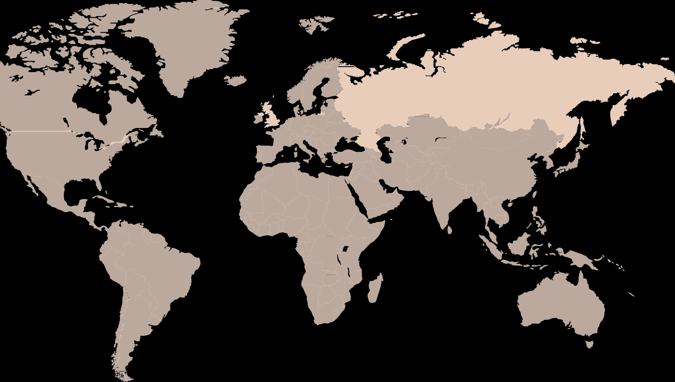

**NEW ZEALAND**

**66%**

**30%**

**62%**

**ARGENTINA**

**26%**

**SOUTH AFRICA**

**URUGUAY**

**AUSTRALIA**

**57%**

**MAURITIUS**

**40%**

**29%**

**BRAZIL**

**56%**

**INDONESIA**

**62%**

**TANZANIA**

**THE PHILIPPINES**

**MALAYSIA 48%**

**56%**

**KENYA**

**45%**

**50%**

**ECUADOR**

**79%**

**PERU**

**54%**

**LAOS**

**35%**

**VIETNAM**

**45%**

**GHANA**

**NEPAL**

**80% BANGLADESH**

**30%**

**INDIA**

**80%**

**BARBADOS**

**60%**

**49%**

**25%**

**HONDURAS**

**29%**

**50%**

**UZBEKISTAN**

**83%**

**PAKISTAN**

**75%**

**EGYPT**

**45%**

**REPUBLIC**

**BELIZE**

**ISRAEL**

**68%**

**JAMAICA DOMINICAN**

**79%**

**66%**

**56%**

**JAPAN**

**98%**

**GREECE**

**71%**

**UNITED STATES**

**28%**

**SOUTH KOREA**

**TÜRKIYE**

**26%**

**ITALY 83%**

**65%**

**SPAIN**

**POLAND**

**47%**

**HUNGARY**

**CROATIA**

**BELGIUM**

**95%**

**CANADA**

**75%**

**ESTONIA**

**88%**

**ICELAND**

**90%**

**2022 Worldwide Collection Rates1**

its own, we are part of a Consumer Goods Forum (CGF) coalition of 40 companies supporting the development of EPR programs in collaboration with governments. The coalition has published guiding principles and key design parameters for optimal EPR programs.

In the United States, we’re making progress one community at a time, through our industry

initiative Every Bottle Back. As of November 2022, the initiative has launched over 25 projects which are projected to collect and capture nearly 700 million pounds of PET over ten years.

We also work with peers and partners to advocate for legislation that enables a circular economy, like a recent EPR law passed in Colorado and minimum recycled content laws passed in California, Washington and New Jersey. However, collection rates in the United States trail those of many other countries, and we know there is much more work to do.

Ensuring respect for the human rights of vulnerable workers in the informal waste sector is an important pillar of our Collection efforts. Over the last two years, we have partnered with industry peers and Tearfund, an NGO advocating for improved livelihoods for informal waste sector workers, on the [Fair](https://faircircularity.org/) [Circularity Initiative](https://faircircularity.org/) to develop human rights principles and guidelines for engaging with the informal waste collection industry. For more information, see the Human Rights section.

**Additional 2022 highlights:**

* + In the **Philippines**, we partnered with the Technical Education and Skills Development Authority to pilot a certified skills training program for workers in the informal waste collection sector. These workers have access to training, tools and equipment for efficient waste collection and connections to materials

recovery facilities (MRF) that buy the waste that is collected. We also are creating more than 2,000 collection hubs in sari-sari (convenience) stores and other retail outlets where community members can drop off used, clear PET bottles

in return for incentives. Participating retailers earn income from selling collected PET bottles to waste management companies and recyclers. Similar programs are in place in Malaysia, Myanmar and Thailand.

* + In **Brazil**, SustentaPET collection centers take in more than 700,000 PET bottles a day to produce recycled resin that ultimately becomes new packaging. In its first three years, the program has recycled more than 83,000 metric tons of PET—and will expand to additional states in 2023.
  + In **Egypt**, we partner with BariQ, the largest bottle-to-bottle recycling plant in the Middle East, to recycle 14,000 metric tons of plastic waste annually to food-grade product compatible with the European Food Safety Authority (EFSA), Food and Drug Administration (FDA) and Egyptian Organization for Standardization (EOS).
  + In **India**, we’re teaming with bicycle grocery delivery service Zepto for the “PET Return and Recycle” initiative. Using the Zepto mobile app, consumers can return up to four empty PET bottles (across any brand) to be collected by Zepto riders during home delivery trips. Following a successful pilot in Mumbai, the program will expand to additional cities.

1 These collection rates represent non-refillable PET packaging only.

CONTENTS

CEO MESSAGE EXECUTIVE SUMMARY

OUR COMPANY

WATER

PORTFOLIO

PACKAGING

CLIMATE

AGRICULTURE

PEOPLE

OPERATIONS

DATA APPENDIX

FRAMEWORKS

##### WORLD WITHOUT WASTE: PARTNER WHAT’S NEXT

Tackling the global plastic waste crisis requires cross-sector collaboration and alignment on common principles and targets. We work with a range of stakeholders at a global, regional and local level. This includes partnering with governments and community organizations to strengthen recycling infrastructures and boost collection rates; collaborating with customers, peers and industry associations to shape public policy that supports a circular economy; and teaming up with suppliers, startups and R&D

|  |
| --- |
| DESIGN PARTNERS |
| A&W |
| ANZPAC Plastics Pact |
| Burger King® and Loop™ |
| Coca-Cola Europacific Partners & Pact Group, Cleanaway and Asahi Beverages |
| Changchun Meihe Science & Technology |
| Tesco and Loop™ |
| UPM |
| Virent |

partners to fuel sustainable packaging innovation.

In 2022, we enhanced our partnership with the Ellen MacArthur Foundation by becoming a Strategic Partner alongside some of the world’s largest and most influential organizations,

with transformative potential to demonstrate what’s possible in the transition to a circular economy. As a Strategic Partner we support the Foundation’s mission to develop and

promote a circular economy beyond our work on plastics and deepen our engagement globally, regionally and locally.



We have no time to waste. The need for global coordination to tackle the plastic pollution crisis has never been more urgent. A Business Coalition for a Global Plastics Treaty will push strongly

for a framework that leaves the business-as- usual approach at the door and ushers us into a new era where ending plastic pollution is finally within reach.”

**ERIN SIMON**

Vice President and Head of Plastic Waste and Business, WWF

We have been working with the Foundation on plastics across a range of projects and initiatives, including as a signatory to their Global Commitment in collaboration with the

UN Environment Programme. In the past couple of years, we increased our ambition and set virgin plastics reduction and reusable packaging targets.

In September 2022, we also joined the Business Coalition for a Global Plastics Treaty convened by the Ellen MacArthur Foundation and WWF, and we have an active role as a Co-Chair of the Coalition’s Policy Working Group. Over 80 organizations, including businesses from across the plastics value chain, financial institutions and NGOs, are supporting the development of an ambitious, effective and legally binding UN treaty to end plastic pollution—which will set common goals, rules and obligations for member states, and in turn, for businesses. Through a shared vision we believe that a legally binding treaty must set the right enabling conditions to successfully scale

a circular economy for plastic and end plastic pollution, and in doing so, will level the playing field across countries and industries. This will help ensure all plastics users participate in the funding of collection systems and will set consistent targets for areas such as recyclability, recycled content and collection.

We continue to play an active role in the **AB InBev 100+ Accelerator program**, a global open innovation program committed to crowdsourcing and piloting sustainability-focused startups

and solutions. The program’s 2022 cohort is supporting 46 startups with funding, training, mentoring and other hands-on support to execute pilot projects in a partner company’s supply chain.

Within the Coca-Cola system, we are pursuing six pilot projects, building on the five pilots from last year. We have focused our investments

in concepts that support a circular economy, water and climate. And while we are early in the process, we are seeing promise. Pilot projects

from the last cycle (2021–2022) with ReciVeci (Ecuador) and RecyclePoints (Nigeria) resulted in ongoing partnerships that are helping to further our World Without Waste plans.

In the **Philippines**, we are partnering with Save Philippine Seas on a campaign to find and scale community-based plastic waste solutions.

In 2022, five startups—Barrio Studios, Sagip Kalikasan, KAKASIE Eco-Park, #RefillNotLandfill and Alon and Araw—received grants from

The Coca-Cola Foundation to advance their collection, recycling and education projects.

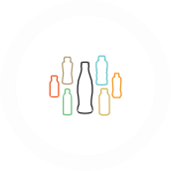

**Collaborating for Impact**

In 2022, we continued to strengthen existing partnerships and establish new ones to align strategically with our World Without Waste priorities and collectively drive progress toward a circular economy. Here are a few examples:

In **Morocco**, we are collaborating with WWF on the Plastic Smart Cities project, which brings together cities and tourism destinations to fight plastic pollution. The partnership in Tangier aims to reduce leakage of plastic waste into nature by 30%. In 2021 and 2022, the partners and the local waste management department have collected more than 3,900 metric tons of plastic waste.

We look forward to partnering with more like- minded organizations and communities to make the vision of a World Without Waste a reality.

We now have five years of experience implementing the World Without Waste program.

With targets for both 2025 and 2030, in 2023 we are taking stock of our current status across

markets to ensure our local teams have the plans and investments in place to continue to make progress. Our experience in a handful of markets that are already achieving high performance against specific goals, or the full suite of targets, indicates that these goals can be met. However, we are not currently on track to meet the World Without Waste targets for 2030. Package design and the use of recycled materials are areas

that are ultimately in our control, but costs, quality, technology and consumer preferences are dynamic factors that affect our ability and timelines for implementation. The key challenge for us is collection for recycling of beverage packaging, which is the key step to ensure a functioning circular economy.

We will continue to invest in innovation for the small percentage of our packaging that

currently has recycling challenges, including juice pouches, opaque packaging currently used for dairy beverages, and cartons. And, we will invest in new recycling technologies for PET plastic

|  |
| --- |
| COLLECT PARTNERS |
| AB InBev 100+ Accelerator |
| BanQu |
| Benioff Ocean Institute |
| Circular Solutions Advisors |
| Circulate Capital |
| Global Plastic Action Partnership & World Economic Forum GPAP |
| Indorama Ventures |
| PETCO |
| Project RECAPP |
| Solar Coca-Cola |
| The Ocean Cleanup™ |

and other packaging materials.

We see a significant opportunity to work more proactively with global and regional customers, many of which have announced their own sustainable packaging goals that can only be achieved in collaboration with key suppliers.

Looking ahead, we will build on our longstanding relationships to make collective progress.

CONTENTS

CEO MESSAGE EXECUTIVE SUMMARY

OUR COMPANY

WATER

PORTFOLIO

PACKAGING

CLIMATE

AGRICULTURE

PEOPLE

OPERATIONS

DATA APPENDIX

FRAMEWORKS

# Climate

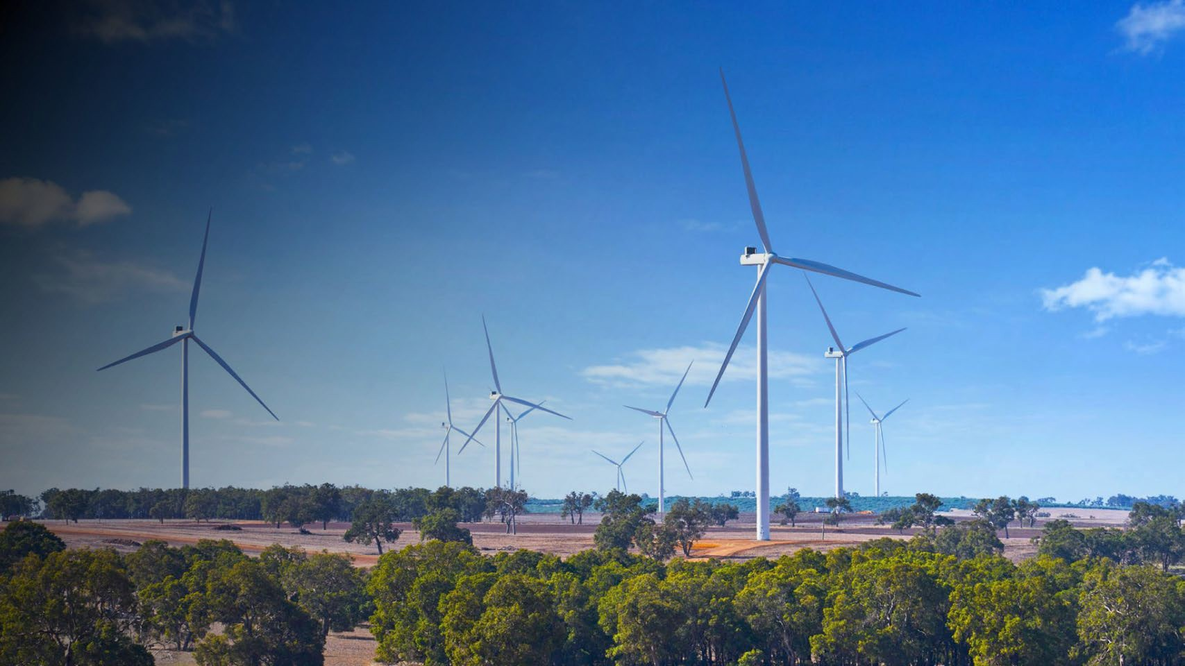

7% DECLINE IN

IN ABSOLUTE EMISSIONS

SINCE 2015 TOWARD A 25% SCIENCE-BASED REDUCTION TARGET BY 2030

Taking well-informed, decisive action to help address climate change is a priority for our company.

Climate change poses risks to our business and

our stakeholders. By implementing an interconnected approach across our priority sustainability issues,

we are reducing the Coca-Cola system’s greenhouse gas (GHG) emissions and building resilience in our business, value chain and local communities.

21% SYSTEM-WIDE

RENEWABLE ELECTRICITY USAGE IN 2022

378 OF OUR SUPPLIERS

(OUT OF 495 REQUESTED) PROVIDED CLIMATE DATA TO CDP IN 2022

(A 12% INCREASE FROM 2021)

**SECTION SCOPE:** In this section

our climate emissions reduction work refers to actions by the company

as well as our owned and independent bottling partners and our independent suppliers and partners.

**THE COCA-COLA COMPANY** 2022 BUSINESS & SUSTAINABILITY REPORT 43

CONTENTS

CEO MESSAGE EXECUTIVE SUMMARY

OUR COMPANY

WATER

PORTFOLIO

PACKAGING

CLIMATE

AGRICULTURE

PEOPLE

OPERATIONS

DATA APPENDIX

FRAMEWORKS

##### 2030 SCIENCE-BASED TARGET

We are working to reduce our carbon footprint in line with science to avoid the worst impacts of climate change.

|  |  |  |  |  |
| --- | --- | --- | --- | --- |
| **Our Carbon Footprint and the Actions We Are Taking** | | | | |
|  |  |  |  |  |
| PACKAGING 30–35% | INGREDIENTS 10–15% | MANUFACTURING & | DISTRIBUTION 5–10% | REFRIGERATION 30–35% |
| A circular economy helps reduce GHG | We work with our agricultural | OTHER FACILITIES 10–15% | We’re working to increase fuel | We are continuing to replace older |
| emissions. We are incorporating more | suppliers to increase energy efficiency | We provide system guidance to | efficiency and the use of hybrid and | equipment with hydrofluorocarbon |
| recycled material, lightweighting | and realize carbon sequestration | improve energy efficiency and | electric vehicles across the system. | (HFC)-free and more energy-efficient |
| our packaging, investing in recycling | benefits from Nature-Based Solutions | increase the generation and purchase | Coca-Cola Europacific Partners | coolers. In 2022, 88% of all new |
| infrastructure and using more | (NBS). We also work with leading | of renewable energy. In 2022, there | (CCEP) increased their use of hybrid | coolers placed were HFC-free. |
| reusable packaging. In 2023, we are | sustainable sourcing schemes to | has been new renewable energy | and electric cars and vans in Europe | This is an increase from 61% of |
| building our capabilities in life cycle | quantify the impact of sustainable | generation at system bottling | from 12% in 2021 to 20% in 2022 and | coolers placed in 2016. |
| assessment (LCA) to further drive | sourcing on emissions reduction. See | plants in Europe, Latin America, | introduced 30 electric trucks to make |  |
| synergies between our work on | Sustainable Agriculture for more. | the Philippines, India and the | last mile deliveries to customers in |  |
| packaging and climate. |  | Middle East. | Belgium, covering approximately 40% |  |
|  |  |  | of the country’s local delivery routes. |  |



We do this by analyzing and prioritizing the sources of GHG emissions across our value chain and by partnering with stakeholders to drive down those emissions.

As of 2022, we reduced our emissions across Scopes 1, 2 and 3 by 7%,1 making progress toward our science-based reduction target of 25% by 2030 against a 2015 baseline1. Our ambition is

to achieve net zero emissions by 2050. Several of our bottling partners have announced

their own science-based targets and net zero pledges to drive climate action across the global Coca-Cola system.

In 2022, our scope 1 emissions were 4.4 million metric tons, scope 2 emissions were 3.5 million metric tons2 and scope 3 emissions were 57.0 million metric tons.

CLIMATE CHANGE GOVERNANCE

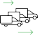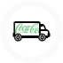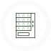

Processing of sold products

Business travel

Heat and steam

Fleet vehicles

Downstream transportation

and distribution

Purchased goods

and services

SCOPE 3

UPSTREAM AND DOWNSTREAM SOURCES

88%

SCOPE 2

INDIRECT EMISSIONS

5%

Electricity

SCOPE 1

DIRECT EMISSIONS

7%

Fossil fuels

**The Coca-Cola System’s Emission Percentages by Scope in 2022**

The [Corporate Governance and Sustainability](https://d1io3yog0oux5.cloudfront.net/_ed81a97c1374ef0031160e255ca2414a/cocacolacompany/db/719/7008/file/Corporate%2BGovernance%2Band%2BSustainability%2BCommittee%2BCharter%2C%2BFebruary%2B16%2C%2B2023.pdf) [Committee](https://d1io3yog0oux5.cloudfront.net/_ed81a97c1374ef0031160e255ca2414a/cocacolacompany/db/719/7008/file/Corporate%2BGovernance%2Band%2BSustainability%2BCommittee%2BCharter%2C%2BFebruary%2B16%2C%2B2023.pdf) of our Board of Directors oversees climate-related issues. The Committee assists our Board in overseeing the company’s environmental, social, legislative, regulatory and public policy matters, including progress against

our science-based emissions reduction target. The committee reports regularly to the full Board on these and other matters.

To learn more about our governance structure, see the Governance section. For more on climate- related governance, see our [CDP 2022 Climate](https://www.coca-colacompany.com/content/dam/journey/us/en/policies/pdf/sustainability/2022-cdp-climate-response.pdf) [Change response](https://www.coca-colacompany.com/content/dam/journey/us/en/policies/pdf/sustainability/2022-cdp-climate-response.pdf), Section C1.

1. This figure was calculated using the market-based emissions method and therefore includes purchased renewable electricity as part of the system’s overall emissions reduction. For exclusions, please see the criteria statement in the Independent Accountant’s Review Report.

**Networks Support Our Net Zero Journey**

We are part of a number of business networks that are supporting our journey to net zero. As a member of the WWF Climate Business Network, we share best practices to drive collective ambition

and scale action together. Participation in the Clean Energy Buyers Association (CEBA) allows us to help deploy market

and policy solutions toward a carbon-free energy system. Membership in Ceres’ Company Network has helped to identify opportunities to drive further progress toward net zero emissions.

1. This figure was calculated using the market-based emissions method and therefore includes purchased renewable electricity.

CONTENTS

CEO MESSAGE EXECUTIVE SUMMARY

OUR COMPANY

WATER

PORTFOLIO

PACKAGING

CLIMATE

AGRICULTURE

PEOPLE

OPERATIONS

DATA APPENDIX

FRAMEWORKS

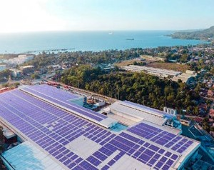**Taking Action Across Our Value Chain**

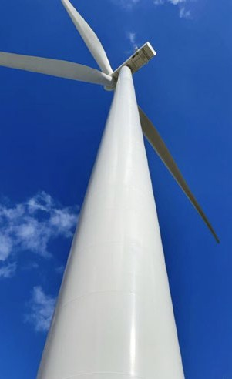

**Coca-Cola Europacific Partners Signs Landmark Renewable Electricity Agreement**

Coca-Cola Europacific Partners (CCEP) in Australia signed an eight-year agreement with Alinta Energy, which includes

large-scale generation certificates and 13,000 MWh per year of renewable electricity supplied from the Yandin Wind Farm. The long-term agreement started in January 2023 and will help CCEP move closer to its goal of using 100% renewable electricity across all of its markets by 2030.

MANAGING CLIMATE RISK

Our Risk Steering Committee oversees regular system-wide risk assessments. We integrate climate risk planning into this cross-functional and cross-company Enterprise Risk Management (ERM) process. We regularly evaluate commodity- specific risks and resilience associated with climate impacts on water and our supply chain.

Risks that could materially affect our business, financial condition and results of operations are disclosed in the company's [Annual Report](https://investors.coca-colacompany.com/filings-reports/annual-filings-10-k) [on Form 10-K](https://investors.coca-colacompany.com/filings-reports/annual-filings-10-k) for the year ended December 31,

2022. This includes risks related to the effects of climate change and legal or regulatory initiatives to address climate change. Our management team works to mitigate these risks through, among other things, business continuity planning, setting targets that drive efficiency and making investments to improve our performance and increase resilience. Ultimately, the Corporate Governance and Sustainability Committee of our Board of Directors oversees climate-related risks.

The involvement of our bottling partners and suppliers is essential to achieving our science- based target to reduce absolute scope 1, 2 and 3 GHG emissions by 25% by 2030. The following are examples of how we are working on climate initiatives with partners across our value chain.

INCREASING RENEWABLE ENERGY (ELECTRICITY) IN MANUFACTURING

One critical strategy for reducing emissions in our system is the increased use of renewable energy in our manufacturing processes.

Renewable electricity usage, which was third- party assured for the first time in 2021, increased from 12% in 2021 to 21% in 2022.

To build knowledge across our system and increase the generation, procurement and accurate reporting of renewable energy, we published a Renewable Energy Implementation Guidebook in March 2022. This guidebook provides a step-by-step process for associates across the system to implement on-site solar photovoltaic and solar hot water and steam systems, on-site and off-site renewable energy power purchase agreements (PPAs), coupled with energy attribute certificates to align with GHG Protocol Scope 2 quality criteria.

In addition to the guidebook, we launched a future-facing initiative called the Renewable Energy Project Pipeline in 2022, where we work closely with bottling partners to increase the number of renewable energy projects throughout our system. Approximately 20 bottling partners and 13 concentrate plants have developed 2023–2025 renewable energy plans. As the number and scope of these projects expands, we will look for opportunities to collaborate

and share best practices.

BOTTLING PARTNERS SET SCIENCE-BASED EMISSIONS TARGETS

Given the size of our network of bottling partners, they are critically important in making progress toward our climate ambitions. Our bottling partners have a major influence on emissions reductions based on what they buy, make and deliver for our shared customers

and consumers.

In September 2022, Arca Continental committed to setting a science-based target. This adds to the growing list of our bottlers with approved emissions reductions goals through the Science- Based Targets initiative (SBTi). This list includes Coca-Cola Hellenic Bottling Company (CCHBC), Coca-Cola Europacific Partners (CCEP), AB Inbev, Swire Coca-Cola Limited and Coca-Cola FEMSA.

We will be working to grow this list in 2023.

ENGAGING WITH SUPPLIERS TO TAKE ACTION ON CLIMATE

We continue to find new ways to collaborate and support our suppliers to collectively reduce emissions.

In 2022, we joined the Supplier Leadership on Climate Transition (Supplier LoCT) initiative, led by Guidehouse along with 18 other companies to mobilize collective climate action by providing suppliers with resources, tools and knowledge to accelerate their decarbonization. As of the end of 2022, there were 94 suppliers to the Coca-Cola system participating in the initiative. The company is directly sponsoring 56 of these suppliers. The program is showing signs of success—10 suppliers that we sponsored, who successfully completed the program, have since set or committed to setting their own SBTi- approved emissions targets.

Thanks to The Coca-Cola Company, in April 2022 we had the great opportunity to join the Supplier LoCT initiative. This program helped us to improve the way we calculate our Scope 1 & 2

emissions and to calculate our Scope 3 emissions for the first time. Last November, we committed to setting a science-based emissions target.”

**NICOLAS LOOTENS**

Group Sustainability Manager, Vetropak

In total, more than 160 of our suppliers have set or committed to setting SBTi-approved emissions targets.

**Reducing Emissions from Coolers**

Coolers have long been a key opportunity because approximately one-third of our emissions comes from cold-drink equipment and dispensing. In early 2023, building on analysis we conducted in 2022, we published internal guidance for coolers used across our value chain. The guidance sets specific energy usage limits, which will require increasing energy efficiency between now and 2030 and help drive the replacement of older, less efficient coolers.

We are also installing more “intelligent connected” coolers that can transmit data such as product throughput, maintenance status, temperature and energy use, which has operational benefits in addition to helping reduce emissions.

In 2022, 88% of all new coolers placed were HFC-free. This is an increase from 61% of coolers placed in 2016.

CONTENTS

CEO MESSAGE EXECUTIVE SUMMARY

OUR COMPANY

WATER

PORTFOLIO

PACKAGING

CLIMATE

AGRICULTURE

PEOPLE

OPERATIONS

DATA APPENDIX

FRAMEWORKS

##### WHAT’S NEXT?

IMPROVING DATA SCOPE AND ACCURACY

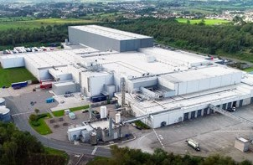

**Coca-Cola Ballina Plant Recognized by World Economic Forum**

The World Economic Forum’s Global Lighthouse Network recognized The Coca-Cola Company’s concentrate manufacturing facility in Ballina, Ireland, as a manufacturer showing leadership in applying Fourth Industrial Revolution technologies at scale to drive step-change financial, operational and sustainability improvements by transforming factories, value chains and business models. Investments

in the facility’s IT infrastructure, advanced technologies and employee training has led to a 6.8% increase in production in three years (2019–2022) and a 29% energy reduction, which brought emissions back to 2011

levels. The Ballina team’s learnings are being shared globally.

Gathering complete and accurate data is critical to identifying a path to achieving our science- based target. We are continuously improving the scope and detail of our data collection to ensure all significant sources of emissions across our value chain are included in our inventory. We are updating our 2015 baseline data due to recent acquisitions. Improving our data helps us prioritize projects and programs with the greatest impact, including more detail on renewable energy usage and more data from suppliers.

**Validate Renewable Energy Claims**

One area of focus has been to validate the accuracy and completeness of our renewable energy claims. We have done this through assuring our claims to the GHG Protocol. This work began in 2021 and continued through 2022.

**Suppliers Disclose Data and Targets**

Because approximately 85% of our total carbon emissions come from goods and services we buy, it is essential to engage with suppliers to accurately capture our full scope 3 emissions and ensure our suppliers join our decarbonization journey. Each year, we encourage key suppliers to complete CDP’s Supply Chain Climate Change questionnaire, which provides useful data on GHG emissions in our supply chain and information on supplier targets and initiatives to

reduce emissions. In 2022, 378 suppliers provided climate data to CDP out of 495 requested,

a 12% increase from 2021.

Additionally, we are working to improve data accuracy in partnership with several major suppliers across ingredients and packaging, starting with sugar and aluminum, in order to develop supplier-specific emissions factors for the commodities we procure. This allows us to better

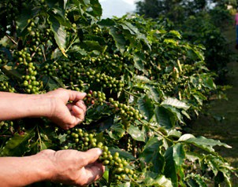

understand our supply chain, drive change and more accurately track emissions reductions of specific suppliers and commodities in key areas.

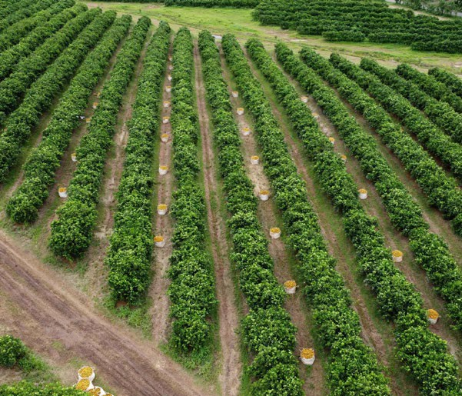

**Accounting for Land Use Emissions**

In line with the launch of the SBTi’s Forest, Land and Agriculture (FLAG) requirements, we are working to update our current science-based target in line with this methodology and a more ambitious trajectory. This new target would consider emissions from land use change in our supply chain as part of our overall GHG footprint and would consider carbon sequestration from land-based projects we implement in our supply chain. While we already work closely with suppliers to engage on water and sustainable agriculture, accounting for land use emissions would require an even closer partnership with our agricultural suppliers. As we incorporate more work across the agricultural supply chain, this would also help us meet evolving climate risk and data disclosure requirements.

Even deeper in our supply chain, work is underway to map and understand how land, water use and farming practices in our major agricultural sourcing regions both generate emissions and have the potential to reduce emissions. Costa began its own work in 2022, launching a Climate Smart coffee project in partnership with the Rainforest Alliance. Phase 1 of the project has been to conduct a GHG

feasibility study to better understand the carbon footprint of coffee farms from Costa’s key sourcing origins, including Colombia and Brazil. This study is being used to inform the design of scalable climate mitigation interventions.

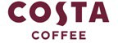

CONTENTS

CEO MESSAGE EXECUTIVE SUMMARY

OUR COMPANY

WATER

PORTFOLIO

PACKAGING

CLIMATE

AGRICULTURE

PEOPLE

OPERATIONS

DATA APPENDIX

FRAMEWORKS

# Sustainable

## Agriculture

Our products and some of our packaging are made from a wide variety of agricultural ingredients which we source from around the world. Our goal is to sustainably source all our ingredients over time.

We publicly report on our 12 global priority ingredients—such as sugar, corn, fruit, coffee, tea and soybeans. Sustainably sourcing our ingredients increases the resilience of our supply chain, helps to conserve nature and empowers producers and farm workers. In practice, we encourage and support our

ingredient suppliers to drive continuous improvement in sustainable farming practices, based on our Principles for Sustainable Agriculture (PSA).

IN 2022,

64%

##### OF OUR GLOBAL PRIORITY INGREDIENT VOLUMES

WERE SUSTAINABLY SOURCED TO OUR LEADER STANDARD1, IN LINE WITH OUR PRINCIPLES FOR SUSTAINABLE AGRICULTURE

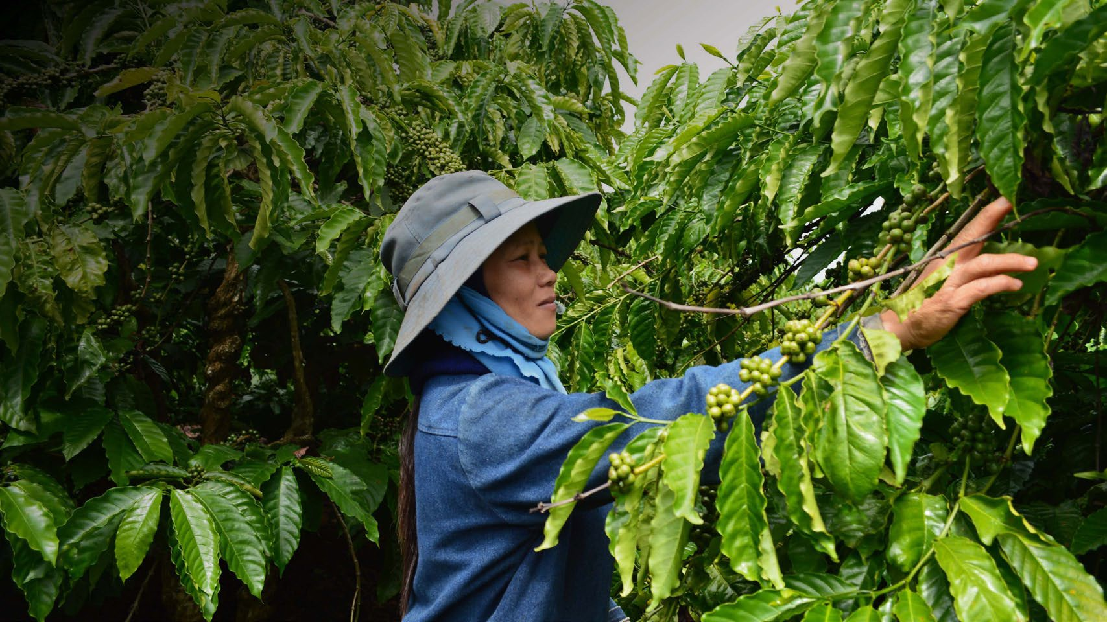

**SECTION SCOPE:** In this section our Sustainable Agriculture work refers to actions by the company as well as our owned and independent bottling partners and our independent suppliers and partners.

1 Leader standard represents supply volume verified to a company-approved, third-party validation, that is aligned with our PSA.

**THE COCA-COLA COMPANY** 2022 BUSINESS & SUSTAINABILITY REPORT 47

CONTENTS

CEO MESSAGE EXECUTIVE SUMMARY

OUR COMPANY

WATER

PORTFOLIO

PACKAGING

CLIMATE

AGRICULTURE

PEOPLE

OPERATIONS

DATA APPENDIX

FRAMEWORKS

##### PRINCIPLES FOR SUSTAINABLE AGRICULTURE IMPROVING WATER MANAGEMENT TO GROW OUR INGREDIENTS

Thriving farmers and farming communities are critically important for our supply chain. Our ability to deliver quality products depends on having a sustainable and secure supply of agricultural ingredients.

Our complex supply chain spans the globe and includes many kinds of suppliers, from

multinational companies to smallholder farmers. [Our Principles for Sustainable Agriculture (PSA)](https://www.coca-colacompany.com/policies-and-practices/principles-for-sustainable-agriculture)

**2022 Progress on Sustainable Sourcing2**

0 20 40 60 80 100

MANGOES 36%

GRAPES 37%

SUGAR CANE 40%

APPLES 55%

Irrigated agriculture remains the largest user of water globally, accounting for 70% of water use worldwide,3 and has significant impacts on watershed health.

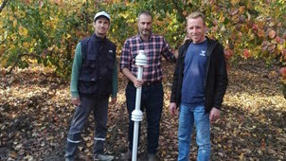Agriculture is also one of the sectors most impacted by water stress and drought.

Water use within our agriculture supply chain accounts for the vast majority of the surface water

and groundwater consumed in the production of

our beverages. Therefore, we are working with

communicate our expectations for environmental, social and economic performance to our agricultural suppliers at the farm level.

The PSA, introduced in 2021 to replace our Sustainable Agriculture Guiding Principles (SAGP), take a long-term perspective and reflect the most recent science, our total beverage portfolio, and our increasingly diverse supply chain. The PSA are designed to encourage continuous improvement in farming practices and lead to more ethical and sustainable sourcing.

The PSA framework for evaluating the compliance and performance of our supply farm base recognizes the on-the-ground realities in sustainable farming practices across a diversity of supply chains, farm structures and risk contexts. Based on the PSA framework, suppliers are designated as either a Leader, Mover or Improver.

We are currently analyzing against the PSA framework the volume of the 12 global priority ingredients we procure. This mapping, which

we aim to complete by the end of 2025, will help determine how we engage with suppliers to drive continuous improvement.

**Our long-term ambition is two-fold:**

**Based on the PSA framework, suppliers are designated as:**

* **LEADER:** Supply volume is verified to company approved standards, with third- party assurance aligned with the PSA.1
* **MOVER:** Supply volume is sourced from farms using other agricultural farming standards, effectively identifying and addressing key sustainability issues and advancing sustainable practices.
* **IMPROVER:** Supply volume is sourced from smallholder/small-scale producers participating in a support program

to continuously improve their priority sustainability practices.

* All of our agricultural-based suppliers will demonstrate continuous improvement and will be categorized by The Coca-Cola Company as either a Leader, Mover or Improver.
* All of our global priority ingredient suppliers and their farm supply base will work toward achieving “Leader” status over time.

CORN 70%

TEA 74%

SUGAR BEETS 80%

PULP AND PAPER 86%

ORANGES 89%

LEMONS 96%

COFFEE 99%

SOYBEANS 100%

In 2022, 64% of our global priority ingredient volumes were sustainably sourced to our Leader standard, in line with our PSA. We currently only report our Leader-level volumes publicly. We do not currently report Mover or Improver volumes publicly.

our suppliers to help promote the long-term sustainability of water resources through the implementation of advanced water management practices at the farm level.

In addition, we are including our priority sourcing regions as part of our water replenishment programs. For example, in 2022, in partnership with Doktar, an agri-tech company, and with funding from The Coca-Cola Foundation, we launched a project in the regions of Bursa and Tekirdağ in Türkiye, which are priority sourcing regions for apples. The project aims to improve irrigation efficiency and agricultural practices on approximately 500 acres of land growing apples, peaches, nectarines and tomatoes, which are major water users. Sensors will be installed to monitor climate and soil moisture conditions and satellite data (Sentinel-2 and PlanetScope) will be used to calculate levels of evapotranspiration. All of this data will be combined to provide personalized irrigation programs for participating farmers and help to avoid excessive watering.

Drip irrigation infrastructure will be built on selected sites, which helps to reduce water use, and artificial reservoirs will be constructed to capture and hold rainwater to be used for irrigation purposes.

It is estimated that drip irrigation will lead to a

This partnership has guided us with a focus on

the right solutions for young farmers in highly water-stressed regions of Türkiye.”

**TANZER BILGEN**



Doktar Co-Founder and CEO

tomato growing as farmers shift from a flood- based irrigation system. We estimate the project will replenish approximately 500 million liters of water per year. The improvements in water-use efficiency are expected to help reduce costs and increase profitability for the farmers.

Over the past year, we have worked closely with our suppliers to map our sourcing regions for our global priority ingredients. While we recognize that traceability is not always perfect, and our supplier base is dynamic, we have begun to understand sourcing regions for our global priority ingredients that are exposed to high or extremely high water stress. We are focusing

on engagement with suppliers in these priority sourcing watersheds.

In 2022 and early 2023, we approached more than 45 suppliers that source ingredients from regions facing high or extremely high water stress, to gather data on their water

1. These approved standards, which can be found on our [website](https://www.coca-colacompany.com/policies-and-practices/principles-for-sustainable-agriculture), currently include Bonsucro for sugar; the Sustainable Agriculture Initiative

Platform—Farm Sustainability Assessment (FSA) for crops including sugar cane, sugar beets and fruit; the Round Table for Responsible Soy for soybean; the Rainforest Alliance for coffee and tea; the Forest Stewardship Council for pulp and paper; and Field to Market for U.S. corn, among other crops.

1. Data is based on supplier reporting according to our PSA governance requirements.

20% increase in water efficiency for apple, peach and nectarine production and a 50% increase for

1. Source: Food and Agriculture Organization of the United Nations: Water for Sustainable Food and Agriculture, a [report](https://www.fao.org/3/i7959e/i7959e.pdf) produced for the G20 Presidency of Germany

management practices. In 2023, we plan to analyze this information to develop a baseline that will feed a supplier engagement strategy and collective action plan.

CONTENTS

CEO MESSAGE EXECUTIVE SUMMARY

OUR COMPANY

WATER

PORTFOLIO

PACKAGING

CLIMATE

AGRICULTURE

PEOPLE

OPERATIONS

DATA APPENDIX

FRAMEWORKS

##### SUPPORTING SMALLHOLDER FARMERS SUPPORTING SUSTAINABLE AGRICULTURAL PRACTICES

Smallholder farmers play an essential role in our supply chain.

Their livelihoods can be particularly vulnerable because they lack the resources and scale of commercial farmers. We partner with a range of nonprofits, communities, industry organizations and other companies to support smallholder farmers in becoming more efficient and productive while improving water and climate footprints, managing soil health, maintaining crop protection, and respecting the human rights of their workforce and labor contractors. The “Improver” category of our PSA segmentation includes smallholders who may never be

able to gain formal certification but who can, with appropriate support, contribute to more sustainable and regenerative agriculture while increasing their own incomes and resilience.

For details on how we address human rights risks in our agricultural supply chain, see the Human Rights section.

For details on how we address deforestation risks in our agricultural supply chain, see our [CDP Forests disclosure](https://www.coca-colacompany.com/content/dam/journey/us/en/policies/pdf/sustainability/2022-cdp-forests-response.pdf).

Regenerative agriculture is often referred to as a system of farming that focuses on positive outcomes that ensure the long-term viability of land to sustain production

by working “with nature” rather than against it.

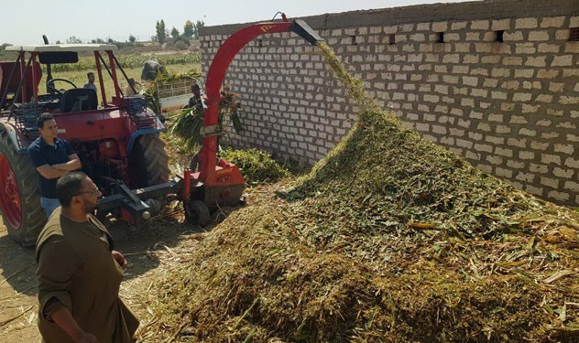

**Applying Compost Drives Positive Outcomes for Egyptian Vegetable Farmers**

Agriculture in Egypt faces many challenges, including water scarcity, water pollution, desertification and land degradation. Through a grant from The Coca-Cola Foundation to Global Water

Challenge (GWC), United Nations Development Programme (UNDP) and the Egypt Network for Sustainable Development (ENID) implemented a project in the Qena governorate in Upper Egypt to demonstrate the value of using a greenhouse cultivation model to produce vegetables (e.g., eggplants and tomatoes), and the recycling and use of crop residues (materials left over after

a crop harvest, e.g., stalks and stems) as compost on local farms. Local farmers and laborers received equipment and training in these improved farming techniques.

The application of compost increased the soil moisture holding capacity on farmland and reduced the need for synthetic fertilizer. It is estimated that composting reduced the use of water for irrigation by as much as 23%. This decreased farming costs and generated an additional revenue stream for farmers. The recycling of crop residues provided income and short-term job opportunities for local residents along with longer-term employment prospects for approximately 500 individuals, including almost 100 women, who received training in the production and

application of compost. The project also reduced the need for burning, which is the traditional way of disposing of agricultural waste.

A number of our completed and ongoing projects promote sustainable agriculture practices (e.g., use of cover crops) and contribute to positive outcomes, including reduced soil erosion and the buildup of organic matter.

We will use key learnings from these projects to inform the design of future projects

and incorporate regenerative agriculture principles and practices.

As a founding member of the [SAI Platform’s](https://saiplatform.org/our-work/news/sai-platform-introduces-regenerative-agriculture-framework-to-align-agricultural-value-chain/) [Regenerative Agriculture Framework](https://saiplatform.org/our-work/news/sai-platform-introduces-regenerative-agriculture-framework-to-align-agricultural-value-chain/), we are supporting the development of an industry solution for measuring outcomes of regenerative agriculture practices at the farm level. We are also actively involved with SAI Platform’s work on the Farm Sustainability Assessment (FSA), a global verification framework and benchmark reference designed to accelerate sustainable agriculture. The latest version, FSA 3.0, includes a self-assessment questionnaire and a continuous improvement module that offers guidance

for developing, implementing and monitoring performance improvement plans.

1 Source: [https://revistacultivar.com.br/noticias/centro-de-](https://revistacultivar.com.br/noticias/centro-de-citricultura-do-iac-obtem-certificacao-internacional-de-sustentabilidade) [citricultura-do-iac-obtem-certificacao-internacional-de-](https://revistacultivar.com.br/noticias/centro-de-citricultura-do-iac-obtem-certificacao-internacional-de-sustentabilidade) [sustentabilidade](https://revistacultivar.com.br/noticias/centro-de-citricultura-do-iac-obtem-certificacao-internacional-de-sustentabilidade)

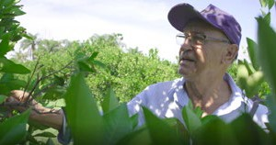

**Strengthening Sustainable Production of Oranges in Brazil**

We are working with partners to support smallholder farmers in Brazil’s citrus sector, which is the largest in the world.

Many smallholder farmers in Brazil have struggled, particularly during the COVID-19 pandemic. As part of an

industry initiative named *Fruto Resiliente*, which began in 2019, we are partnering with Eckes-Granini, Cutrale, one of our citrus juice suppliers, Solidaridad and innocent drinks, with co-funding from The Coca-Cola Foundation, to support nearly 500 smallholder farmers. The project aims to improve sustainable agriculture practices in the production of oranges

by providing training to smallholders, including female farmers, in topics such as water, soil management and labor standards. Technical materials and resources (including booklets, podcasts, and videos) are shared for free online, and smallholders benefit from field visits to a demonstration farm operated by Sylvio Moreira Citrus Research Center (CCSM)

of the Agronomic Institute (IAC). With project support, this state experimental farm reached the FSA/SAI gold level1.

In 2022, the project directly assisted approximately 200 orange farms.

CONTENTS

CEO MESSAGE EXECUTIVE SUMMARY

OUR COMPANY

WATER

PORTFOLIO

PACKAGING

CLIMATE

AGRICULTURE

PEOPLE

OPERATIONS

DATA APPENDIX

FRAMEWORKS

**Improving Water Use in Agriculture**

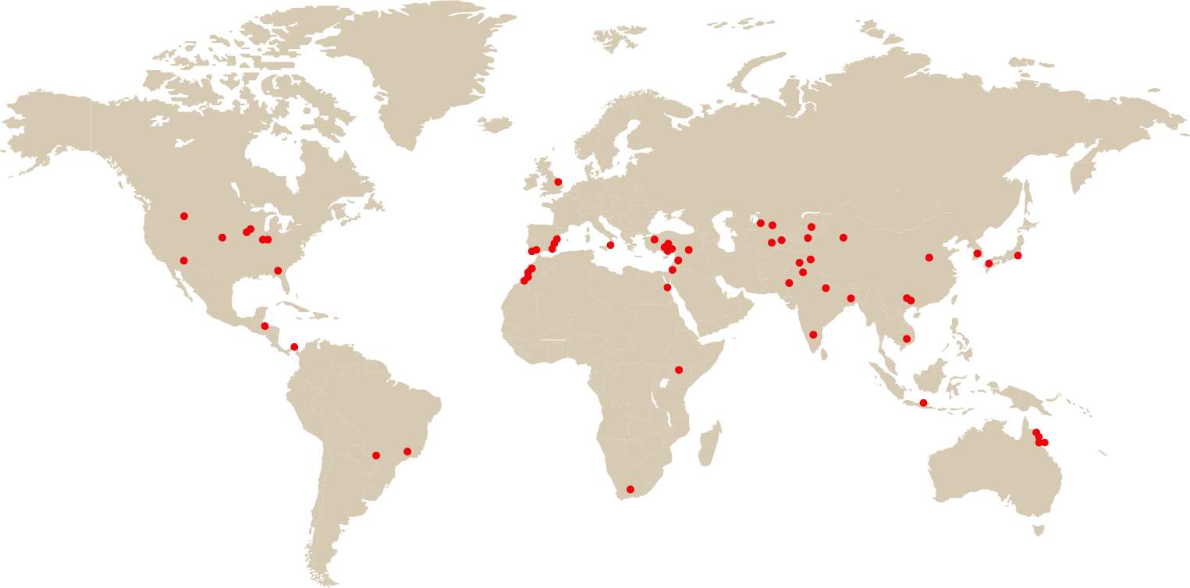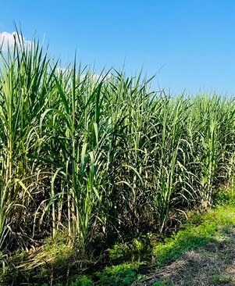

**Demonstrating Sustainable Sugarcane Production**

In partnership with Biofábrica Siglo XXI, an agro-biotechnological company, and Unión Nacional de Cañeros, A.C.–CNPR, one of the most important canegrower organizations in Mexico, we developed a project in 2021–2022 in Huasteca Potosina and the state of Morelos in Mexico to demonstrate the positive outcomes of regenerative agriculture

practices in the production of sugarcane.

Farming practices promoted include the use of biofertilizers—made from microorganisms—and compost. The 24-month project is expected to show that such a production model can increase productivity, reduce the need

for chemical fertilizer, improve soil health and increase carbon sequestration and retention. In 2022, the project was one of the winners of the [Bonsucro Impact Fund](https://bonsucro.com/impact-fund/biofabrica-siglo/).

The Coca-Cola system and The Coca-Cola Foundation have a long history of supporting projects that help improve efficiency of water use in irrigation, promote advanced water management, and drive improvement in sustainable farming practices. Below is a snapshot of some of our projects.

1. NORTH AMERICA
2. LATIN AMERICA
3. EUROPE
4. AFRICA
5. EURASIA & MIDDLE EAST
6. INDIA & SOUTHWEST ASIA

**USA/Arizona, Colorado, Nebraska, Florida, Georgia**: Farm irrigation efficiency (alfalfa, corn, peanuts, cotton, pecans)

**USA/Montana:** Water distribution system improvement (alfalfa, barley, beet)

**USA/Indiana, Michigan, Iowa:** Water retention and quality improvement (corn, soybean)

**USA/California:** Groundwater

**Brazil/Sao Paolo:** Improved agricultural practices (oranges)

**Honduras/San Pedro Sula:** Agroforestry and forest protection (fruits)

**Panama/Colon:** Agroforestry and forest protection (coffee, plantain)

**Paraguay/Canindeyú:** Sustainable agricultural practices (black oats, perennial crops)

**Spain/Sevilla:** Irrigation efficiency (oranges)

**UK/East Anglia:** Water quality improvement (sugar beet)

**Spain/Huelva, Valencia:** Irrigation efficiency (strawberries, oranges)

**Italy/Sicily:** Irrigation efficiency (citrus fruits)

**Egypt/Qena:** Irrigation efficiency (banana)

**Egypt/Qena:** Hydroponics (vegetables, quinoa)

**Kenya/Turkana:** Improved irrigation (many crops)

**Morocco/Tata, Demnate, Nicer, Assa, Ourika Valley:** Irrigation efficiency (date palm, fruits, nuts, medicinal and aromatic plants)

**Türkiye/Konya:** Conservation agriculture (wheat, barley, rye, oats, corn)

**Türkiye/Sanliurfa, Bursa:** Improved irrigation (cotton, apple, pear, peach, nectarine)

**Kyrgyzstan/Naryn:** Improved irrigation (wheat, barley, potatoes)

**Uzbekistan/Navoy:** Water-saving technologies (cotton, wheat)

**Bangladesh:** Irrigation efficiency (rice, mango)

**India/Uttar Pradesh, Karnataka Maharashtra:** Yield improvement and water use efficiency

(sugar cane)

**India/12 states:** Yield improvement and water use efficiency

(many fruits)

recharge basins (fruits, nuts)

**USA/Illinois, Iowa, Minnesota:**

**South Africa/Eastern Cape:** Sustainable agriculture (rosemary, lavandin, livestock)

**Gaza:** Greywater reuse for irrigation (fruits, alfalfa)

1. GREATER CHINA & MONGOLIA

Treatment wetland (corn, soybean)

**Kazakhstan/Kyzylorda, South Kazakhstan:** Water-saving technology (many crops)

**Kazakhstan/Kyzylorda, Karoy, Eskeldi, Jambyl:** Improved irrigation (many crops)

**China/Sichuan, Guangxi, Tarim Basin:** Irrigation efficiency (tea, pear, sugarcane, cotton, wheat)

**China/Jilin:** Irrigation efficiency (corn)

**Pakistan:** Wastewater treatment and reuse for irrigation (sugarcane, wheat, cotton)

**Pakistan/Western Himalaya:** Conservation agriculture and forest conservation (vegetables)

1. JAPAN & SOUTH KOREA

**Japan/Kumamoto, Kanagawa:**

Water retention and recharge (rice)

**1 3 7**

**Pakistan/Gilgit-Baltistan:**

Improved irrigation (many crops)

1. ASEAN & SOUTH PACIFIC

**Pakistan/Lahore:** Floating

**5** wetlands (sugarcane, wheat,

barley)

**8**

**4 6**

**2 9**

**Australia/Queensland:** Water quality improvement (sugarcane)

**Vietnam/Mekong:** Improved ﬂood-based agriculture (rice, lotus, ﬁsh)

**Indonesia/Central Java, East Nusa Tenggara:** Improved irrigation (fruits, grains)

Many projects have multiple locations, and many projects have the same description.

Many of these projects support agricultural ingredients that are not tied directly to our supply chain.

Many of these projects have been funded by The Coca-Cola Foundation.

CONTENTS

CEO MESSAGE EXECUTIVE SUMMARY

OUR COMPANY

WATER

PORTFOLIO

PACKAGING

CLIMATE

AGRICULTURE

PEOPLE

OPERATIONS

DATA APPENDIX

FRAMEWORKS

OVERVIEW

HUMAN RIGHTS

SAFETY & HEALTH

DIVERSITY, EQUITY & INCLUSION GIVING BACK TO OUR COMMUNITIES ECONOMIC EMPOWERMENT

# People &

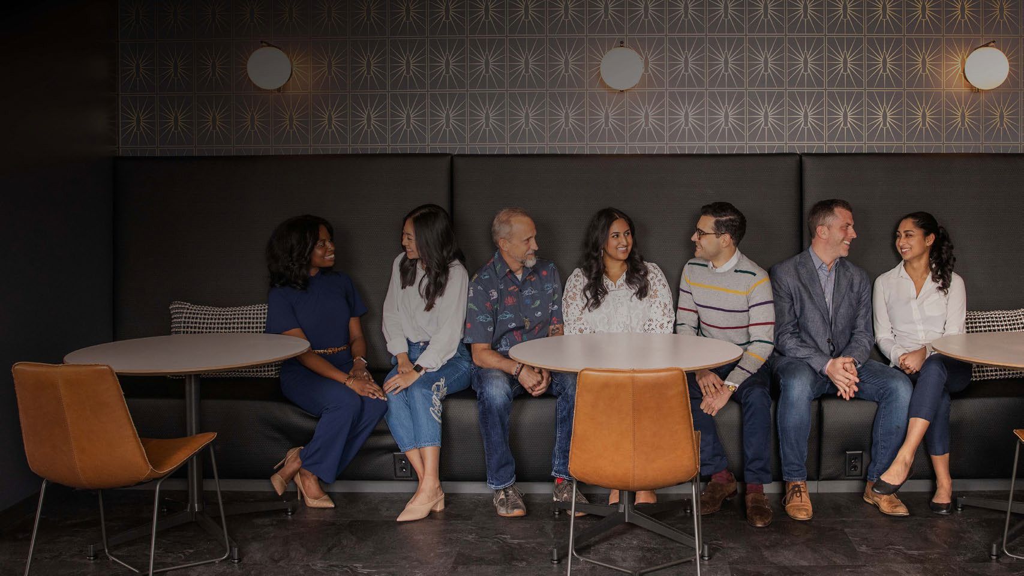

## Communities

OUR PEOPLE POWER OUR PURPOSE

Our focus on people starts with our employees. They steward our beloved beverage brands, fuel our innovation agenda, drive our sustainability priorities and programs, and create a multiplier effect in local

communities through partnerships with governments, nonprofits, industry peers and other stakeholders.

We remain committed to caring for the people across our value chain who contribute to our success—

by respecting human rights across our operations and supply chain, empowering access to equal

~82.5K

EMPLOYED BY THE COCA-COLA COMPANY1

~700K

EMPLOYED BY THE COCA-COLA COMPANY AND OUR APPROXIMATELY 200 BOTTLING PARTNERS

opportunities, supporting more sustainable agriculture practices, and giving back to communities through our philanthropic initiatives. And we use our global scale as a force for progress and for good.

1 As of December 31, 2022.

**THE COCA-COLA COMPANY** 2022 BUSINESS & SUSTAINABILITY REPORT 51

CONTENTS

CEO MESSAGE EXECUTIVE SUMMARY

OUR COMPANY

WATER

PORTFOLIO

PACKAGING

CLIMATE

AGRICULTURE

PEOPLE

OPERATIONS

DATA APPENDIX

FRAMEWORKS

OVERVIEW

HUMAN RIGHTS

SAFETY & HEALTH

DIVERSITY, EQUITY & INCLUSION GIVING BACK TO OUR COMMUNITIES ECONOMIC EMPOWERMENT

Respecting human rights is one of our core values.

HUMAN RIGHTS

The Coca-Cola Company was among the first companies to commit to the United Nations Guiding Principles on Business and Human Rights in 2011, and we have strived to inspire and drive responsible business practices ever since, embedding respect for human rights across our business and value chain.

REAL IMPACT: SETTING THE STAGE FOR THE FUTURE

The foundation of our human rights program is our commitment to continuous improvement. That’s why, in 2022, we engaged a human

**Our New Framework to Transform Tomorrow**

**The future of human rights at The Coca-Cola Company is empowerment.**

Real Impact is our new framework for tomorrow. It is about respecting rights while working to drive progress. We will seek to bring enduring changes to the lives of those we touch around the world. To make our ambition concrete, Real Impact is grounded in three signature initiatives.

OUR COMMITMENT TO HUMAN RIGHTS

As a part of our Real Impact framework, we are renewing and refining our Human Rights Policy. The new Policy will draw on our stakeholder engagement and risk assessment to better align with the UN Guiding Principles on Business and Human Rights and the OECD Guidelines for Multinational Enterprises.

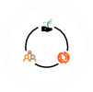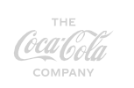

The rights underpinning our commitment

are drawn from the International Bill of Human Rights, the ILO Core Conventions, and other instruments foundational to the dignity of vulnerable stakeholders. While we are committed to respecting all human rights, we have identified 10 of our most salient issues:

rights advisory firm to conduct a holistic and rigorous review of our human rights program to ensure that we remain at the vanguard of responsible business.

The process included extensive engagement with internal and external stakeholders to understand their primary human rights concerns and their expectations of an industry-leading program.

We also conducted a global risk assessment to identify salient human rights risks1 across our global value chain and evaluate the strength of our governance to meet future challenges. The aim of this extensive analysis was to establish a framework to drive meaningful human rights

IMPACT

Work

Empowering workers across our value chain — from upstream supply chain workers and

our 700,000+ system employees to down- stream informal waste collection workers supporting recycling around the world.

**Real**

**IMPACT**

**Toward a Better Tomorrow**

IMPACT

IMPACT

Agriculture

Driving meaningful and enduring change in the lives of everyone touched by the commodities

at the heart of our products — from smallholder farmers and their families to the communities we serve.

1. Safe and healthy workplace
2. Diversity and inclusion
3. Freedom of association
4. Prohibition on slavery and forced labor
5. Prohibition of child labor
6. Work hours, wages, and benefits
7. Land rights
8. Water and environmental stewardship
9. Privacy
10. Consumer wellbeing

Our Human Rights Policy is embedded in expectations of our employees through the company’s Code of Business Conduct, and its precepts are extended through our

progress across our operations and value chain.

The result of our year-long assessment is **Real Impact**, a new vision for the company’s human rights program. Our mission is to take actions that lead to a better tomorrow. We will take the lessons learned from existing programs and partnerships and seek to scale and adapt best practices across more geographies to deliver real impact to more people across our value chain. We will work to drive progress across our company, our industry and beyond through rigorous analysis, creative partnerships and constant innovation to turn commitment into action.

**Innovation**

Developing transformative due diligence and remediation programs through emerging technologies and creative partnerships with stakeholders and experts.

For more information about our vision for the future, click on the icon.

supply chain through the [Supplier Guiding](https://www.coca-colacompany.com/policies-and-practices/supplier-guiding-principles#%3A~%3Atext%3DOur%20responsibility%20does%20not%20end%2Cour%20commitment%20to%20social%20justice) [Principles (SGP)](https://www.coca-colacompany.com/policies-and-practices/supplier-guiding-principles#%3A~%3Atext%3DOur%20responsibility%20does%20not%20end%2Cour%20commitment%20to%20social%20justice) and our [Principles for](https://www.coca-colacompany.com/policies-and-practices/principles-for-sustainable-agriculture) [Sustainable Agriculture (PSA)](https://www.coca-colacompany.com/policies-and-practices/principles-for-sustainable-agriculture).

In line with the UN Guiding Principles, we carry out human rights due diligence across our value chain. We regularly assess our key human rights risks to ensure that we are taking sufficient steps to identify and address them and, if needed, to support remediation of impacts.

1 Salient human rights risks are human rights at risk of the most severe negative impact through a company’s activities and business relationships.

**SECTION SCOPE:** In this section, our Human Rights Policy and Supplier Guiding Principle audits refer to actions by the company as well as our owned and independent bottling partners and our Tier 1 independent suppliers and partners.

CONTENTS

CEO MESSAGE EXECUTIVE SUMMARY

OUR COMPANY

WATER

PORTFOLIO

PACKAGING

CLIMATE

AGRICULTURE

PEOPLE

OPERATIONS

DATA APPENDIX

FRAMEWORKS

OVERVIEW

HUMAN RIGHTS

SAFETY & HEALTH

DIVERSITY, EQUITY & INCLUSION GIVING BACK TO OUR COMMUNITIES ECONOMIC EMPOWERMENT

EMBEDDING HUMAN RIGHTS ACROSS OUR NETWORK

Our industry-leading global audit program is a key component of our long-term, ongoing

commitment to supporting human rights. We use the same rigorous SGP protocols to audit our own operations as we do our bottling partners and Tier 1 suppliers (packaging and ingredients). In 2022, we conducted 2,770 audits and found that 99% of our own operations, 93% of system bottlers and 91% of our Tier 1 suppliers complied with our SGP protocols. These audit results

are reviewed by the Corporate Governance and Sustainability Committee of our Board of Directors on an annual basis.

While this process helps us hold our company and partners accountable, we also focus on building capacity to support respect for human rights across our value chain. This includes providing training and resources such as checklists, toolkits and guidelines. In 2022, we conducted bottler and supplier human rights-focused training

across seven of our operating units, attended by over 1,000 participants.

### 2,770 AUDITS

conducted in 2022

COLLABORATING TO COMBAT FORCED LABOR

Forced labor is a human rights issue that plagues global supply chains and is a risk in virtually every company’s value chain. No company can solve this systemic failure alone—collaboration is the cornerstone of progress. We have joined with other companies as part of The Consumer Goods Forum to support its Human Rights Coalition (HRC). Serving as Co-Chair of the HRC,



SGP AUDITS FOR WASTE MANAGEMENT

Customized audit module to understand and improve the economic conditions and practices for people working across the waste collection sector

END-OF-USE PACKAGING COLLECTION

MANUFACTURING

(Company-owned facilities &

bottling partners)

SUPPLIER GUIDING PRINCIPLES (SGP) AUDITS

Audits against our SGP protocols at facilities—

~2,700 audits annually

TIER 1 SUPPLIERS

(Packaging & Ingredients)

SELF-ASSESSMENT ECOVADIS PLATFORM

Validated self-assessments to monitor environmental and social performance—over 2,000 system suppliers on the platform

INDIRECT SUPPLIERS

(e.g., information technology)

PRINCIPLES FOR SUSTAINABLE AGRICULTURE (PSA) VALIDATION

Third-party validation programs approved under our PSA

FARMS GROWING INGREDIENTS

**Examples of Human Rights Due Diligence Approaches**

**Our Value Chain**

**Human Rights Due Diligence Approaches Across Our Value Chain**

The Coca-Cola Company has helped HRC drive action to:

* Help make Human Rights Due Diligence (HRDD) the norm in our industry by implementing forced labor-focused HRDD systems;
* Implement HRDD systems in certain targeted high-risk supply chains, starting with palm oil in the People Positive Palm Project; and
* Support the development of responsible recruitment markets through capacity building and government advocacy.

We also collaborate with leading responsible businesses as part of the [Leadership Group for](https://www.ihrb.org/employerpays/leadership-group-for-responsible-recruitment) [Responsible Recruitment](https://www.ihrb.org/employerpays/leadership-group-for-responsible-recruitment). This business group works closely with international organizations, trade unions, and key NGOs such as the Institute for Human Rights and Business and Verité to eliminate all worker fees in recruitment, both in law and in practice, by 2026.

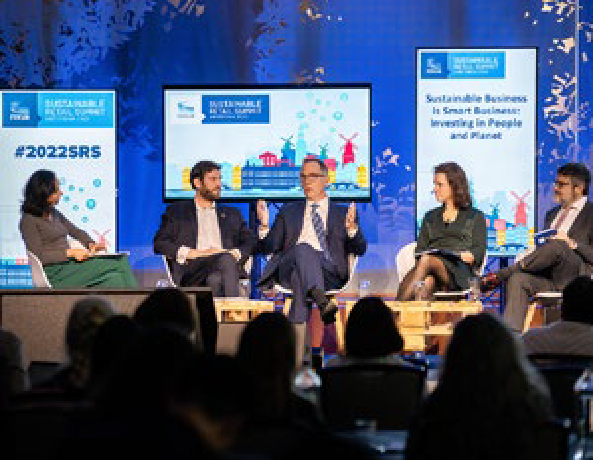

See our [Human Rights 2022](https://www.coca-colacompany.com/content/dam/journey/us/en/policies/pdf/human-workplace-rights/human-rights-principles/human-rights-overview-2022.pdf) [Overview](https://www.coca-colacompany.com/content/dam/journey/us/en/policies/pdf/human-workplace-rights/human-rights-principles/human-rights-overview-2022.pdf) for comprehensive disclosures of our human rights policies, governance, due diligence, as well as access to remedy and grievance mechanisms.

CONTENTS

CEO MESSAGE EXECUTIVE SUMMARY

OUR COMPANY

WATER

PORTFOLIO

PACKAGING

CLIMATE

AGRICULTURE

PEOPLE

OPERATIONS

DATA APPENDIX

FRAMEWORKS

OVERVIEW

HUMAN RIGHTS

SAFETY & HEALTH

DIVERSITY, EQUITY & INCLUSION GIVING BACK TO OUR COMMUNITIES ECONOMIC EMPOWERMENT

LIVING WAGE

As part of our commitment to respect human rights, we are actively engaging on the topic of a [living wage](https://www.globallivingwage.org/about/what-is-a-living-wage/). Over the past year, we have

partnered with Business for Social Responsibility (BSR) to conduct a rigorous living wage gap analysis across our global offices and company- owned manufacturing sites. While further analysis is needed, we are proud to meet or exceed the BSR living wage benchmark in the vast majority of our own operations. Where

gaps exist, we will be developing a roadmap to progress toward a living wage. We have also been working with peers through AIM-Progress, a forum of fast-moving consumer goods companies enabling and promoting responsible sourcing practices, to advance industry understanding

and progress toward living wages in global supply chains. Visit [AIM-Progress](https://www.aim-progress.com/05-12-2022) for additional information about our work.

enactment of significant labor reforms and FIFA’s announcement of a Legacy Fund to establish

a labor excellence hub in partnership with the International Labor Organization.

INFORMAL WASTE COLLECTION WORKERS & HUMAN RIGHTS

The Coca-Cola Company has been a leader in driving ambitious sustainable packaging through our [World Without Waste program](https://www.coca-colacompany.com/reports/world-without-waste-2021). We have collaborated with peers across our industry, government, and civil society to tackle the issue of ocean-bound plastics.

Informal waste workers—or grassroots recyclers— collect and sort up to 60% of plastic waste that

is recycled around the world.1 They are integral to the functioning of an efficient, circular economy for packaging. They are also extremely vulnerable to human rights abuse. The severity and complexity of human rights impacts on grassroots

HUMAN RIGHTS CONFERENCE

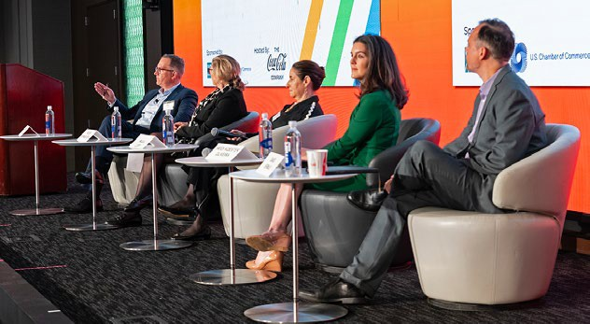In October, The Coca-Cola Company was delighted to host the [14th Annual Engaging Business Forum](https://engagingbusiness.org/) at our headquarters in Atlanta. Sponsored by

the International Organization of Employers, the United States Council for International Business and the U.S. Chamber of Commerce, the Forum has become one of the preeminent business and human rights conferences, where business leaders and experts from civil society, trade

unions and governments hold candid discussions on business experience in respecting human rights across their operations and supply chains. The theme of this latest Forum was The Future of Responsible Business Conduct, with stakeholder panels discussing subjects such as the increasing regulation of human rights, grievance mechanisms and effective remedy collaborations, and the growth of investor benchmarks.

SPORTS & HUMAN RIGHTS

The Coca-Cola Company is a long-time sponsor of global sporting events, including the Olympic Games and the FIFA World Cup. As a sponsor, the company has worked consistently with sport governing bodies, NGOs, governments, and unions to embed respect for human rights into the life cycle of these events. This work includes our leadership in the [Centre for Sport](https://www.sporthumanrights.org/) [& Human Rights](https://www.sporthumanrights.org/), an organization that promotes

human rights in the world of sport. We have seen progress in this space, including the International Olympic Committee issuing its first [Strategic](https://olympics.com/ioc/news/ioc-approves-strategic-framework-on-human-rights#%3A~%3Atext%3DThe%20IOC%20also%20established%20a%2CSex%20Variations%20in%20November%202021) [Framework on Human Rights](https://olympics.com/ioc/news/ioc-approves-strategic-framework-on-human-rights#%3A~%3Atext%3DThe%20IOC%20also%20established%20a%2CSex%20Variations%20in%20November%202021), and FIFA adopting its own [human rights policy](https://www.fifa.com/social-impact/human-rights) and establishing

a dedicated [human rights program](https://sporthumanrights.org/news/centre-and-fifa-partner-to-deliver-human-rights-volunteers-for-fifa-world-cup-qatar-2022/). Leading up to the 2022 FIFA World Cup in Qatar, the company and other sponsors engaged with FIFA, the Government of Qatar, and NGOs to help improve labor rights in the country, with important developments including Qatar’s

1 Source: [https://www.pewtrusts.org/en/research-and-analysis/](https://www.pewtrusts.org/en/research-and-analysis/articles/2020/07/23/breaking-the-plastic-wave-top-findings) [articles/2020/07/23/breaking-the-plastic-wave-top-findings](https://www.pewtrusts.org/en/research-and-analysis/articles/2020/07/23/breaking-the-plastic-wave-top-findings)

recyclers makes multi-stakeholder collaboration

essential. In 2022, we partnered with other leading consumer goods companies and NGOs to launch the [Fair Circularity Principles](https://faircircularity.org/fair-circularity-principles/), which apply the expectations and responsibilities in the UN Guiding Principles to grassroots recycling.

**Improving Sustainable and Responsible Labor Practices in Our Sugar Supply Chain in Pakistan**

Our company has been working with Bonsucro, a leading international NGO, as well as other local and international experts to address human rights risks in the sugarcane supply chain in Pakistan. Our partners include GoodWeave International, a non-profit with expertise in stopping child, forced and bonded labor in global supply chains, and AgNovate, a respected local organization and licensed Bonsucro trainer. This two-and-a-half-year project, which runs to the end of 2024, aims to improve the adoption of sustainable and responsible labor practices in sugar production and develop remediation plans to address child labor and forced labor prevalent in the industry. In November 2022, AgNovate delivered the first training session of the project to 31 participants, including managers of sugar mills. The training was based on GoodWeave’s best practices on ending child and worker exploitation. Gap assessments were then conducted of the six partner sugar mills and selected smallholder farmers on their compliance with the requirements of

the Bonsucro Production Standard, which includes ensuring workers do not suffer from forced labor and there is no child labor. The project will support the mills to develop their own action plans toward continuous improvement and compliance with version 5.1 of the Bonsucro Production Standard.

**Using Technology-Led Solutions for Deeper Supply Chain Due Diligence**

The Coca-Cola Company has developed a digital platform that identifies recruitment-related human rights risks within supply chains together with our partners Diginex, an impact technology company, and Reckitt, another consumer goods company. The platform aims to improve respect for human rights in the hiring process through due diligence and ethical recruitment.

The platform evolved to include a multilingual worker- voice tool, diginexAPPRISE, which allows companies to conduct digital worker interviews in supply chains at scale, increasing transparency and preventing unethical recruitment practices. The use of smartphone technology allows a greater number of workers to be reached and

helps ensure that foreign migrant workers with low literacy levels are included in the interview process.

For more information, see the Packaging section.



We were pleased to convene the Fair Circularity Initiative, which was launched by

The Coca-Cola Company and three of their peers in late 2022. When companies adopt and advance the new Fair Circularity Principles in their value chains, engaging meaningfully with waste pickers, it will lead to human rights being respected, including better incomes and working conditions, and inclusion in decision-making processes

that affect their lives.”

**NIGEL HARRIS**

Chief Executive, Tearfund

CONTENTS

CEO MESSAGE EXECUTIVE SUMMARY

OUR COMPANY

WATER

PORTFOLIO

PACKAGING

CLIMATE

AGRICULTURE

PEOPLE

OPERATIONS

DATA APPENDIX

FRAMEWORKS

OVERVIEW

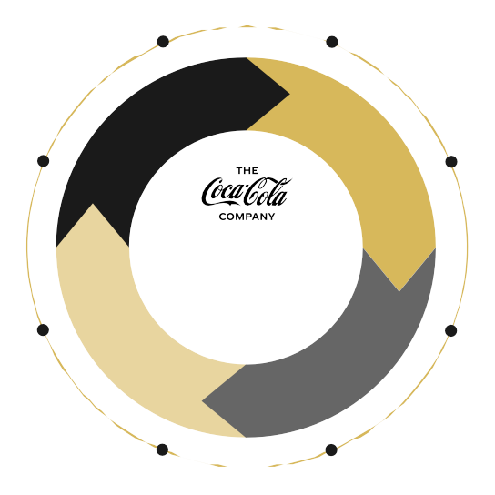

**Human and Organizational Performance**

We have strengthened our health and safety strategy with multi-year purposeful actions across our end-to-end supply chain. We have committed to integrating the Human and Organizational Performance (HOP) philosophy into our operational learning processes; building an environment of active employee engagement; accelerating learning and improvement processes; building better controls based on work in practice; and supporting the right culture.

Several of our bottling partners across regions have deployed HOP operational learning into their organizations.

To date, over 100 operations across our system have begun integrating HOP principles with significant improvements, and this journey will continue in 2023 and onwards.

HUMAN RIGHTS

SAFETY & HEALTH

DIVERSITY, EQUITY & INCLUSION GIVING BACK TO OUR COMMUNITIES ECONOMIC EMPOWERMENT

We make and deliver our products and provide services with a goal of zero work-related injuries for our employees,

SAFETY & HEALTH

**Zero Is Possible—Our Safety Framework**

contractors and communities. Providing our employees with a safe workplace environment is

Continuous improvement

Set safety expectations

among the company’s greatest responsibilities and is part of our commitment to employees, customers and consumers.

Our employees are our most valuable partners, sources of best

Review and reﬁne results

Audit, set actions

ACT PLAN

4-TIER ACTION PLAN

Support strong safety culture

Deﬁne

OVERARCHING GOALS

Keep safety at the center

Reinforce through

practices and the implementors of

our strategy to embed safe habits and strengthen our safety culture.

and report

CHECK

DO metrics

leadership

Execute

The Coca-Cola Company’s global Lost-Time Incident Rate (LTIR) was

**0.25** in 2022.1

plan

Engage stakeholders

Our “Zero Is Possible” vision aims to identify risks and control preventable serious incidents in our system facilities, fleet and distribution operations. We are focused on creating

safe and healthy workplaces and supporting a culture of continuous learning and improvement. Management commitment and strong employee engagement are foundational to establishing this culture.

We have implemented comprehensive, preventative programs to further identify and mitigate the potential for serious incidents to occur in our facilities. We are integrating operational learning while also demonstrating progress

and embedding safety as a key organizational value.

**In 2022, we focused on three key pillars of our safety program:**

**SECTION SCOPE:** In this section our safety and health strategy refers to actions by the company as well as our owned and independent bottling partners. The data reported for LTIR only includes company- owned facilities.

* **CULTURE:** We revamped our Safety Training Academy in 2022, providing enhanced resources, tools and training which include operational safety and road safety programs. As part of our approach to safety culture across the

Coca-Cola system, we incorporated a new Human and

Organizational Performance (HOP) philosophy that focuses on critical and interconnected aspects including people, culture, equipment, work systems and processes.

* **SERIOUS INCIDENT PREVENTION:** We expanded our self- assessments and governance audits beyond production operations to include fleet and distribution operations (route-to-market). We continue our focus on identifying, implementing and strengthening controls to prevent serious injuries. We also continue to build unique solutions (i.e., toolkits, guidance) to enhance the capacity and capability of our system in identifying and mitigating risks.
* **TECHNOLOGY AND INNOVATION:** We continued investing in new technologies and shared learnings across the

organization. We completed more than 20 technology pilots globally, which are now being implemented by many of

our bottling partners. These include AI technology camera systems to detect unsafe conditions and driver simulators to train and prepare drivers, among others.



Safe, high-quality drinks people can trust, and a safe, secure workplace are an essential part of who we are at The Coca-Cola Company. Although we have seen significant improvements in our safety performance, we know there is more

to be done. By building capabilities across our system, identifying where we need to improve, leveraging industry best practices and engaging with our employees, we are working toward our vision of “Zero Is Possible” as it relates to serious injuries in the workplace.”

**ZOLTAN SYPOSS**

Chief Quality, Safety & Environmental Officer

1 This is company-owned data. For exclusions,

please view the criteria statement in the Independent Accountants’ Review Report.

CONTENTS

CEO MESSAGE EXECUTIVE SUMMARY

OUR COMPANY

WATER

PORTFOLIO

PACKAGING

CLIMATE

AGRICULTURE

PEOPLE

OPERATIONS

DATA APPENDIX

FRAMEWORKS

OVERVIEW

HUMAN RIGHTS

SAFETY & HEALTH

DIVERSITY, EQUITY & INCLUSION GIVING BACK TO OUR COMMUNITIES ECONOMIC EMPOWERMENT

As a purpose-driven company, we help create a better shared future for everyone our brands and business system touches by working to provide access to equal opportunity and fostering

DIVERSITY, EQUITY & INCLUSION

belonging both in our workplaces and the communities we serve.

**We approach our DEI strategy through the lens of three core ambitions:**

**ASPIRE TO**

###### CREATE

a workforce that mirrors the markets we serve.

**In 2022, we continued to embed our DEI priorities across our business.**

EQUAL PAY FOR EQUAL WORK



Pay equity is defined as compensating employees fairly and equitably, without regard to gender (globally), or race and ethnicity (in the United States). On an annual basis, we conduct audits to ensure our employees are paid equitably. Additionally, we are diligent and stay aware of the changing regulatory

Together with global, national and local

organizations—plus our network of bottling partners—we remain focused on investing to improve people’s lives, from our employees to those our business system touches to the

communities we call home. While we continued to make meaningful progress in 2022, our work is an ongoing journey in an ever-changing landscape. That’s why we continue to prioritize listening and learning; executing our strategy

consistently; and holding ourselves accountable for continuous progress.



Diversity, equity and inclusion is in our DNA.

It’s woven into all aspects of how we do business and function as a team—from talent acquisition, to supply chain, to the processes that shape

our strategy and operations. It fosters greater

creativity, innovation and connection to the

###### ENABLE

an inclusive culture where our employees thrive.

###### ADVANCE

equity within our business, communities, and the marketplace.

**Inclusion Networks**

landscape. In 2022, we published our first-ever [pay gap report](https://www.coca-cola.ie/content/dam/one/ie/en/pdf-files/IrelandPayGap_2022_Final.pdf)

[for Coca-Cola Ireland](https://www.coca-cola.ie/content/dam/one/ie/en/pdf-files/IrelandPayGap_2022_Final.pdf).

We are working to embed our philosophy into our business practices and processes, and to extend our analyses beyond base pay to broader aspects of our total rewards policies. [Read more](https://www.coca-colacompany.com/social-impact/diversity-and-inclusion/pay-equity) [about our pay equity philosophy.](https://www.coca-colacompany.com/social-impact/diversity-and-inclusion/pay-equity)

BUILDING AN INCLUSIVE CULTURE

In 2022, we added specific inclusion-related questions to our annual Culture & Engagement Survey. Responses serve as a baseline for an Inclusion Index reflecting employee sentiment about belonging, fairness, respect and psychological safety, as well as conditions and behaviors that create an inclusive environment at our company.

Our employee-led Inclusion Networks serve as valuable resources to both employees and our company by providing opportunities to connect with colleagues who share similar interests and backgrounds. They also create diverse sounding boards for business strategies and initiatives, capturing input on potential actions through the lens of diversity, equity and inclusion.

* + **JAPAN:** We earned a “Rainbow”, the highest rating in the 2022 PRIDE Index, for our LGBTQI+-friendly workplace initiatives.
  + **SOUTH AFRICA:** We participated in Johannesburg Pride by partnering with Pride of Africa, an umbrella brand born out of need for LGBTQI+ representation in Africa.
  + **ITALY:** As a continuation of a longstanding partnership, we were the primary sponsor of the XXXVII edition of the Special Olympics National Summer Games in Turin, where athletes with intellectual disabilities competed in 20 sports. More than 90 Coca-Cola system volunteers supported the event, which also included a communications campaign celebrating participating athletes.
  + As part of our efforts to create a diverse, equitable and inclusive workplace, we are partnering with t[he Valuable 500’s](https://www.thevaluable500.com/update/generation-valuable)

[Generation Valuable initiative](https://www.thevaluable500.com/update/generation-valuable). This program,

wider community. This journey requires ongoing determination, and we are committed to

UNITED STATES

EUROPE

EURASIA &

INDIA &

JAPAN & SOUTH KOREA

These regionally structured, globally connected employee groups help build affinity and allyship that enhance our ability to recruit,

which kicks off in 2023, is designed

to accelerate opportunities for people

developing lasting change through sustainable and measurable actions.”

**TAMEKA HARPER**

Global Chief Diversity, Equity & Inclusion Officer

LATIN AMERICA

MIDDLE EAST

AFRICA

SOUTHWEST ASIA

ASEAN & SOUTH PACIFIC

retain, engage and develop diverse talent. Inclusion Networks enable associates to participate in professional and personal growth opportunities through training and education, community projects, networking events, cultural heritage month celebrations and management opportunities.

with disabilities to become the talented voices of tomorrow’s C-Suite.

**SECTION SCOPE:** In this section, our DEI actions refer to actions by the company, but exclude our independent bottling partners and independent suppliers and partners.

CONTENTS

CEO MESSAGE EXECUTIVE SUMMARY

OUR COMPANY

WATER

PORTFOLIO

PACKAGING

CLIMATE

AGRICULTURE

PEOPLE

OPERATIONS

DATA APPENDIX

FRAMEWORKS

OVERVIEW

HUMAN RIGHTS

SAFETY & HEALTH

DIVERSITY, EQUITY & INCLUSION GIVING BACK TO OUR COMMUNITIES ECONOMIC EMPOWERMENT

##### MIRRORING THE MARKETS WE SERVE

In 2022, our global female representation **increased 1.1%** overall, with increases across all levels. In the United States, we saw an increase in Asian and Black/African American representation.

By 2030, we aspire to be 50% led by women globally and, in the United States, to align race and ethnicity representation to U.S. census data. While these metrics are important indicators of our progress, we are taking an iterative and holistic approach focused on continuous learning. Here’s a 2022 update on our progress against these aspirations:

**2022 Gender Representation by Level (global)1**

|  |  |  |  |  |
| --- | --- | --- | --- | --- |
|  | **SENIOR LEADERSHIP** | **MIDDLE MANAGEMENT** | **PROFESSIONALS** | **TOTAL** |
| Female | 39.0% | 51.3% | 36.0% | **44.0%** |
| Male | 61.0% | 48.7% | 64.0% | **56.0%** |

**2022 Race/Ethnicity Representation by Level (U.S. only)1**

|  |  |  |  |  |
| --- | --- | --- | --- | --- |
|  | **SENIOR LEADERSHIP** | **MIDDLE MANAGEMENT** | **PROFESSIONALS** | **TOTAL** |
| American Indian/Alaskan Native | 0.0% | 0.3% | 0.4% | **0.3%** |
| Asian | 10.0% | 10.4% | 5.4% | **8.1%** |
| Black/African American | 8.6% | 16.1% | 30.3% | **22.0%** |
| Hispanic/Latino | 9.9% | 8.7% | 21.2% | **14.6%** |
| Native Hawaiian/ Other Pacific Islander | 0.1% | 0.1% | 0.5% | **0.3%** |
| Not specified | 9.1% | 5.2% | 2.4% | **4.3%** |
| Two or more races | 0.9% | 2.2% | 3.0% | **2.5%** |
| White | 61.4% | 57.1% | 36.7% | **48.1%** |

1 Data as of December 31, 2022, for salaried and hourly employees. Race/ethnicity data is for U.S. workforce only. This data excludes

Bottling Investments Group (BIG), Global Ventures, fairlife and BODYARMOR. For exclusions, please view the criteria statement in the Independent Accountants’ Review Report.

Note: The percentages in each column in these charts may not sum to 100% due to rounding.

CHALLENGING OURSELVES TO EMPOWER COMMUNITIES

The Coca-Cola North America operating unit recently launched Asian Pacific, Black and Hispanic Equity Accountability Councils (EACs) to guide community engagement and investment, with an emphasis on economic equity. The



EACs are designed to drive quality of life improvements in under-resourced communities through economic mobility, financial stability and the well-being of individuals and households.

The councils will identify initiatives that reflect diversity in communities which have direct links to our DEI strategy.

DRIVING ACCOUNTABILITY

To continue progress toward achieving our sustainability goals, the Talent and Compensation Committee approved DEI links to executive compensation as part of the annual incentive

for our executive officers, which will help drive our 2030 DEI aspirations. The links to executive compensation are based on achieving predefined qualitative and quantitative DEI components.

TRANSPARENCY AND REPORTING

We believe in full transparency and disclosure. We share diversity metrics quarterly with senior leaders, and we externally publish

our representation data annually by race/ ethnicity (U.S.) and gender (globally) for our overall workforce and leadership. We publish data submitted to the U.S. Equal Employment Opportunity Commission (EEO-1 survey results) on our [website](https://www.coca-colacompany.com/policies-and-practices/equal-employment-opportunity-employer-reports).

CONTENTS

CEO MESSAGE EXECUTIVE SUMMARY

OUR COMPANY

WATER

PORTFOLIO

PACKAGING

CLIMATE

AGRICULTURE

PEOPLE

OPERATIONS

DATA APPENDIX

FRAMEWORKS

OVERVIEW

HUMAN RIGHTS

SAFETY & HEALTH

DIVERSITY, EQUITY & INCLUSION GIVING BACK TO OUR COMMUNITIES ECONOMIC EMPOWERMENT

##### RECRUITING AND DEVELOPING DIVERSE TALENT

In 2022, we continued to enhance our diversity hiring efforts through equitable recruitment, interviewing and onboarding processes.

We expanded our partnerships with Historically Black Colleges and Universities as well as leadership development organizations, including the National Black MBA Association, Executive Leadership Council and Thurgood Marshall National Black Talent Bank.

##### SUPPLIER DIVERSITY

Coca-Cola is working to maximize procurement opportunities



**Crowdfunding for Minority-Owned Small Business**

We are a founding sponsor of Rise Up Crowdfunding, an equity crowdfunding portal focused on women and minority-owned businesses. The platform connects diverse startups with investors to expand access to capital while also providing business management resources and coaching.

We share Rise Up’s mission to support businesses and underrepresented groups within the communities we serve. This much-needed resource can, in many cases, help small businesses scale up or expand their operations, open new locations and grow their brands.”

**FERNANDO HERNANDEZ**

Senior Director, Supplier Diversity

and proactively engaging and building partnerships with diverse- owned suppliers spanning a

range of industries.

We are focused on increasing the overall diversity of our suppliers and are working to spend at least $1 billion annually with diverse suppliers. We aspire to join the Billion Dollar Roundtable—the gold standard of supplier diversity, currently with only 27 member companies.

In 2022, our supplier diversity team connected independent Coca-Cola bottlers in the United States and Canada with business partners

to boost our overall impact via sponsored matchmaking events at the National Minority Supplier Development Council and Women’s Business Enterprise National Council conferences. The team is exploring ways to expand our supplier diversity program internationally.

### $900M+

spent in 2022 with diverse Tier 1 suppliers in the United States, an increase over prior years and progress toward our

$1 billion annual goal.

### $200M

of incremental spend with Black-owned enterprises in the United States, contributing to the company’s overall goal of

$500 million.

CONTENTS

CEO MESSAGE EXECUTIVE SUMMARY

OUR COMPANY

WATER

PORTFOLIO

PACKAGING

CLIMATE

AGRICULTURE

PEOPLE

OPERATIONS

DATA APPENDIX

FRAMEWORKS

OVERVIEW

HUMAN RIGHTS

SAFETY & HEALTH

DIVERSITY, EQUITY & INCLUSION GIVING BACK TO OUR COMMUNITIES ECONOMIC EMPOWERMENT

##### LEVERAGING THE POWER OF OUR BRANDS AND PARTNERSHIPS

**Coca-Cola Backlot Movie Experience**

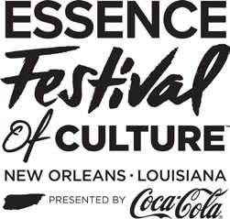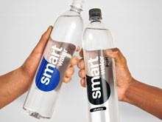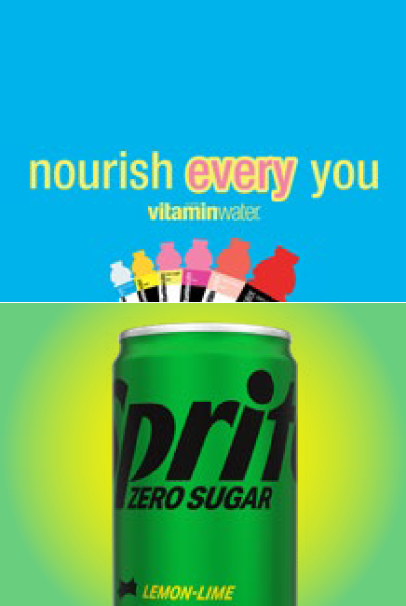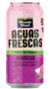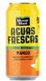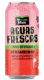

For the sixth consecutive year, Coca-Cola sponsored Univision’s “Premios Juventud” awards show in 2022, expanding the Coca-Cola Backlot Movie Experience at La Marqueta in Puerto Rico. Attendees enjoyed Coca-Cola and Latin food pairings, cooking demos, live music performances and more.

**Extending Our Partnership With ESSENCE**

Coca-Cola returned for its 26th year as Presenting Sponsor of the 2022 ESSENCE Festival of Culture in New Orleans as part of a five-year

partnership extension with ESSENCE Communications, a leading media, technology and commerce company dedicated to serving Black women and communities. In 2021, we committed to doubling our spend with minority-owned media companies—to 8% of our total annual media budget—by 2024. By working with legacy partners like ESSENCE, along with new minority-owned and minority-led media companies, we are on track to meet this commitment.

**Multicultural Marketing**

In 2022, our brands further expanded into diverse and inclusive marketing. In the United States, smartwater and vitaminwater launched brand ambassador partnerships with Zendaya and Lil Nas X, respectively, and Minute Maid Aguas Frescas (a Latin-inspired fruit drink innovation) partnered with Mexican NASCAR driver Daniel Suárez for a [Hispanic](https://www.coca-colacompany.com/news/aguas-frescas-daniel-suarez-celebrate-hispanic-heritage-month) [Heritage Month activation](https://www.coca-colacompany.com/news/aguas-frescas-daniel-suarez-celebrate-hispanic-heritage-month). Sprite Zero Sugar teamed up with Marvel Studios’ *Black Panther: Wakanda Forever* on the [“Infinite Potential.](https://www.coca-colacompany.com/news/sprite-zero-sugar-encourages-young-creators)

[Zero Limits” campaign](https://www.coca-colacompany.com/news/sprite-zero-sugar-encourages-young-creators), which highlighted underrepresented Black and Latino creators from STEAM (Science, Technology, Engineering, Arts and Mathematics) communities. Globally, our Coca-Cola campaign for the FIFA World Cup 2022™ was anchored by a [multicultural music anthem](https://www.coca-colacompany.com/news/coca-cola-fifa-world-cup-2022-music-anthem) recorded by female artists from the Middle East and Latin America.

CONTENTS

CEO MESSAGE EXECUTIVE SUMMARY

OUR COMPANY

WATER

PORTFOLIO

PACKAGING

CLIMATE

AGRICULTURE

PEOPLE

OPERATIONS

DATA APPENDIX

FRAMEWORKS

OVERVIEW

HUMAN RIGHTS

SAFETY & HEALTH

DIVERSITY, EQUITY & INCLUSION GIVING BACK TO OUR COMMUNITIES ECONOMIC EMPOWERMENT

In 2022, The Coca-Cola Foundation, the philanthropic arm of The Coca-Cola Company, contributed $94.8 million to 301 organizations around the world to help create a better shared future for the communities

GIVING BACK TO OUR COMMUNITIES

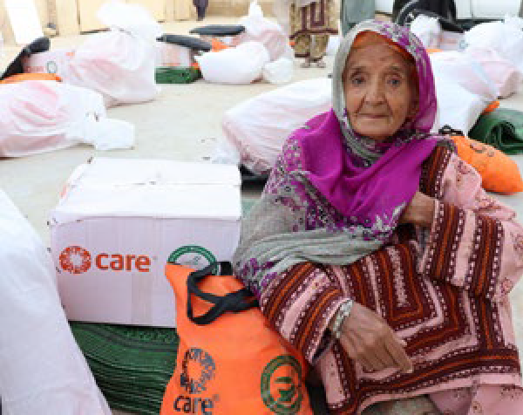

**Disaster Relief**

We have a long history of supporting local communities in times of crisis— a commitment we continued in 2022. In addition to our support for Ukraine,

the Foundation provided approximately

$4 million in funding for natural disaster and humanitarian relief efforts in 11 countries around the world, complementing financial and in-kind

donations from The Coca-Cola Company and bottling partners.

In addition to supporting local communities, the Coca-Cola system’s top priority following a natural disaster is to ensure the safety of all associates and their families. The Coca-Cola Employee Disaster Relief Fund (EDRF) provided nearly $5 million (including humanitarian relief for Ukraine) through more than 4,000 grants to company and bottling partner employees impacted by natural disasters and humanitarian crises in 2022. The EDRF consists of contributions from The Coca-Cola Company, The

Coca-Cola Foundation, bottling partners and system associates.

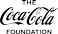

1 This percentage was calculated based on the company’s prior year operating income (excluding the Bottling Investments Group operating segment).

$1.5B+

DONATED

by The Coca-Cola Foundation since its inception in 1984

1.4%

of operating income invested back into local communities from The Coca-Cola Company and

The Coca-Cola Foundation in 2022—above our annual goal of 1%1

Recycling

**13%**

$14.1M

$13.0M

Matching Gifts

**7%**

Education &

Youth Development

**14%**

$12.0M

Women’s Empowerment

**7%**

Disaster Relief & Humanitarian Aid

**15%**

$94.8M

2022 Contributions

$10.1M

$31.8M

Community Well-Being

**11%**

Water & Environment

**33%**

$7.0M

$6.8M

**The Coca-Cola Foundation: 2022 Contributions**

GIVING BACK TO OUR COMMUNITIES

our business serves. Grants funded by the Foundation complement the contributions of our company operating units and bottling partners.

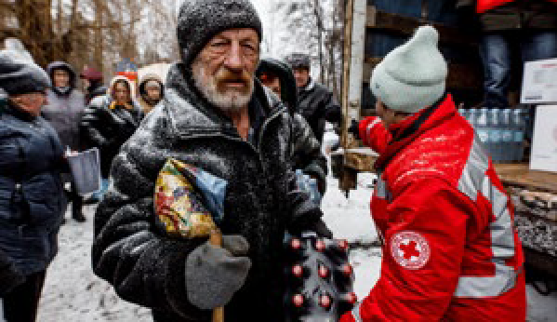

**Standing with Ukraine**

The Coca-Cola Foundation awarded more than $3 million in grants to support the International Federation of Red Cross and Red Crescent Societies (IFRC) and other humanitarian organizations providing on- the-ground emergency relief to millions of people impacted by the war in Ukraine.

These grants will also provide support to displaced people and refugees in surrounding countries. The Coca-Cola Foundation, along with The Coca-Cola

Company and its global bottling partners, committed to contributions totaling more than $20 million to support employees and humanitarian relief efforts.

**SECTION SCOPE:** The philanthropic giving refers to contributions from The Coca-Cola Foundation.

CONTENTS

CEO MESSAGE EXECUTIVE SUMMARY

OUR COMPANY

WATER

PORTFOLIO

PACKAGING

CLIMATE

AGRICULTURE

PEOPLE

OPERATIONS

DATA APPENDIX

FRAMEWORKS

OVERVIEW

HUMAN RIGHTS

SAFETY & HEALTH

DIVERSITY, EQUITY & INCLUSION GIVING BACK TO OUR COMMUNITIES ECONOMIC EMPOWERMENT

**A Refreshed Giving Approach**

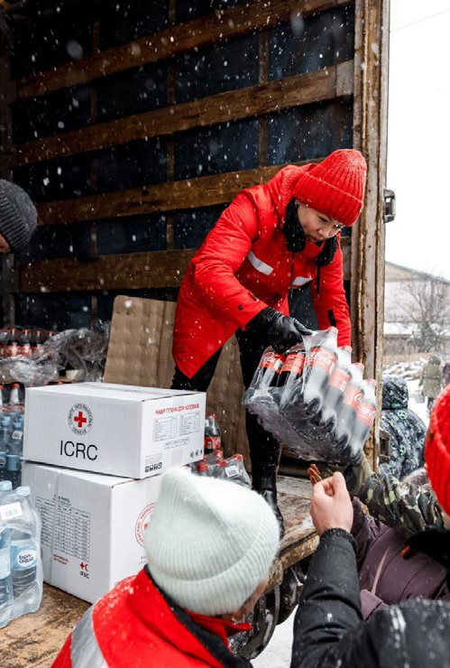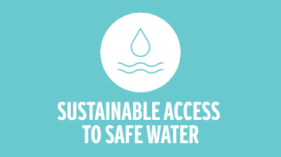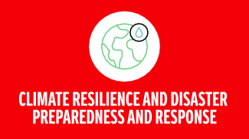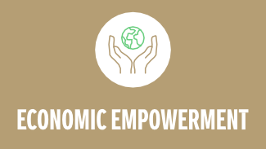

**Hometown Support**

Atlanta—where the first Coca-Cola was served in 1886—is a thriving city we are proud to call home. In 2022, the Foundation continued to invest in community organizations working to create a better shared future for our hometown:

* **$3 million** to fund scholarship programs at 10 Atlanta institutions of higher learning
* **$1 million** to the Atlanta Police Foundation to expand youth development services for at-risk youth
* **$500,000** to the Atlanta Women’s Foundation to educate, train and prepare 1,000 women for employment or to become entrepreneurs
* **$500,000** to the National Center for Civil and Human Rights to expand its civil rights education curriculum
* **$300,000** to the Latin American Association to expand

entrepreneurial education throughout the state of Georgia

The Coca-Cola Foundation’s mission is to make a difference in communities where our company operates and where our employees live and work. The Foundation supports transformative ideas and institutions that address pressing and complex global challenges. Our goal is to leave a measurable and lasting impact in local communities through a focus on the environment and society. As of 2022, our giving is focused on impacting these areas:

ENVIRONMENTAL

The Coca-Cola Foundation remains committed to making a difference by addressing the complex

global challenges that impact our communities around the world.”

**SAADIA MADSBJERG**

President of The Coca-Cola Foundation and Vice President of Global Community Affairs for The Coca-Cola Company

SOCIAL

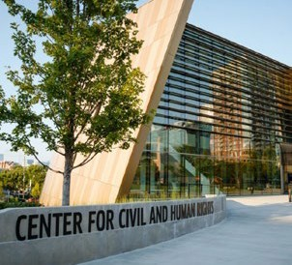**The following three grants reflect the Foundation’s new giving strategy:**

**$1 million to fund the CARE Humanitarian Surge Fund**, a global reserve fund to support life-saving relief efforts immediately following natural disasters, plus preparedness efforts such as prepositioning supplies, training staff and partnering with local and national organizations to develop crisis plans.

**$1 million to the American Red Cross** to support the Global Disaster Preparedness Center (GDPC) in seven countries facing significant climate risks and social vulnerability: Bangladesh, El Salvador, Guatemala,

Honduras, Indonesia, Nepal and the Philippines.

**$1.25 million to Imagine H20** to launch the Sustainable Access Solution Fund, a fund that will support water and climate-focused innovation projects in both emerging markets and the United States with a focus on ensuring sustainable access to safe drinking water.

CONTENTS

CEO MESSAGE EXECUTIVE SUMMARY

OUR COMPANY

WATER

PORTFOLIO

PACKAGING

CLIMATE

AGRICULTURE

PEOPLE

OPERATIONS

DATA APPENDIX

FRAMEWORKS

OVERVIEW

HUMAN RIGHTS

SAFETY & HEALTH

DIVERSITY, EQUITY & INCLUSION GIVING BACK TO OUR COMMUNITIES ECONOMIC EMPOWERMENT

The Coca-Cola Company has a long history of enhancing the livelihoods of the people in the communities we proudly serve.

ECONOMIC EMPOWERMENT

We continue to help enable the economic empowerment of a diverse network of customers, suppliers and communities across our value chain. This includes smallholder farmers that supply agricultural ingredients used in our beverages and juice processors and sugar millers—to warehousing, construction engineering, transportation and facilities management partners, IT, marketing and other service providers.

We embrace the [Organization for Economic](https://www.oecd.org/social/gender-development/womenseconomicempowerment.htm)

[Co-operation and Development (OECD) definition](https://www.oecd.org/social/gender-development/womenseconomicempowerment.htm) [of economic empowerment](https://www.oecd.org/social/gender-development/womenseconomicempowerment.htm), which we see as fundamental to strengthening human rights and enabling all people, particularly vulnerable and underrepresented groups, to have control over their lives and positively influence society. Our economic empowerment efforts deliver tangible results in markets around the world, where we harness partnerships and deliver programs tailored to local needs and nuances. This work builds on the momentum created by our

decade-long 5by20® program, created in 2010 to enable the economic empowerment of

5 million women entrepreneurs. Together with our public and private sector partners, including our bottling partners and The Coca-Cola Foundation, we exceeded our target, enabling the economic empowerment of more than 6 million women.

**SECTION SCOPE:** In this section our economic empowerment work refers to actions by the company, The Coca-Cola Foundation, our owned and independent bottling partners and our independent suppliers and partners.

We have seen evidence that helping female entrepreneurs overcome social and economic barriers to success creates a ripple effect in local communities with both societal and commercial impacts. According to a 2015 McKinsey Global Institute report, if women were to play an identical role in the global labor market to that of men, it is estimated that $28 trillion could be added to the global gross domestic product (GDP).

While women’s entrepreneurship continues to play an active role in business sustainability, we are broadening economic empowerment

efforts to help create shared value—and a better shared future—through training, networking

and mentoring programs aimed at working with underrepresented groups. These programs focus on building financial and digital literacy and enabling access to opportunities through our supplier diversity work.

**Empowering Communities Around the World**

NEPAL

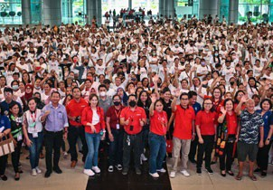

The Saksham initiative has provided skills training, planning tools and networking opportunities to help over 1,000 small-scale women entrepreneurs from three provinces grow their retail businesses.

THE PHILIPPINES

An estimated 1,500 micro-entrepreneurs from Davao del Norte have completed iSTAR, an enhanced digital version of the Sari-Sari Store Training and Access to Resources (STAR) program featuring entrepreneurship training, access to financial resources and online business development tools. The collaboration with the Technical Education and Skills Development Authority (TESDA) and Tagum City Council of Women Foundation supports Coca-Cola Philippines’ broader economic empowerment strategy to break the cycle of generational poverty.

Economic empowerment is

one of The Coca-Cola Foundation’s six new priority giving pillars.

The Coca-Cola Foundation envisions inclusive economies around the world with expanded opportunities for shared prosperity, especially for the communities that face the greatest barriers to advancing

their well-being.

KAZAKHSTAN

The Belesteri (“Stepping Stones”) program has empowered more than 50,000 aspiring business owners in rural areas over the last

10 years. An annual competition awards financial grants to women entrepreneurs to launch or expand their enterprises. The program, which

is supported by The Coca-Cola Foundation, has helped create more than 300 jobs and has provided life-changing income streams for

hundreds of families. More than 15,000 women were trained in 2022.

LATIN AMERICA

In 2022, the Coca-Cola system in Latin America continued to support small retailers to rebound from the adverse economic impacts of COVID-19 through business and financial skills training programs in Bolivia, Brazil, Chile, Colombia, Costa Rica, the Dominican Republic, Ecuador, Mexico, Paraguay and Peru.

AFRICA

Coca-Cola Beverages Africa recently expanded its approach to promoting economic inclusion across its value chain to include under-served women, youth and persons with disabilities. Our

bottling partner has worked with local non-profits to launch entrepreneurship and employability programs in Ethiopia, Kenya, South Africa, Tanzania and Uganda.

CONTENTS

CEO MESSAGE EXECUTIVE SUMMARY

OUR COMPANY

WATER

PORTFOLIO

PACKAGING

CLIMATE

AGRICULTURE

PEOPLE

OPERATIONS

DATA APPENDIX

FRAMEWORKS

OVERVIEW

ASIA PACIFIC

EUROPE, MIDDLE EAST & AFRICA

LATIN AMERICA NORTH AMERICA GLOBAL VENTURES/BOTTLING INVESTMENTS GROUP

# Operations

## Highlights

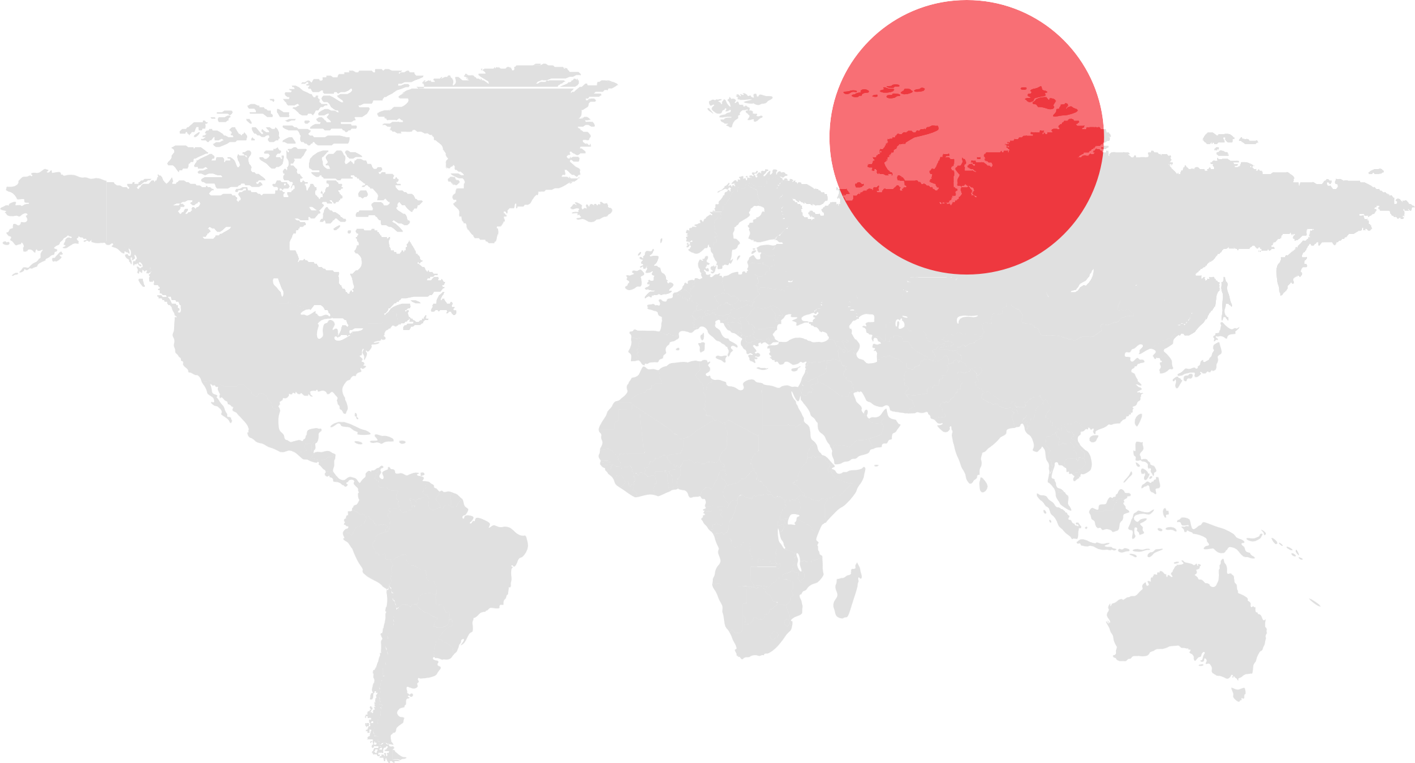

Our networked organization is comprised of nine operating units that are focused on regional and local execution and sit under four geographic operating segments—Asia Pacific; Europe, Middle

East & Africa; Latin America; and North America—plus Global Ventures and Bottling Investments Group.

This structure is supported by our Platform Services organization and center functions, which collectively provide global services and expertise across a range of critical capabilities.

The following pages offer a look at our operations, their business results and some key activities from 2022.

##### 2022 GLOBAL UNIT CASE VOLUME MIX

By Operating Segment

#### 17%

North America

#### 27%

Latin America

#### 28%

Europe, Middle East & Africa

2.2B

servings per day in

more than 200 countries and territories around the world

#### 24%

Asia Pacific

#### 4%

Global Ventures

**THE COCA-COLA COMPANY** 2022 BUSINESS & SUSTAINABILITY REPORT 63

CONTENTS

CEO MESSAGE EXECUTIVE SUMMARY

OUR COMPANY

WATER

PORTFOLIO

PACKAGING

CLIMATE

AGRICULTURE

PEOPLE

OPERATIONS

DATA APPENDIX

FRAMEWORKS

OVERVIEW

ASIA PACIFIC

EUROPE, MIDDLE EAST & AFRICA

LATIN AMERICA NORTH AMERICA GLOBAL VENTURES/BOTTLING INVESTMENTS GROUP

2022 HIGHLIGHTS

ASIA PACIFIC

* In 2022, the company gained value share in total nonalcoholic ready-to-drink beverages, led by share gains in India, Australia, Japan and South Korea.
* We made significant progress on World Without Waste initiatives in the Maldives by launching a returnable glass bottle and commissioning

a can line, scaling up collection and recycling, and advocating for Extended Producer Responsibility regulation embracing circularity.

* With funding from The Coca-Cola Foundation, we supported Planet Water Foundation in scaling the deployment of AquaTower community water filtration systems in Cambodia, providing communities in need with clean water access and hygiene education.

**2022 Unit Case Volume Mix by Operating Unit**

 Greater China and Mongolia ASEAN and South Paciﬁc

 India and Southwest Asia  Japan and South Korea

15%

39%

20%

26%

**Organic Revenue Growth (Non-GAAP)1**

12

9%

5%

2020

2019

2021

2022

|  |  |
| --- | --- |
| **2022 Unit Case Volume Mix by Country** | |
| China | **37%** |
| India | **18%** |
| Japan | **12%** |
| Philippines | **8%** |
| Thailand | **6%** |
| Australia | **4%** |
| South Korea | **3%** |
| Indonesia | **2%** |
| Vietnam | **2%** |
| Other | **8%** |

8

4

0

-4

-8

-12

11%

* Our Unnati Grapes initiative in India trained over 3,000 smallholder farmers to increase the quality and yield of grape cultivation, and supported an all-women farmer producer company.
* Coca-Cola Australia and Coca-Cola Europacific Partners Australia pledged to reduce the sugar content in their nonalcoholic beverage portfolio

by 25% by 2025, as part of an updated industry-wide pledge announced by the Australian Beverages Council.

**2022 Unit Case Volume Mix by Category**

 Trademark Coca-Cola  Sparkling Flavors

 Water, Sports, Coffee and Tea

 Juice, Value-Added Dairy and Plant-Based Beverages

(12%)

**Comparable Currency Neutral Operating Income Growth (Non-GAAP)2**

|  |  |
| --- | --- |
| **2022 Unit Case Volume Growth** | |
| Trademark Coca-Cola | **6%** |
| Sparkling Flavors | **8%** |
| Water, Sports, Coffee and Tea | **4%** |
| Juice, Value-Added Dairy and Plant-Based Beverages | **9%** |

9%

8

3%

4%

2020

2019

2021

2022

4

0

-4

8%

33%

28%

31%

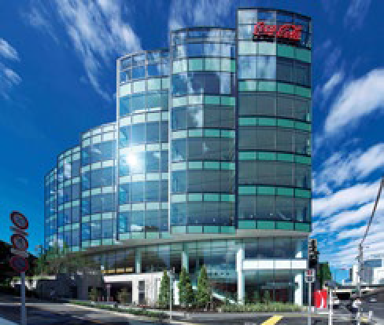

**Renewable Energy in Japan**

Coca-Cola Japan Company has taken steps to transform their offices and concentrate plant to renewable energy sources for their electricity use. The headquarters in Shibuya has been running on renewable electricity since May 2021.

-8 (6%)

1. Reported net operating revenues grew 3%, declined 11%, grew 12% and grew 3% for the years ended December 31, 2019, 2020,

2021 and 2022, respectively.

1. Reported operating income was even, declined 7%, grew 9% and declined 1% for the years ended December 31, 2019, 2020, 2021

and 2022, respectively.

Note: See pages 72–74 for reconciliations of non-GAAP financial measures to our results as reported under U.S. GAAP.

CONTENTS

CEO MESSAGE EXECUTIVE SUMMARY

OUR COMPANY

WATER

PORTFOLIO

PACKAGING

CLIMATE

AGRICULTURE

PEOPLE

OPERATIONS

DATA APPENDIX

FRAMEWORKS

OVERVIEW

ASIA PACIFIC

EUROPE, MIDDLE EAST & AFRICA

LATIN AMERICA NORTH AMERICA GLOBAL VENTURES/BOTTLING INVESTMENTS GROUP

2022 HIGHLIGHTS

EUROPE, MIDDLE EAST & AFRICA

* For the year, the company gained value share in total nonalcoholic ready- to-drink beverages, led by share gains in France, Spain and Poland.
* The Coca-Cola Foundation funded a partnership between the Water and Development Alliance, the Global Environment and Technology Foundation, U.S. Agency for International Development and the Soran Water Directorate to improve water access and quality and to reduce water losses in Iraq.
* We launched the Coca-Cola “Believing is Magic” global campaign for FIFA World Cup Qatar 2022 by creating end-to-end, digitally driven experiences. Our digital platform, the Coca-Cola Fan Zone, was activated

**2022 Unit Case Volume Mix by Operating Unit**

 Europe Africa

 Eurasia and Middle East

25%

48%

27%

**Organic Revenue Growth (Non-GAAP)1**

20

|  |  |
| --- | --- |
| **2022 Unit Case Volume Mix by Country** | |
| Germany | **7%** |
| South Africa | **7%** |
| Türkiye | **7%** |
| Great Britain | **6%** |
| Spain | **5%** |
| Nigeria | **5%** |
| Pakistan | **5%** |
| France | **4%** |
| Italy | **3%** |
| Other | **51%** |

15

5%

2020

2019

2021

2022

10

5

0

-5

-10

18%

18%

in 41 markets and featured social experiences for soccer fans.

* In Eswatini, The Coca-Cola Foundation supported the Ministry of Health’s Project Last Mile to strengthen the government’s capacity to store ultra-

-15

(13%)

cold chain COVID-19 vaccines.

* Coca-Cola Europacific Partners is supporting the hospitality industry across Spain to measure their emissions, identify emissions reduction opportunities and offset emissions to help reach carbon neutrality through the Hosteleria #PorElClima campaign.

**2022 Unit Case Volume Mix by Category**

 Trademark Coca-Cola Sparkling Flavors

5%

14%

55%

26%

 Water, Sports, Coffee and Tea

**Improving Watershed Health in Pakistan**

We worked with WWF-Pakistan to develop a watershed stewardship plan for the Ravi River watershed, a sub-basin of the Indus River Basin, and a priority watershed because it is a key ingredient sourcing (sugarcane) and market growth region. The river extends through both India and Pakistan and supports approximately 38 million people. Our analysis found that the river faces increasing water scarcity and quality challenges. The plan addresses infrastructure and ecosystems, community well- being, information management, policy and regulations, finance and planning. One project already underway is a partnership with WWF-Pakistan to address the identified water issues for approximately 360,000 people in Lahore. Between 2022–2023, the project will install household rainwater harvesting systems, recharge wells to replenish a groundwater aquifer, reforest urban areas and construct floating treatment wetlands. The treatment wetlands will allow wastewater to be reused for agriculture purposes and remove pollutants and excess nutrients from village ponds.

 Juice, Value-Added Dairy and Plant-Based Beverages

**Comparable Currency Neutral Operating Income Growth (Non-GAAP)2**

18%

|  |  |
| --- | --- |
| **2022 Unit Case Volume Growth** | |
| Trademark Coca-Cola | **4%** |
| Sparkling Flavors | **2%** |
| Water, Sports, Coffee and Tea | **6%** |
| Juice, Value-Added Dairy and Plant-Based Beverages | **(13%)** |

|  |  |
| --- | --- |
| 20 |  |
| 15 |
| 10 | 9% |
| 5 |  |
| 0 |  |
| -5 | 2019 |

13%

2020

2021

2022

(1%)

1. Reported net operating revenues declined 1%, declined 14%,

grew 19% and grew 5% for the years ended December 31, 2019,

2020, 2021 and 2022, respectively.

1. Reported operating income declined 4%, declined 7%, grew 13%

and grew 6% for the years ended December 31, 2019, 2020, 2021

and 2022, respectively.

Note: See pages 72–74 for reconciliations of non-GAAP financial measures to our results as reported under U.S. GAAP.

CONTENTS

CEO MESSAGE EXECUTIVE SUMMARY

OUR COMPANY

WATER

PORTFOLIO

PACKAGING

CLIMATE

AGRICULTURE

PEOPLE

OPERATIONS

DATA APPENDIX

FRAMEWORKS

OVERVIEW

ASIA PACIFIC

EUROPE, MIDDLE EAST & AFRICA

LATIN AMERICA NORTH AMERICA GLOBAL VENTURES/BOTTLING INVESTMENTS GROUP

2022 HIGHLIGHTS

LATIN AMERICA

* Coca-Cola Brazil joined the Yes to Racial Equality program run by the Identities of Brazil Institute to help generate opportunities for 3 million people in the coming years, and 10,000 new leadership positions for black people by 2030.
* Coca-Cola Argentina and four bottling partners launched “Ruta Verde” or the “Green Road”, a recycling project that aims to increase the recovery of materials at collection points. This new project connects 28 municipalities across three provinces and helps more than 590,000 people access public places to recycle plastic, paper, cardboard, glass and cans.
* In the face of the 2022 water shortage in Nuevo Leon, Mexico, Coca-Cola and its bottling partners responded quickly to implement additional measures including rehabilitating 15 public water wells, with the goal of

**2022 Unit Case Volume Mix by Category**

 Trademark Coca-Cola

 Water, Sports, Coffee and Tea  Sparkling Flavors

 Juice, Value-Added Dairy and Plant-Based Beverages

6%

16%

21%

57%

**Organic Revenue Growth (Non-GAAP)1**

25

19%

13%

2020

2019

(1%)

2021

2022

|  |  |
| --- | --- |
| **2022 Unit Case Volume Mix by Country** | |
| Mexico | **45%** |
| Brazil | **23%** |
| Argentina | **6%** |
| Chile | **4%** |
| Colombia | **4%** |
| Peru | **3%** |
| Bolivia | **2%** |
| Guatemala | **2%** |
| Ecuador | **2%** |
| Other | **9%** |

20

15

10

5

0

-5

24%

expanding water access to families throughout the city of Monterrey and its more than 5 million inhabitants. We also continued to provide clean drinking water, at all times, free of charge, to local families through an outdoor faucet at the Topo Chico bottling plant.

* Funded by The Coca-Cola Foundation, the Safe Water project in Pucusana, Peru, focused on providing running water systems for the soup kitchens in the district, guaranteeing adequate hygienic conditions for meal preparation. The project installed elevated water tanks and piping for each community kitchen, allowing proper washing of the ingredients. Safe Water for Pucusana has installed 19 running water systems, guaranteeing safe meal preparation for more than 1,600 neighbors and users of the community kitchens.

**Comparable Currency Neutral Operating Income Growth (Non-GAAP)2**

20

17%

18%

19%

12%

|  |  |
| --- | --- |
| **2022 Unit Case Volume Growth** | |
| Trademark Coca-Cola | **5%** |
| Sparkling Flavors | **6%** |
| Water, Sports, Coffee and Tea | **10%** |
| Juice, Value-Added Dairy and Plant-Based Beverages | **10%** |

15

10

5

0

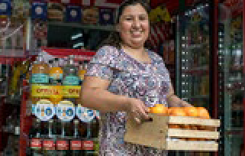

**Encouraging Consumers to Shop Local**

Coca-Cola launched the “Little Giants” or “Pequeños Gigantes” campaign in Latin America to encourage consumers to buy from their local store or market. The project demonstrates the importance of these mini markets in every neighborhood and

the role of consumers and companies to contribute to their growth. This campaign was launched in Colombia, Peru, Costa Rica, Guatemala, the Dominican Republic and other countries in Latin America as part of our efforts to promote the economic development and empowerment of the traditional trade.

2019

2020

2021

2022

1. Reported net operating revenues grew 3%, declined 15%, grew 18% and grew 19% for the years ended December 31, 2019, 2020,

2021 and 2022, respectively.

1. Reported operating income grew 2%, declined 11%, grew 20%

and grew 13% for the years ended December 31, 2019, 2020,

2021 and 2022, respectively.

Note: See pages 72–74 for reconciliations of non-GAAP financial measures to our results as reported under U.S. GAAP.

CONTENTS

CEO MESSAGE EXECUTIVE SUMMARY

OUR COMPANY

WATER

PORTFOLIO

PACKAGING

CLIMATE

AGRICULTURE

PEOPLE

OPERATIONS

DATA APPENDIX

FRAMEWORKS

OVERVIEW

ASIA PACIFIC

EUROPE, MIDDLE EAST & AFRICA

LATIN AMERICA NORTH AMERICA GLOBAL VENTURES/BOTTLING INVESTMENTS GROUP

2022 HIGHLIGHTS

NORTH AMERICA

* The company gained value share in total nonalcoholic ready-to-drink beverages for the year, driven by the continued recovery in away-from- home channels along with strong performance in at-home channels for sparkling soft drinks and value-added dairy beverages.
* In 2022, Sprite began shifting all of its plastic packaging from green to clear, which helps with the recycling process and increases the material’s likelihood of being remade into new beverage bottles. Coca-Cola North America’s entire green plastic portfolio—including packaging for Fresca, Seagram’s and Mello Yello—is also making the transition to clear PET.

**2022 Unit Case Volume Mix by Category**

 Trademark Coca-Cola

 Water, Sports, Coffee and Tea  Sparkling Flavors

Juice, Value-Added Dairy and Plant-Based Beverages

13%

20%

44%

23%

**Organic Revenue Growth (Non-GAAP)2**

20

|  |  |
| --- | --- |
| **2022 Unit Case Volume Mix by Country** | |
| United States | **95%** |
| Canada | **5%** |

15

14%

13%

3%

2020

2019

2021

2022

10

|  |  |
| --- | --- |
| **2022 Unit Case Volume Growth** | |
| Trademark Coca-Cola | **1%** |
| Sparkling Flavors | **3%** |
| Water, Sports, Coffee and Tea | **0%** |
| Juice, Value-Added Dairy and Plant-Based Beverages | **3%** |

5

0

* The Coca-Cola Company donated $2 million to support the Smithsonian’s landmark new National Museum of the American Latino and Molina Family Latino Gallery. The museum will showcase Latino achievements and stories in U.S. art, history, culture and science, and will be built

over a 10-year period.

* Minute Maid launched Aguas Frescas, a Latin American-inspired, noncarbonated beverage made with real fruit juices and natural flavors. The juice drinks deliver a bold, “refreshing AF” sensorial experience tailored to Gen Z tastes.

-5

(5%)

**Comparable Currency Neutral Operating Income Growth (Non-GAAP)3**

20

19%

18%

5%

6%

15

10

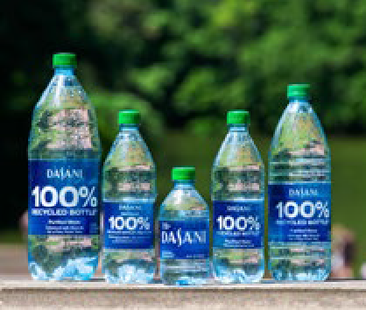

**DASANI 100% rPET Launch**

A majority of DASANI bottles in the United States—from 20-oz. and 1.5-liter singles to 10-oz. and 12-oz. multipacks— are now offered in 100% recycled plastic1. In Canada, this innovation spans all DASANI bottles. The brand’s transition to 100% recycled plastic1

is projected to save more than 20 million pounds of new plastic, compared to

2019, and cut more than 25,000 metric tons of greenhouse gas emissions in 2023 alone.

5

0

2019

2020

2021

2022

2 Reported net operating revenues grew 2%, declined 4%, grew 15% and grew 19% for the years ended December 31, 2019, 2020,

2021 and 2022, respectively.

3 Reported operating income grew 12%, declined 5%, grew 35%

and grew 12% for the years ended December 31, 2019, 2020,

2021 and 2022, respectively.

1 Excluding cap and label Note: See pages 72–74 for reconciliations of non-GAAP financial measures to our results as reported under U.S. GAAP.

CONTENTS

CEO MESSAGE EXECUTIVE SUMMARY

OUR COMPANY

WATER

PORTFOLIO

PACKAGING

CLIMATE

AGRICULTURE

PEOPLE

OPERATIONS

DATA APPENDIX

FRAMEWORKS

OVERVIEW

ASIA PACIFIC

EUROPE, MIDDLE EAST & AFRICA

LATIN AMERICA NORTH AMERICA GLOBAL VENTURES/BOTTLING INVESTMENTS GROUP

##### GLOBAL VENTURES

GLOBAL VENTURES/ BOTTLING INVESTMENTS GROUP

Global Ventures includes Costa Limited (Costa), Monster beverages, innocent, and doğadan tea. The majority of Global Ventures’ revenue consists of Costa and innocent, which together account for approximately 90% of total Global Ventures’ revenue.

2022 HIGHLIGHTS

##### BOTTLING INVESTMENTS GROUP

In January 2006, our company-owned bottling operations were brought together to form the Bottling Investments Group, or BIG. BIG ensures these operations receive the appropriate investments and expertise to foster long-term success. Our current footprint of bottlers exists in Southeast and Southwest Asia, the Middle East, and parts of Africa.

We continue to drive strong performance within BIG while

* To celebrate the Christmas spirit, Costa launched Costa Expressions, a unique platform that celebrates and nurtures young artists in India.
* Costa Coffee was voted the Nation’s Favorite Coffee Shop in the UK for the 12th consecutive year, according to a World Coffee Portal survey.
* In 2022, innocent launched its Revitalise super smoothie, the lowest sugar smoothie recipe it has ever launched. It has 11% less sugar than the brand’s other super smoothies.
* In 2022, innocent launched the Big Rewild, its first pan-European campaign to give nature a helping hand. Together with 11 NGOs and local organizations, innocent is aiming to protect and restore 2 million hectares of land by 2025.
* In 2022, doğadan made all packaging for its tea products plastic-free and added a “plant-based teabag” badge to inform consumers.

maximizing returns on our investments.

2022 HIGHLIGHTS

* + Gained share in sparkling soft drinks in India, Bangladesh and Singapore.
  + Strengthened supply chain resilience and operational efficiency.

**Coca-Cola Beverages Africa Other BIG Bottlers**

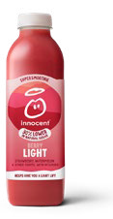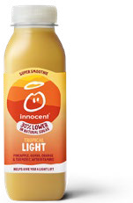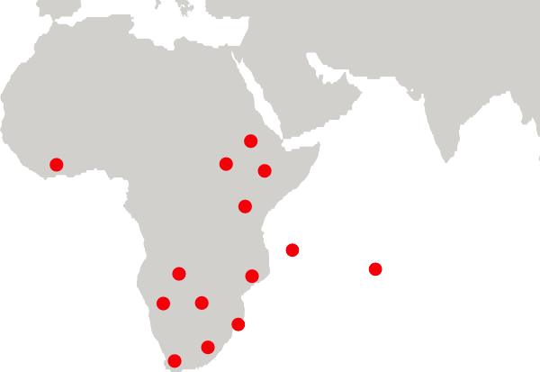

GHANA

UGANDA

ETHIOPIA

KENYA TANZANIA

COMOROS

ZAMBIA NAMIBIA

MAYOTTE

SOUTH AFRICA

MOZAMBIQUE BOTSWANA

ESWATINI

LESOTHO

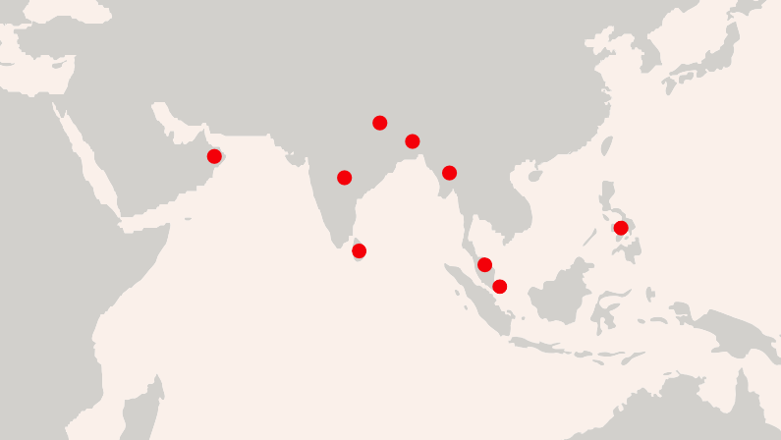

NEPAL

OMAN

BANGLADESH

MYANMAR

INDIA

THE PHILIPPINES

SRI LANKA

MALAYSIA

SINGAPORE

CONTENTS

CEO MESSAGE EXECUTIVE SUMMARY

OUR COMPANY

WATER

PORTFOLIO

PACKAGING

CLIMATE

AGRICULTURE

PEOPLE

OPERATIONS

DATA APPENDIX

FRAMEWORKS

SCOPE OF THE REPORT

This 2022 Business & Sustainability Report is

ABOUT THIS REPORT

The Coca-Cola Company’s fifth report to integrate overall business and sustainability performance, data and context, reflecting our continued journey toward driving sustainable business practices into our core strategy. This report has been prepared in accordance with Global Reporting Initiative (GRI) Standards: Core option. In addition, we provide indices for the standards set by the Sustainability Accounting Standards Board (SASB), the Task Force on Climate-related Financial

Disclosures, the United Nations Sustainable Development Goals (SDGs), the United Nations Global Compact

(UNGC) and the United Nations Guiding Principles Reporting Framework (UNGPRF).

Limited assurance under attestation standards American Institute of Certified Public Accountants over select sustainability metrics was obtained from Ernst & Young LLP (as indicated in the Independent Accountant’s Review Report).

Except as otherwise noted, this report covers the 2022 performance of The Coca-Cola Company and the Coca-Cola system (our company and our owned

and independent bottling partners), as applicable. Therefore, references to “currently,” “to date” or similar expressions reflect data and information as of

December 31, 2022. Some initiatives that were launched in early 2023 are included to provide the most relevant information to stakeholders.

In this report, any use of the terms “material,” “materiality,” “immaterial,” “substantive,” “significant” and other similar terminology refers to topics that reflect important economic, environmental and social impacts of The Coca-Cola Company or the Coca-Cola system

or to topics or standards designated as “material” or “substantive” under the GHG Protocol, GRI or SASB standards. These terms as used in this report are not used, or intended to be construed, as they have been defined by or construed in accordance with the securities laws or any other laws of the United States or any other jurisdiction, or as these terms are used in the context of financial statements and financial reporting.

The data presented in this report is collected using accepted and relevant scientific and industry accepted methodologies, which in some instances, are based

on assumptions and estimates. Although our data has been internally vetted, there are inherent uncertainties and limitations in the collection and presentation of our data. For example, certain information in this report regarding the Coca-Cola system’s progress against our sustainability goals comes from third-party sources and operations outside of our control. While we believe such information is reasonably accurate and is based

on generally accepted principles and methodology, the collection of this data is beyond our direct influence. In addition, the achievement of certain of our sustainability goals and targets that are discussed in this report are dependent on the actions of our bottling partners, suppliers and other third parties, all of which are outside of our control.

Historical performance data may be revised due to reasons such as new data availability; industry-driven changes to methodologies; improvement in data collection and measuring systems; or activities such as joint ventures, mergers and acquisitions or divestitures. In cases where historical information is revised, we will footnote the change with a clear explanation. Statements about future developments and past occurrences are based on information and assumptions available as

of the date of publication. While we are committed to providing timely updates, the company holds no obligation to update information or statements.

COMMON STOCK

The Coca-Cola Company common stock is listed on the New York Stock Exchange, traded under the ticker symbol KO. The company has been one of the 30 companies in the Dow Jones Industrial Average since

1987. As of December 31, 2022, there were approximately

4.33 billion shares outstanding and 188,068 shareowners of record.

DIVIDENDS

At its February 2023 meeting, the Board of Directors increased our quarterly dividend 4.5% to $0.46 per share, equivalent to an annual dividend of $1.84, up from $1.76 in 2022. The company has increased its dividend per share in each of the last 61 years. Dividends are normally paid four times a year, usually in April, July, October

and December. The company has paid 407 consecutive dividends, beginning in 1920.

DIRECT STOCK PURCHASE AND DIVIDEND REINVESTMENT

Computershare Trust Company, N.A., sponsors and administers a direct stock purchase and dividend reinvestment plan for common stock of The Coca-Cola Company. The Computershare Investment Plan allows investors to directly purchase and sell shares of company common stock and reinvest dividends. To view or request plan materials please log on to [www.computershare.](https://www-us.computershare.com/Investor/%23Home?gcc=us) [com/investor](https://www-us.computershare.com/Investor/%23Home?gcc=us) and click on “invest now.”

SHAREOWNER ACCOUNT ASSISTANCE

For information and maintenance on your shareowner of record account, please contact:

Computershare Investor Services

P.O. Box 43078

Providence, RI 02940-3078

Telephone: (888) COKE-SHR (265-3747) or (781) 575-2653

Hearing Impaired: (800) 952-9245 Email: [coca-cola@computershare.com](mailto:coca-cola@computershare.com)

Internet: [www.computershare.com/coca-cola](https://www-us.computershare.com/investor/%23Home?landing=y&issuerid=scuscoca&showinvestorcontact=y)

SHAREOWNER INTERNET ACCOUNT ACCESS

For account access via the internet, please log on to [www.computershare.com/investor](https://www-us.computershare.com/Investor/%23Home?gcc=us). Once registered, shareowners can view account history and complete transactions online.

ELECTRONIC DELIVERY

If you are a shareowner of record, you have an opportunity to help the environment by signing up to receive your shareowner communications,

including proxy materials, account statements and tax forms, electronically.

To enroll in e-delivery, please log on to your account at [www.computershare.com/investor](https://www-us.computershare.com/Investor/%23Home?gcc=us) and click on “View and update your profile” and then click on “Communication Preferences.” As a thank you, the company will have a tree planted on your behalf through American Forests.

FORWARD-LOOKING STATEMENTS

This report may contain statements, estimates or projections that constitute “forward-looking statements” as defined under U.S. federal securities laws. Generally, the words “believe,” “expect,” “intend,” “estimate,” “anticipate,” “project,” “will” and similar expressions identify forward-looking statements, which generally

are not historical in nature. Forward-looking statements are subject to certain risks and uncertainties that could cause The Coca-Cola Company’s actual results to differ materially from its historical experience and our present expectations or projections. These risks include, but are not limited to, unfavorable economic and geopolitical conditions, including the direct or indirect negative impacts of the conflict between Russia and Ukraine; increased competition; an inability to be successful in our innovation activities; changes in the retail landscape or the loss of key retail or foodservice customers;

an inability to expand our business in emerging and developing markets; an inability to successfully manage the potential negative consequences of our productivity initiatives; an inability to attract or retain a highly

skilled and diverse workforce; disruption of our supply chain, including increased commodity, raw material, packaging, energy, transportation and other input costs; the negative impacts of, and continuing uncertainties associated with the scope, severity and duration of the global COVID-19 pandemic and the substance and pace of the post-pandemic economic recovery; an inability

to successfully integrate and manage our acquired businesses, brands or bottling operations or an inability realize a significant portion of the anticipated benefits of our joint ventures or strategic relationships; failure by our third-party service providers and business partners to satisfactorily fulfill their commitments

and responsibilities; an inability to renew collective bargaining agreements on satisfactory terms, or we or our bottling partners experience strikes, work stoppages, labor shortages or labor unrest; obesity and other health-related concerns; evolving consumer product and shopping preferences; product safety and quality concerns; perceived negative health consequences of certain ingredients, such as non- nutritive sweeteners and biotechnology-derived substances, and of other substances present in our beverage products or packaging materials; failure

to digitalize the Coca-Cola system; damage to our brand image, corporate reputation and social license to operate from negative publicity, whether or not

warranted, concerning product safety or quality, workplace and human rights, obesity or other issues; an inability to successfully manage new product launches; an inability to maintain good relationships with our bottling partners; deterioration in our bottling partners’ financial condition; an inability to successfully manage our refranchising activities; increases in income tax rates, changes in income tax laws or the unfavorable resolution of tax matters, including the outcome of our ongoing tax dispute or any related disputes with the

U.S. Internal Revenue Service (“IRS”); the possibility that the assumptions used to calculate our estimated aggregate incremental tax and interest liability related to the potential unfavorable outcome of the ongoing tax dispute with the IRS could significantly change; increased or new indirect taxes; changes in laws

and regulations relating to beverage containers and packaging; significant additional labeling or warning requirements or limitations on the marketing or sale of our products; litigation or legal proceedings; conducting business in markets with high-risk legal compliance environments; failure to adequately protect, or disputes relating to, trademarks, formulas and other intellectual property rights; changes in, or failure to comply with, the laws and regulations applicable to our products or our business operations; fluctuations in foreign currency exchange rates; interest rate increases; an inability

to achieve our overall long-term growth objectives; default by or failure of one or more of our counterparty financial institutions; impairment charges; an inability to protect our information systems against service interruption, misappropriation of data or cybersecurity incidents; failure to comply with privacy and data protection laws; failure to achieve our sustainability goals and targets or accurately report our progress due to operational, financial, legal and other risks, many

of which are outside our control and are dependent on the actions of our bottling partners and other third parties; increasing concerns about the environmental

impact of plastic bottles and other packaging materials; water scarcity and poor quality; increased demand for food products, decreased agricultural productivity and increased regulation of ingredient sourcing due diligence; climate change and legal or regulatory responses thereto; adverse weather conditions; and other risks discussed in our filings with the Securities and Exchange Commission (the “SEC”), including our Annual Report

on Form 10-K for the year ended December 31, 2022, which filing is available from the SEC. You should not place undue reliance on forward-looking statements, which speak only as of the date they are made. We undertake no obligation to publicly update or revise any forward-looking statements.

**Design:** Ideas On Purpose, NYC.

**Content:** Buzzword, Inc.

CONTENTS

CEO MESSAGE EXECUTIVE SUMMARY

OUR COMPANY

WATER

PORTFOLIO

PACKAGING

CLIMATE

AGRICULTURE

PEOPLE

OPERATIONS

DATA APPENDIX

FRAMEWORKS

OVERVIEW

FINANCIAL AND PORTFOLIO DATA

PACKAGING

WATER

GREENHOUSE GAS EMISSIONS & WASTE WORKPLACE, SAFETY & GIVING BACK HUMAN RIGHTS & AGRICULTURE DEFINITIONS OF PRIORITY TOPICS ASSURANCE STATEMENTS

# Data

## Appendix

To respond to stakeholder interest and provide greater disclosure and transparency, we have prepared this Data Appendix. It provides additional financial and sustainability data, including performance data for our sustainability goals as well as other important topics.

Some data provided is for The Coca-Cola Company, while some is for the Coca-Cola system. This is noted with color-coded circles.

 THE COCA-COLA COMPANY  COCA-COLA SYSTEM

FOR MORE INFORMATION ON THE COCA COLA SYSTEM 

**THE COCA-COLA COMPANY** 2022 BUSINESS & SUSTAINABILITY REPORT 70

CONTENTS

CEO MESSAGE EXECUTIVE SUMMARY

OUR COMPANY

WATER

PORTFOLIO

PACKAGING

CLIMATE

AGRICULTURE

PEOPLE

OPERATIONS

DATA APPENDIX

FRAMEWORKS

OVERVIEW

FINANCIAL AND PORTFOLIO DATA

PACKAGING

WATER

GREENHOUSE GAS EMISSIONS & WASTE WORKPLACE, SAFETY & GIVING BACK HUMAN RIGHTS & AGRICULTURE DEFINITIONS OF PRIORITY TOPICS ASSURANCE STATEMENTS

##### FINANCIAL AND PORTFOLIO DATA

|  |  |  |  |  |  |  |  |  |  |  |  |  |  |
| --- | --- | --- | --- | --- | --- | --- | --- | --- | --- | --- | --- | --- | --- |
| **2019–2022 Net Operating Revenues, Operating Income and Unit Case Volume by Operating Segment** | | | | | | | | | | | | | |
| Year ended December 31, |  |  | 2019 |  |  | 2020 |  |  | 2021 |  |  | **2022** |  |
| (In millions) |  | Net Operating Revenues |  | Unit Case Volume Growth | Net Operating Revenues |  | Unit Case Volume Growth | Net Operating Revenues |  | Unit Case Volume Growth | Net Operating Revenues |  | Unit Case Volume Growth |
|  | Operating Income | Operating Income | Operating Income | Operating Income |
| Europe, Middle East & Africa |  | $ 7,058 | $ **3,551** | 2% | $ 6,057 | $ 3,313 | (6%) | $ 7,193 | $ 3,735 | 9% | **$ 7,523** | **$ 3,958** | **3%** |
| Latin America |  | **4,118** | **2,375** | 1% | 3,499 | 2,116 | (2%) | 4,143 | 2,534 | 6% | **4,910** | **2,870** | **6%** |
|  |  |  |  |  |  |  |  |  |  |  |  |  |  |
| North America |  | **11,915** | **2,594** | 0% | 11,477 | 2,471 | (7%) | 13,190 | 3,331 | 5% | **15,674** | **3,742** | **2%** |
|  |  |  |  |  |  |  |  |  |  |  |  |  |  |
| Asia Pacific |  | **5,327** | **2,282** | 5% | 4,722 | 2,133 | (9%) | 5,291 | 2,325 | 10% | **5,445** | **2,303** | **6%** |
|  |  |  |  |  |  |  |  |  |  |  |  |  |  |
| Global Ventures |  | **2,562** | **334** | 7% | 1,991 | (123) | (13%) | 2,805 | 293 | 17% | **2,843** | **185** | **13%** |
|  |  |  |  |  |  |  |  |  |  |  |  |  |  |
| Bottling Investments |  | **7,440** | **358** | 24% | 6,265 | 308 | (15%) | 7,203 | 473 | 11% | **7,891** | **487** | **12%** |
| **Equity Method Investments in Publicly Traded Bottling Companies**  (Top 5 based on unit case volume) | | | | | | | |  |  |  | Percent of Company’s 2022 Worldwide Unit Case Volume | | Company’s Ownership Interest as of Dec. 31, 2022 |
| **Coca‑Cola FEMSA S.A.B. de C.V.** | | | | | | | |  |  |  |  | **12%** | **28%** |
| Coca-Cola FEMSA is the largest independent Coca-Cola bottler in the world by volume. Coca-Cola FEMSA operates in Mexico and nine other countries in Central America and South America. | | | | | | | |  |  |  |  |  |  |
|  | | | | | | | |  |  |  |  |  |  |
| **Coca‑Cola Europacific Partners** | | | | | | | |  |  |  |  | **10%** | **19%** |
| Coca-Cola Europacific Partners is the second largest independent Coca-Cola bottler by volume and the largest independent bottler by revenues, operating in 29 countries in Europe and the South Pacific—serving a population of more than 600 million people. | | | | | | | |  |  |  |  |  |  |
|  | | | | | | | |  |  |  |  |  |  |
| **Coca‑Cola HBC AG (Coca‑Cola Hel**l**enic)** | | | | | | | |  |  |  |  | **8%** | **21%** |
| Coca-Cola Hellenic is the third largest independent Coca-Cola bottler by volume, operating in 29 countries across three continents—serving a population of more than 715 million people. | | | | | | | |  |  |  |  |  |  |
|  | | | | | | | |  |  |  |  |  |  |
| **Coca‑Cola Icecek A.S.** | | | | | | | |  |  |  |  | **5%** | **20%** |
| Coca-Cola Icecek is one of the largest independent Coca-Cola bottlers, with operations in 11 countries across Eurasia and the Middle East—serving a population of more than 430 million people. | | | | | | | |  |  |  |  |  |  |
|  | | | | | | | |  |  |  |  |  |  |
| **Coca‑Cola Bottlers Japan Holdings Inc.** | | | | | | | |  |  |  |  | **3%** | **19%** |
| In 2017, Coca-Cola West Co., Ltd. and Coca-Cola East Japan Co., Ltd. integrated their businesses to establish Coca-Cola Bottlers Japan, the largest Coca-Cola bottler in Japan, serving a population of more than 100 million people. | | | | | | | |  |  |  |  |  |  |

The Coca-Cola Company  Coca-Cola System

CONTENTS

CEO MESSAGE EXECUTIVE SUMMARY

OUR COMPANY

WATER

PORTFOLIO

PACKAGING

CLIMATE

AGRICULTURE

PEOPLE

OPERATIONS

DATA APPENDIX

FRAMEWORKS

OVERVIEW

FINANCIAL AND PORTFOLIO DATA

PACKAGING

WATER

GREENHOUSE GAS EMISSIONS & WASTE WORKPLACE, SAFETY & GIVING BACK HUMAN RIGHTS & AGRICULTURE DEFINITIONS OF PRIORITY TOPICS ASSURANCE STATEMENTS

**Reconciliation of GAAP and Non-GAAP Financial Measures**

The company reports its financial results in accordance with accounting principles generally accepted in the United States (“GAAP” or referred to herein as “reported”). However, management believes that certain non-GAAP financial measures provide investors with additional meaningful financial information that should be considered when assessing our underlying business performance and trends. Management also uses these non-GAAP financial measures in making financial, operating, compensation and planning decisions and in evaluating the company’s performance. Non-GAAP financial measures should be viewed in addition to, and not as an alternative for, the company’s reported results prepared in accordance with GAAP. Our non-GAAP financial measures do not represent a comprehensive basis of accounting.

For additional details regarding the reconciliation of GAAP and non-GAAP financial measures below, see the company’s Current Reports on Form 8-K filed with the SEC on Feb. 14, 2023, Feb. 10, 2022, Feb. 10, 2021 and Jan. 30, 2020. This information is also available in the “Investors” section of the company’s website, [www.coca-colacompany.com](https://investors.coca-colacompany.com/).

|  |  |  |  |  |  |
| --- | --- | --- | --- | --- | --- |
| Year ended December 31, |  | 2019 | 2020 | 2021 | **2022** |
| (Percent change) |  |  |  |  |  |
| **Net Operating Revenues** |  |  |  |  |  |
| **Reported Net Operating Revenues (GAAP)** |  | **9** | **(11)** | **17** | **11** |
| Less: Adjustments to Reported Net Revenues |  |  |  |  |  |
| Currency Impact |  | (4) | (2) | 1 | (7) |
| Impact of Acquisitions, Divestitures and Structural Changes, Net |  | 7 | 0 | 0 | 2 |
| Organic Revenues (Non-GAAP) |  | 6 | (9) | 16 | 16 |
| **Operating Income** |  |  |  |  |  |
| **Reported Operating Income (GAAP)** |  | **10** | **(11)** | **15** | **6** |
| Less: Adjustments to Reported Operating Income |  |  |  |  |  |
| Items Impacting Comparability |  | 5 | (5) | 1 | (5) |
| Currency Impact |  | (8) | (6) | 2 | (8) |
| Comparable Currency Neutral Operating Income (Non-GAAP) |  | 13 | 0 | 12 | 19 |
| **EPS** |  |  |  |  |  |
| **Reported EPS (GAAP)** |  | **38** | **(13)** | **26** | **(3)** |
| Less: Adjustments to Reported EPS |  |  |  |  |  |
| Items Impacting Comparability |  | 37 | (6) | 7 | (9) |
| Currency Impact |  | (8) | (6) | 2 | (10) |
| Comparable Currency Neutral EPS (Non-GAAP) |  | 9 | (2) | 17 | 17 |

The Coca-Cola Company  Coca-Cola System

Note: Certain columns may not add due to rounding.

CONTENTS

CEO MESSAGE EXECUTIVE SUMMARY

OUR COMPANY

WATER

PORTFOLIO

PACKAGING

CLIMATE

AGRICULTURE

PEOPLE

OPERATIONS

DATA APPENDIX

FRAMEWORKS

OVERVIEW

FINANCIAL AND PORTFOLIO DATA

PACKAGING

WATER

GREENHOUSE GAS EMISSIONS & WASTE WORKPLACE, SAFETY & GIVING BACK HUMAN RIGHTS & AGRICULTURE DEFINITIONS OF PRIORITY TOPICS ASSURANCE STATEMENTS

**Reconciliation of GAAP and Non-GAAP Financial Measures**

The company reports its financial results in accordance with accounting principles generally accepted in the United States (“GAAP” or referred to herein as “reported”). However, management believes that certain non-GAAP financial measures provide investors with additional meaningful financial information that should be considered when assessing our underlying business performance and trends. Management also uses these non-GAAP financial measures in making financial, operating, compensation and planning decisions and in evaluating the company’s performance. Non-GAAP financial measures should be viewed in addition to, and not as an alternative for, the company’s reported results prepared in accordance with GAAP. Our non-GAAP financial measures do not represent a comprehensive basis of accounting.

For additional details regarding the reconciliation of GAAP and non-GAAP financial measures below, see the company’s Current Reports on Form 8-K filed with the SEC on Feb. 14, 2023, Feb. 10, 2022, Feb. 10, 2021 and Jan. 30, 2020. This information is also available in the “Investors” section of the company’s website, [www.coca-colacompany.com](https://investors.coca-colacompany.com/).

|  |  |  |  |  |
| --- | --- | --- | --- | --- |
| **Free Cash Flow and Adjusted Free Cash Flow Conversion Ratio** |  |  |  |  |
| Year ended December 31, | 2019 | 2020 | 2021 | **2022** |
| (In millions) |  |  |  |  |
| **Net Cash Provided by Operating Activities** | **$ 10,471** | **$ 9,844** | **$ 12,625** | **$ 11,018** |
| **Purchases of Property, Plant and Equipment** | **(2,054)** | **(1,177)** | **(1,367)** | **(1,484)** |
| Free Cash Flow (Non-GAAP) | 8,417 | 8,667 | 11,258 | 9,534 |
| Plus: Cash Payments for Pension Plan Contributions | — | — | — | — |
| Adjusted Free Cash Flow (Non-GAAP) | $ 8,417 | $ 8,667 | $ 11,258 | $ 9,534 |
| **Net Income Attributable to Shareowners of The Coca‑Cola Company** | **$ 8,920** | **$ 7,747** | **$ 9,771** | **$ 9,542** |
| Noncash Items Impacting Comparability: |  |  |  |  |
| Asset Impairments | 773 | 493 | 62 | 153 |
| Equity Investees | 96 | 216 | 23 | 33 |
| Transaction Gains/Losses | (463) | (933) | (1,109) | 589 |
| CCBA Unrecognized Depreciation and Amortization | (67) | — | — | — |
| Other Items | (148) | 291 | 555 | 526 |
| Certain Tax Matters | (331) | 207 | 410 | (128) |
| Adjusted Net Income Attributable to Shareowners of The Coca-Cola Company (Non-GAAP) | $ 8,780 | $ 8,021 | $ 9,712 | $ 10,715 |
| **Cash Flow Conversion Ratio1** | **117%** | **127%** | **129%** | **115%** |
| Adjusted Free Cash Flow Conversion Ratio (Non-GAAP)2 | 96% | 108% | 116% | 89% |
|  |  |  |  |  |

The Coca-Cola Company  Coca-Cola System

1. Cash flow conversion ratio is calculated by dividing net cash provided by operating activities by net income attributable to shareowners of The Coca-Cola Company.
2. Adjusted free cash flow conversion ratio is calculated by dividing adjusted free cash flow by adjusted net income attributable to shareowners of The Coca-Cola Company.

CONTENTS

CEO MESSAGE EXECUTIVE SUMMARY

OUR COMPANY

WATER

PORTFOLIO

PACKAGING

CLIMATE

AGRICULTURE

PEOPLE

OPERATIONS

DATA APPENDIX

FRAMEWORKS

OVERVIEW

FINANCIAL AND PORTFOLIO DATA

PACKAGING

WATER

GREENHOUSE GAS EMISSIONS & WASTE WORKPLACE, SAFETY & GIVING BACK HUMAN RIGHTS & AGRICULTURE DEFINITIONS OF PRIORITY TOPICS ASSURANCE STATEMENTS

**Reconciliation of GAAP and Non-GAAP Financial Measures**

The company reports its financial results in accordance with accounting principles generally accepted in the United States (“GAAP” or referred to herein as “reported”). However, management believes that certain non-GAAP financial measures provide investors with additional meaningful financial information that should be considered when assessing our underlying business performance and trends. Management also uses these non-GAAP financial measures in making financial, operating, compensation and planning decisions and in evaluating the company’s performance. Non-GAAP financial measures should be viewed in addition to, and not as an alternative for, the company’s reported results prepared in accordance with GAAP. Our non-GAAP financial measures do not represent a comprehensive basis of accounting.

For additional details regarding the reconciliation of GAAP and non-GAAP financial measures below, see the company’s Current Reports on Form 8-K filed with the SEC on Feb. 14, 2023, Feb. 10, 2022, Feb. 10, 2021 and Jan. 30, 2020. This information is also available in the “Investors” section of the company’s website, [www.coca-colacompany.com](https://investors.coca-colacompany.com/).

|  |  |  |  |  |  |  |  |  |  |  |  |  |  |  |  |  |  |
| --- | --- | --- | --- | --- | --- | --- | --- | --- | --- | --- | --- | --- | --- | --- | --- | --- | --- |
| **Net Operating Revenues by Geographic Operating Segment** | | | | | | | | | | | | | | | | | |
| Year ended December 31, |  |  | 2019 |  |  |  | 2020 |  |  |  | 2021 |  |  |  | **2022** | |  |
| (Percent change) |  | Europe, Middle East  & Africa |  |  |  | Europe, Middle East  & Africa |  |  |  | Europe, Middle East  & Africa |  |  |  | Europe, Middle East  & Africa |  |  |  |
|  | Latin America | North America | Asia Pacific | Latin America | North America | Asia Pacific | Latin America | North America | Asia Pacific | Latin America | North America | Asia Pacific |
| **Reported Net Operating Revenues (GAAP)** |  | **(1)** | **3** | **2** | **3** | **(14)** | **(15)** | **(4)** | **(11)** | **19** | **18** | **15** | **12** | **5** | **19** | **19** | **3** |
| Less: Adjustments to Reported Net Operating Revenues |  |  |  |  |  |  |  |  |  |  |  |  |  |  |  |  |  |
|  |  |  |  |  |  |  |  |  |  |  |  |  |  |  |  |  |  |
| Currency Impact |  | (9) | (10) | 0 | (1) | (2) | (14) | 0 | 0 | 1 | 0 | 0 | 3 | (14) | (5) | 0 | (9) |
|  |  |  |  |  |  |  |  |  |  |  |  |  |  |  |  |  |  |
| Impact of Acquisitions, Divestitures and Structural Changes, Net |  | 3 | 0 | 0 | (1) | 0 | 0 | 2 | 0 | 0 | 0 | 0 | 0 | 0 | 0 | 6 | 0 |
|  |  |  |  |  |  |  |  |  |  |  |  |  |  |  |  |  |  |
| Organic Revenues (Non-GAAP) |  | 5 | 13 | 3 | 5 | (13) | (1) | (5) | (12) | 18 | 19 | 14 | 9 | 18 | 24 | 13 | 11 |
| **Operating Income by Geographic Operating Segment** | | | | | | | | | | | | | | | | | |
| Year ended December 31, |  |  | 2019 |  |  |  | 2020 |  |  |  | 2021 |  |  |  | **2022** | |  |
| (Percent change) |  |  |  |  |  |  |  |  |  |  |  |  |  |  |  |  |  |
|  |  | Europe, Middle East  & Africa | Latin America | North America | Asia Pacific | Europe, Middle East  & Africa | Latin America | North America | Asia Pacific | Europe, Middle East  & Africa | Latin America | North America | Asia Pacific | Europe, Middle East  & Africa | Latin America | North America | Asia Pacific |
| **Reported Operating Income (GAAP)** |  | **(4)** | **2** | **12** | **0** | **(7)** | **(11)** | **(5)** | **(7)** | **13** | **20** | **35** | **9** | **6** | **13** | **12** | **(1)** |
| Less: Adjustments to Reported Operating Income |  |  |  |  |  |  |  |  |  |  |  |  |  |  |  |  |  |
|  |  |  |  |  |  |  |  |  |  |  |  |  |  |  |  |  |  |
| Items Impacting Comparability |  | 0 | 0 | 7 | (2) | (2) | (1) | (10) | 0 | (2) | 1 | 16 | 1 | 3 | 0 | (5) | (2) |
|  |  |  |  |  |  |  |  |  |  |  |  |  |  |  |  |  |  |
| Currency Impact |  | (12) | (14) | 0 | (1) | (4) | (21) | 0 | (1) | 1 | 1 | 0 | 4 | (15) | (6) | 0 | (8) |
| Comparable Currency Neutral Operating Income (Non-GAAP) |  | 9 | 17 | 5 | 3 | (1) | 12 | 6 | (6) | 13 | 18 | 19 | 4 | 18 | 19 | 18 | 9 |

The Coca-Cola Company  Coca-Cola System

Note: Certain columns may not add due to rounding.

CONTENTS

CEO MESSAGE EXECUTIVE SUMMARY

OUR COMPANY

WATER

PORTFOLIO

PACKAGING

CLIMATE

AGRICULTURE

PEOPLE

OPERATIONS

DATA APPENDIX

FRAMEWORKS

OVERVIEW

FINANCIAL AND PORTFOLIO DATA

PACKAGING

WATER

GREENHOUSE GAS EMISSIONS & WASTE WORKPLACE, SAFETY & GIVING BACK HUMAN RIGHTS & AGRICULTURE DEFINITIONS OF PRIORITY TOPICS ASSURANCE STATEMENTS

**Portfolio**

|  |  |  |  |  |  |  |  |  |  |  |
| --- | --- | --- | --- | --- | --- | --- | --- | --- | --- | --- |
| Year ended December 31, |  | 2014 | 2015 | 2016 | 2017 | 2018 | 2019 | 2020 | 2021 | **2022** |
| **Volume** (in billions) |  |  |  |  |  |  |  |  |  |  |
| Volume — Unit Cases |  | 28.6 | 29.2 | 29.3 | 29.2 | 29.6 | 30.3 | 29.0 | 31.3 | **32.7** |
|  |  |  |  |  |  |  |  |  |  |  |
| Volume — Liters |  | 162.4 | 165.8 | 166.4 | 165.8 | 168.1 | 172.0 | 164.5 | 177.5 | **185.8** |
| **Responsible Marketing** |  |  |  |  |  |  |  |  |  |  |
| (Market responsibly, including no advertising to children under the age of 13 anywhere in the world.1) |  |  |  |  |  |  |  |  |  |  |
|  |  |  |  |  |  |  |  |  |  |  |
| Print |  | 100% | 100% | 100% | 100% | not available | not available | not available | not available | **not available** |
|  |  |  |  |  |  |  |  |  |  |  |
| Online |  | 99.5% | 99.8% | 100% | 99.8% | not available | not available | not available | not available | **99.8%** |
|  |  |  |  |  |  |  |  |  |  |  |
| Television |  | 88.5% | 97.0% | 95.2% | 95.0% | not available | not available | not available | not available | **91.3%** |
| **Low- and No-Calorie Portfolio** |  |  |  |  |  |  |  |  |  |  |
| Low- or no-calorie sales (percent of volume sold that is low- or no-calorie) |  |  |  | 25.2% | 27.3% | 27.2% | 29.0% | 28.2% | 28.0% | **28.7%** |
|  |  |  |  |  |  |  |  |  |  |  |
| Percent of the company’s sparkling soft drink brands available in packages of 250 milliliters (8.5 ounces) or less |  |  |  | about 40% | > 40% | 44% | 42% | 42% | 41% | **44%** |
| **Front of Package Labeling** |  |  |  |  |  |  |  |  |  |  |
| Provide transparent nutrition information, featuring calories on the front of all of our packages. |  | nearly all markets | nearly all markets | nearly all markets | nearly all markets | nearly all markets | nearly all markets | nearly all markets | nearly all markets | **nearly all markets** |

The Coca-Cola Company  Coca-Cola System

1. [2022 IFBA Marketing Report](https://ifballiance.org/wp-content/uploads/2023/02/IFBA_2022_Global_Marketing_Policy_Compliance_Report_FINAL.pdf)

CONTENTS

CEO MESSAGE EXECUTIVE SUMMARY

OUR COMPANY

WATER

PORTFOLIO

PACKAGING

CLIMATE

AGRICULTURE

PEOPLE

OPERATIONS

DATA APPENDIX

FRAMEWORKS

OVERVIEW

FINANCIAL AND PORTFOLIO DATA

PACKAGING

WATER

GREENHOUSE GAS EMISSIONS & WASTE WORKPLACE, SAFETY & GIVING BACK HUMAN RIGHTS & AGRICULTURE DEFINITIONS OF PRIORITY TOPICS ASSURANCE STATEMENTS

##### PACKAGING

|  |  |  |  |  |  |  |  |  |  |  |
| --- | --- | --- | --- | --- | --- | --- | --- | --- | --- | --- |
| Year ended December 31, |  | 2014 | 2015 | 2016 | 2017 | 2018 | 2019 | 2020 | 2021 | **2022** |
| **World Without Waste** |  |  |  |  |  |  |  |  |  |  |
| Total weight of our packaging (metric tons)1 |  |  |  |  |  |  |  | 5.10M2 | 5.30M | **5.95M** |
|  |  |  |  |  |  |  |  |  |  |  |
| Percentage of recycled material in our packaging3 |  |  |  |  |  | 30% | 20%4 | 22% | 23% | **25%** |
|  |  |  |  |  |  |  |  |  |  |  |
| Percentage of recycled material used in our PET plastic packaging globally |  |  |  |  |  | 9% | 9.4% | 11.5% | 13.6% | **15%** |
|  |  |  |  |  |  |  |  |  |  |  |
| Percentage of bottles and cans we collected and refilled or collected for recycling5 |  | 61% | 59% | 59% | 59% | 58% |  |  |  |  |
|  |  |  |  |  |  |  |  |  |  |  |
| Percentage of bottles and cans we collected and refilled or collected for recycling6 |  |  |  |  |  | 56% | 60% | 60% | 61% | **61%** |
|  |  |  |  |  |  |  |  |  |  |  |
| Percentage of packaging recyclable globally7 |  |  |  |  | 85% | 88% | 88% | 90% | 90% | **90%** |
| **Packaging Mix (by units)** |  |  |  |  |  |  |  |  |  |  |
| Plastic (primarily PET) bottles |  |  |  |  |  | 45.5% | 45.2% | 44.9% | 47.3% | **47.4%** |
|  |  |  |  |  |  |  |  |  |  |  |
| Aluminum and steel bottles and cans |  |  |  |  |  | 23.5% | 23.8% | 24.7% | 25.7% | **25.9%** |
|  |  |  |  |  |  |  |  |  |  |  |
| Other |  |  |  |  |  | 12.1% | 11.8% | 13.4% | 9.7% | **11.3%** |
|  |  |  |  |  |  |  |  |  |  |  |
| Refillable glass bottles |  |  |  |  |  | 11.7% | 11.1% | 9.3% | 9.4% | **9.0%** |
|  |  |  |  |  |  |  |  |  |  |  |
| Non-refillable glass bottles |  |  |  |  |  | 2.3% | 2.0% | 1.4% | 1.6% | **1.6%** |
|  |  |  |  |  |  |  |  |  |  |  |
| Beverage cartons and juice boxes |  |  |  |  |  | 2.5% | 2.8% | 2.7% | 3.0% | **2.9%** |
|  |  |  |  |  |  |  |  |  |  |  |
| Refillable (primarily PET) plastic bottles |  |  |  |  |  | 1.6% | 1.5% | 1.6% | 1.5% | **1.4%** |
|  |  |  |  |  |  |  |  |  |  |  |
| Pouches |  |  |  |  |  | 0.6% | 0.5% | 0.4% | 0.4% | **0.5%** |
| **Number of Packages** |  |  |  |  |  |  |  |  |  |  |
| Plastic (primarily PET) bottles |  |  |  |  |  | ~117B | ~120B | ~112B | ~125B | **~134B** |
|  |  |  |  |  |  |  |  |  |  |  |
| Aluminum and steel bottles and cans |  |  |  |  |  | ~60B | ~63B | ~62B | ~68B | **~73B** |
|  |  |  |  |  |  |  |  |  |  |  |
| Refillable glass bottles |  |  |  |  |  | ~30B | ~30B | ~23B | ~25B | **~25B** |
|  |  |  |  |  |  |  |  |  |  |  |
| Non-refillable glass bottles |  |  |  |  |  | ~6B | ~5B | ~4B | ~4B | **~4.5B** |
|  |  |  |  |  |  |  |  |  |  |  |
| Refillable (primarily PET) plastic bottles |  |  |  |  |  | ~4B | ~4B | ~4B | ~4B | **~4B** |
|  |  |  |  |  |  |  |  |  |  |  |
| Beverage cartons and juice boxes |  |  |  |  |  | ~6.7B | ~7.3B | ~6.8B | ~7.9B | **~8B** |
|  |  |  |  |  |  |  |  |  |  |  |
| Pouches |  |  |  |  |  | ~1.7B | ~1.3B | ~0.9B | ~1.0B | **~1.3B** |

The Coca-Cola Company  Coca-Cola System

1. This is the focused scope of Primary Consumer Packaging (PET, Glass, Cans, Cartons).
2. This number has been updated following the completed assurance process for the 2020 World Without Waste Report, which was completed post-publication of the 2020 Business & ESG Report.
3. Includes select Primary Consumer Packaging materials.
4. In 2019, we modified the methodology we use for calculating the amount of recycled material used in our Primary Consumer Packaging. These changes are designed to integrate a more accurate dataset, including primary data where it is available. Moving forward, we expect that these numbers will continue to evolve as data sources improve, at the same time that we work to increase rates of recycled material use.
5. We changed our method to track the packaging collection rate against our World Without Waste goal beginning with 2018 data. With better data available, we expanded the metric to encompass all of our packaging types, including beverage cartons, juice boxes and pouches, etc.
6. Collection rate represents a weighted average of national collection rates, collected for recycling rates or refillable rates by packaging type to TCCS’s sales in units to express the percent of equivalent bottles and cans introduced into the market that were collected and refilled or collected for recycling for the year. Collection rates are determined by country for each packaging type based on either national studies (approximately 82%), plant standards (approximately 17%), and internal estimates (approximately 1%).
7. Only recyclable where infrastructure exists.

**Corrections since issuance of report in April 2023:**

Page 39 was updated to correct details about the plant- based plastic bottle technology licensed to a company in Germany and plant-based plastic bottle prototypes.

Page 40 was updated to correct information about the collection rate in Germany and the types of packaging to which the collection rate applies.

CONTENTS

CEO MESSAGE EXECUTIVE SUMMARY

OUR COMPANY

WATER

PORTFOLIO

PACKAGING

CLIMATE

AGRICULTURE

PEOPLE

OPERATIONS

DATA APPENDIX

FRAMEWORKS

OVERVIEW

FINANCIAL AND PORTFOLIO DATA

PACKAGING

WATER

GREENHOUSE GAS EMISSIONS & WASTE WORKPLACE, SAFETY & GIVING BACK HUMAN RIGHTS & AGRICULTURE DEFINITIONS OF PRIORITY TOPICS ASSURANCE STATEMENTS

##### WATER

|  |  |  |  |  |  |  |  |  |  |  |
| --- | --- | --- | --- | --- | --- | --- | --- | --- | --- | --- |
| Year ended December 31, |  | 2014 | 2015 | 2016 | 2017 | 2018 | 2019 | 2020 | 2021 | **2022** |
| **Water Use and Water Withdrawn** |  |  |  |  |  |  |  |  |  |  |
|  |  |  |  |  |  |  |  |  |  |  |
|  |  |  |  |  |  |  |  |  |  |  |
| Water Use Ratio (liters of water used per liter of product produced) |  | 2.03 | 1.98 | 1.96 | 1.92 | 1.89 | 1.85 | 1.84 | 1.81 | **1.79** |
|  |  |  |  |  |  |  |  |  |  |  |
|  |  |  |  |  |  |  | 1.88 | 1.96 | 1.94 | **1.97** |
|  |  |  |  |  |  |  |  |  |  |  |
|  |  |  |  |  |  |  |  |  |  |  |
| Total Water Withdrawn (megaliters) |  | 301,068 | 300,733 | 294,925 | 288,990 | 298,797 | 295,014 | 281,991 | 298,235 | **308,736** |
|  |  |  |  |  |  |  |  |  |  |  |
|  |  |  |  |  |  |  | 40,375 | 36,946 | 40,473 | **44,500** |
|  |  |  |  |  |  |  |  |  |  |  |
|  |  |  |  |  |  |  |  |  |  |  |
| Fresh Surface Water Sources (megaliters) |  |  |  |  | 15,058 | 12,986 | 12,777 | 10,554 | 12,025 | **13,048** |
|  |  |  |  |  |  |  |  |  |  |  |
|  |  |  |  |  |  |  | 3,554 | 2,152 | 2,899 | **3,420** |
|  |  |  |  |  |  |  |  |  |  |  |
|  |  |  |  |  |  |  |  |  |  |  |
| Brackish Surface Water (megaliters) |  |  |  |  | 2,681 | 2,738 | 4,377 | 5,654 | 5,725 | **4,946** |
|  |  |  |  |  |  |  |  |  |  |  |
|  |  |  |  |  |  |  | 1,151 | 1,046 | 351 | **336** |
|  |  |  |  |  |  |  |  |  |  |  |
|  |  |  |  |  |  |  |  |  |  |  |
| Third-Party Sources (megaliters) |  |  |  |  | 140,588 | 135,217 | 147,430 | 139,581 | 144,256 | **147,642** |
|  |  |  |  |  |  |  |  |  |  |  |
|  |  |  |  |  |  |  | 20,317 | 19,475 | 21,706 | **24,144** |
|  |  |  |  |  |  |  |  |  |  |  |
|  |  |  |  |  |  |  |  |  |  |  |
| Ground Water — Renewable (megaliters) |  |  |  |  | 130,663 | 147,857 | 130,430 | 126,202 | 136,195 | **143,099** |
|  |  |  |  |  |  |  |  |  |  |  |
|  |  |  |  |  |  |  | 15,352 | 14,273 | 15,491 | **16,599** |
| **Water Consumption** (megaliters) |  |  |  |  | 182,455 | 186,642 | 187,132 | 167,301 | 170,358 | **183,616** |
|  |  |  |  |  |  |  | 23,889 | 21,687 | 24,918 | **25,562** |
|  |  |  |  |  |  |  |  |  |  |  |
| Percentage of Water Consumption in Regions With High or Extremely High Baseline Water Stress |  |  |  |  |  |  |  | 21% | 20% | **21%** |
| **Wastewater** |  |  |  |  | 106,534 | 112,154 | 107,883 | 114,690 | 127,877 | **125,120** |
| Wastewater Discharged (megaliters) |  |  |  |  |  |  | 16,486 | 15,257 | 15,555 | **18,938** |
| **Water Returned to Nature and Communities** |  |  |  |  |  |  |  |  |  |  |
| Percentage1 |  | 94% | 115% | 132.9% | 150% | 155% | 160.7% | 170% | 167% | **159%** |
|  |  |  |  |  |  |  |  |  |  |  |
| Amount (billions of liters)1 |  | 153.6 | 190.9 | 221.2 | 248.3 | 257 | 273.7 | 277.8 | 293.3 | **291** |

The Coca-Cola Company  Coca-Cola System

1. Substantially all replenish data is internally validated and verified; the equivalent volume for 100% Replenish rate (182.9 Billion litres BL) is externally assured. Peer-reviewed methodologies were used to calculate volumetric benefits per project and operating unit for all externally assured data; one exception was approved for internally validated and verified data. The replenish benefit is typically estimated as a long-term, average annual volume, but for some project activities it varies annually. Replenish benefits fall under three categories: Watershed Protection and Restoration (233.5 BL), Water for Productive Use (40.9 BL) and Water Access and Sanitation (17.4 BL). Due to joint venture or merger and acquisition activities in 2019–2022, certain brands may not be accounted for in this metric. Unless otherwise stated, in this report finished beverages is based on global sales volume. Approximately 13.5 BL (approx. 7%) of the water used in our beverages that we returned to nature and communities is from 7 projects located in Ukraine and Belarus where since May 2019 we have not been able to monitor projects on intervals aligned with internal guidelines due to COVID and the ongoing war.

Note: Due to joint venture or merger and acquisition activities, certain brands may not be accounted for in The Coca-Cola Company-specific metrics included on this page.

CONTENTS

CEO MESSAGE EXECUTIVE SUMMARY

OUR COMPANY

WATER

PORTFOLIO

PACKAGING

CLIMATE

AGRICULTURE

PEOPLE

OPERATIONS

DATA APPENDIX

FRAMEWORKS

OVERVIEW

FINANCIAL AND PORTFOLIO DATA

PACKAGING

WATER

GREENHOUSE GAS EMISSIONS & WASTE WORKPLACE, SAFETY & GIVING BACK HUMAN RIGHTS & AGRICULTURE DEFINITIONS OF PRIORITY TOPICS ASSURANCE STATEMENTS

##### GREENHOUSE GAS EMISSIONS & WASTE

|  |  |  |  |  |  |  |  |  |  |  |
| --- | --- | --- | --- | --- | --- | --- | --- | --- | --- | --- |
| Year ended December 31, |  | 2014 | 2015 | 2016 | 2017 | 2018 | 2019 | 2020 | 2021 | **2022** |
| **Reduce our absolute emissions by 25% by 2030 against a 2015 baseline** |  |  |  |  |  |  |  |  |  | **7%** |
| **GHG Emissions1** |  |  |  |  |  |  |  |  |  |  |
|  |  |  |  |  |  |  |  |  |  |  |
| Direct, from manufacturing sites (metric tons) (in millions) |  | 1.7 | 1.7 | 1.6 | 1.78 | 1.79 | 1.83 | 1.49 | 1.61 | **1.65** |
|  |  |  |  |  |  |  |  |  |  |  |
| Indirect, from electricity purchased and consumed (without energy trading) at manufacturing sites (metric tons) (in millions) |  | 3.6 | 3.8 | 3.8 | 3.76 | 3.76 | 3.73 | 3.75 | 3.88 | **3.91** |
| Indirect, from electricity purchased and consumed (without energy trading) at manufacturing sites (using GHG protocol market-based method)2 (metric tons) (in millions) |  |  |  |  | 3.44 | 3.35 | 3.88 | 3.28 | 3.56 | **3.33** |
| Total, from manufacturing sites (metric tons) (in millions) |  | 5.55 | 5.58 | 5.45 | 5.54 | 5.55 | 5.56 | 5.24 | 5.49 | **5.56** |
|  |  |  |  |  |  |  |  |  |  |  |
| Total, from manufacturing sites (using GHG protocol market-based method)2 (in millions) |  |  |  |  | 5.22 | 5.14 | 5.71 | 4.77 | 5.18 | **4.97** |
|  |  |  |  |  |  |  |  |  |  |  |
| Emissions Ratio (gCO2 /L) |  | 36.89 | 36.23 | 35.29 | 33.96 | 34.83 | 34.74 | 33.96 | 33.33 | **28.85** |
| **Business & Sustainability Report and CDP Manufacturing Emissions Reconciliation** |  |  |  |  |  |  |  |  |  |  |
| **Reported Manufacturing Emissions in Business & Sustainability Report (millions of MT CO2e)–TCCS Reporting Entity3** |  |  |  |  |  |  |  |  |  |  |
| Scope 1 emissions per Business & Sustainability Report |  |  |  |  |  |  |  |  | 1.61 | **1.65** |
| Scope 2 emissions per Business & Sustainability Report |  |  |  |  |  |  |  |  | 3.88 | **3.91** |
| Total manufacturing emissions per Business & Sustainability Report |  |  |  |  |  |  |  |  | 5.49 | **5.56** |
|  |  |  |  |  |  |  |  |  |  |  |
| **Reported Manufacturing Emissions in CDP (MT CO2e)–TCCC Reporting Entity3, 4** |  |  |  |  |  |  |  |  |  |  |
| Scope 1–Manufacturing per CDP C7.3c |  |  |  |  |  |  |  |  | 325,833 | **304,144** |
|  |  |  |  |  |  |  |  |  |  |  |
| Scope 2 (location-based)–Manufacturing per CDP C6.3 |  |  |  |  |  |  |  |  | 869,832 | **890,400** |
|  |  |  |  |  |  |  |  |  |  |  |
| Scope 3–Franchises per CDP C6.5 |  |  |  |  |  |  |  |  | 4,299,247 | **4,363,071** |
|  |  |  |  |  |  |  |  |  |  |  |
| Total manufacturing emissions per CDP |  |  |  |  |  |  |  |  | 5,494,912 | **5,577,615** |
|  |  |  |  |  |  |  |  |  |  |  |
| Total manufacturing emissions per CDP (in millions) |  |  |  |  |  |  |  |  | 5.49 | **5.56** |
| **Energy Use5** |  |  |  |  |  |  |  |  |  |  |
|  |  |  |  |  |  |  |  |  |  |  |
| Total Energy Use (megajoules) (in millions) |  | 61,764.0 | 61,037.4 | 61,558.7 | 59,070.9 | 61,464.0 | 62,419.9 | 58,888.1 | 63,735.8 | **65,389** |
|  |  |  |  |  |  |  |  |  |  |  |
|  |  |  |  |  |  |  | 11,758.9 | 10,985.2 | 12,731.5 | **10,680** |
|  |  |  |  |  |  |  |  |  |  |  |
| Percentage renewable (electricity) |  |  |  |  |  |  | 15% | 17% | 12% | **21%** |
|  |  |  |  |  |  |  |  |  |  |  |
| Energy Use Ratio (megajoules per liter of product) |  | 0.42 | 0.41 | 0.40 | 0.40 | 0.39 | 0.39 | 0.38 | 0.39 | **0.38** |
|  |  |  |  |  |  |  |  |  |  |  |
|  |  |  |  |  |  |  | 0.54 | 0.58 | 0.61 | **0.57** |

The Coca-Cola Company  Coca-Cola System

1. The direct, Scope 1 and indirect Scope 1 manufacturing emissions results shown in this section exclude fugitive emissions and flavor manufacturing plants. However, for the system-wide GHG results reported, these emissions sources are included.
2. This metric accounts for renewable energy usage.
3. The GHG emissions reported in the Business & Sustainability report represent the Coca-Cola system’s manufacturing emissions, which include emissions from activities which are under the Company’s operational control and activities that are related to Coca-Cola brands that are under direct control of franchise bottlers. Our CDP reporting is aligned with an operational control approach as defined by the GHG Protocol, which includes only emissions from activities within The Coca-Cola Company’s operational control as Scope 1 and 2 emissions, while manufacturing emissions from franchise bottlers are categorized as “Scope 3- Franchises”.
4. The below emissions figures will be reported in the Company's forthcoming 2023 CDP Climate Change response.
5. Systemwide total based on estimated total use.

Note: Due to joint venture or merger and acquisition activities, certain brands may not be accounted for in The Coca-Cola Company-specific metrics included on this page.

CONTENTS

CEO MESSAGE EXECUTIVE SUMMARY

OUR COMPANY

WATER

PORTFOLIO

PACKAGING

CLIMATE

AGRICULTURE

PEOPLE

OPERATIONS

DATA APPENDIX

FRAMEWORKS

OVERVIEW

FINANCIAL AND PORTFOLIO DATA

PACKAGING

WATER

GREENHOUSE GAS EMISSIONS & WASTE WORKPLACE, SAFETY & GIVING BACK HUMAN RIGHTS & AGRICULTURE DEFINITIONS OF PRIORITY TOPICS ASSURANCE STATEMENTS

GREENHOUSE GAS EMISSIONS & WASTE (continued)

|  |  |  |  |  |  |  |  |  |  |
| --- | --- | --- | --- | --- | --- | --- | --- | --- | --- |
| Year ended December 31, | 2014 | 2015 | 2016 | 2017 | 2018 | 2019 | 2020 | 2021 | **2022** |

|  |  |  |  |  |  |  |  |
| --- | --- | --- | --- | --- | --- | --- | --- |
| **Fleet Fuel Management** |  |  |  |  |  |  |  |
|  |  |  |  |  |  |  |  |
| Fleet fuel consumed (liters of diesel equiv.) |  |  |  |  | 1.01B1 | 1.10B | **0.77B** |
| **HFC-Free Coolers** |  |  |  |  |  |  |  |
|  |  |  |  |  |  |  |  |
| Number of pieces of HFC-free refrigeration equipment placed | 623,160 | 730,876 | 886,693 | 918,009 | 571,753 | 803,602 | **1,070,739** |
|  |  |  |  |  |  |  |  |
| Percentage of all coolers introduced in year that are HFC-free2 | 61% | 65% | 80% | 82% | 83% | 87% | **88%** |
| **Waste2** |  |  |  |  |  |  |  |
|  |  |  |  |  |  |  |  |
| Total Waste Generated (kilograms) (in millions) | 1,441.3 | 1,360.5 | 1,297.4 | 1,367.8 | 1,269.9 | 1,490.3 | **1,749.6** |
|  |  |  |  |  |  |  |  |
| Total Waste Ratio (grams per liter of product) | 9.42 | 9.42 | 8.89 | 9.17 | 8.82 | 8.89 | **9.74** |
|  |  |  |  |  |  |  |  |
| Total Waste Recovered (kilograms) (in millions) | 1,264.6 | 1,181.3 | 1,134 | 1,212 | 1,135 | 1,324.8 | **1,587.3** |
|  |  |  |  |  |  |  |  |
| Waste Recovered Percentage | 87% | 86% | 87% | 89% | 89% | 88.6% | **90.7%** |

The Coca-Cola Company  Coca-Cola System

1. This 2020 figure has been adjusted.
2. Systemwide total based on estimated total use.

**Corrections since issuance of report in April 2023:**

Page 79 was updated to enter information that was not available at the time of report issuance related to equivalent liters of diesel fuel consumed by Fleet Fuel Management.

CONTENTS

CEO MESSAGE EXECUTIVE SUMMARY

OUR COMPANY

WATER

PORTFOLIO

PACKAGING

CLIMATE

AGRICULTURE

PEOPLE

OPERATIONS

DATA APPENDIX

FRAMEWORKS

OVERVIEW

FINANCIAL AND PORTFOLIO DATA

PACKAGING

WATER

GREENHOUSE GAS EMISSIONS & WASTE WORKPLACE, SAFETY & GIVING BACK HUMAN RIGHTS & AGRICULTURE DEFINITIONS OF PRIORITY TOPICS ASSURANCE STATEMENTS

##### WORKPLACE, SAFETY & GIVING BACK

|  |  |  |  |  |  |  |  |  |  |  |
| --- | --- | --- | --- | --- | --- | --- | --- | --- | --- | --- |
| Year ended December 31, |  | 2014 | 2015 | 2016 | 2017 | 2018 | 2019 | 2020 | 2021 | **2022** |
| **Lost-Time Incident Rate** |  | 1.9 | 1.6 | 1.29 | 0.57 | 0.38 | 0.32 | 0.34 | 0.281 | **0.251** |
| **Number of Employees** |  |  |  |  |  |  |  |  |  |  |
| **Global Workforce2** |  | 129,200 | 123,200 | 100,300 | 61,800 | 62,600 | 86,200 | 80,300 | 79,000 | **82,500** |
| North America |  | 7,000 | 10,000 | 10,700 | 11,000 | 12,100 | 10,800 | 10,000 | 10,000 | **9,600** |
| Bottling Investments |  | 64,700 | 57,200 | 46,600 | 7,700 | — | — | — | — | **—** |
| Latin America |  | 2,500 | 2,400 | 2,500 | 2,500 | 2,400 | 2,400 | 2,200 | 2,400 | **2,600** |
| Bottling Investments |  | 2,200 | 2,000 | 2,000 | 1,900 | — | — | — | — | **—** |
| Europe, Middle East & Africa |  | 5,100 | 4,900 | 4,400 | 4,100 | 4,300 | 5,700 | 5,300 | 5,500 | **5,800** |
| Bottling Investments |  | 10,400 | 10,700 | — | 15,300 | 15,400 | 17,000 | 17,300 | 16,300 | **16,500** |
| Asia Pacific |  | 2,800 | 2,600 | 2,600 | 2,600 | 2,600 | 2,900 | 2,700 | 2,900 | **3,100** |
| Bottling Investments |  | 34,500 | 33,400 | 31,500 | 16,700 | 25,800 | 25,700 | 23,800 | 22,900 | **21,300** |
| Global Ventures |  |  |  |  |  |  | 21,700 | 19,000 | 19,000 | **23,600** |
| **Gender Representation by Level (global)3** |  |  |  |  |  |  |  |  |  |  |
|  |  |  |  |  |  |  |  |  |  |  |
| **Female (global)** |  |  |  |  |  |  |  |  |  |  |
| Senior Leadership |  |  |  |  |  |  |  | 34% | 38.7% | **39.0%** |
| Middle Management |  |  |  |  |  |  |  | 49% | 50.5% | **51.3%** |
| Professionals |  |  |  |  |  |  |  | 36% | 35.3% | **36.0%** |
| **Total** |  |  |  |  |  |  |  | 42% | 42.9% | **44.0%** |
| **Male (global)** | | | | | | | | |  |  |

|  |  |  |  |
| --- | --- | --- | --- |
| Senior Leadership | 66% | 61.3% | **61.0%** |
| Middle Management | 51% | 49.5% | **48.7%** |
| Professionals | 64% | 64.7% | **64.0%** |
| **Total** | 58% | 57.1% | **56.0%** |

The Coca-Cola Company  Coca-Cola System

1. For exclusions, please view the criteria statement in the Independent Accountants’ Review Report.
2. Corporate employees are included in the geographic area in which they work. Bottling Investments is an operating segment with employees located in two of our four geographic operating segments. Numbers are approximate and as of December 31, 2022.
3. Data as of December 31, 2022, for salaried and hourly employees. This data excludes Bottling Investments, Costa, fairlife and BODYARMOR employees. For exclusions, please view the criteria statement in the Independent Accountants’ Review Report.

CONTENTS

CEO MESSAGE EXECUTIVE SUMMARY

OUR COMPANY

WATER

PORTFOLIO

PACKAGING

CLIMATE

AGRICULTURE

PEOPLE

OPERATIONS

DATA APPENDIX

FRAMEWORKS

OVERVIEW

FINANCIAL AND PORTFOLIO DATA

PACKAGING

WATER

GREENHOUSE GAS EMISSIONS & WASTE WORKPLACE, SAFETY & GIVING BACK HUMAN RIGHTS & AGRICULTURE DEFINITIONS OF PRIORITY TOPICS ASSURANCE STATEMENTS

WORKPLACE, SAFETY & GIVING BACK (continued)

|  |  |  |  |  |  |  |
| --- | --- | --- | --- | --- | --- | --- |
| Year ended December 31, |  | 2020 |  | 2021 |  | **2022** |
| **Race/Ethnicity Representation by Level (U.S. only)** |  |  |  |  |  |  |
| **Senior Leadership** |  | 29%1 |  |  |  |  |
| Asian |  |  |  | 10.0% |  | **10.0%** |
| Hispanic/Latino |  |  |  | 9.4% |  | **9.9%** |
| Black/African American |  |  |  | 8.2% |  | **8.6%** |
| American Indian/Alaskan Native |  |  |  | 0.2% |  | **0.0%** |
| Native Hawaiian/Other Pacific Islander |  |  |  | 0.2% |  | **0.1%** |
| White |  |  |  | 62.7% |  | **61.4%** |
| Two or more races |  |  |  | 0.9% |  | **0.9%** |
| Not specified |  |  |  | 8.4% |  | **9.1%** |
| **Middle Management** |  | 35%1 |  |  |  |  |
| Asian |  |  |  | 10.4% |  | **10.4%** |
| Hispanic/Latino |  |  |  | 8.9% |  | **8.7%** |
| Black/African American |  |  |  | 15.4% |  | **16.1%** |
| American Indian/Alaskan Native |  |  |  | 0.3% |  | **0.3%** |
| Native Hawaiian/Other Pacific Islander |  |  |  | 0.2% |  | **0.1%** |
| White |  |  |  | 58.0% |  | **57.1%** |
| Two or more races |  |  |  | 2.0% |  | **2.2%** |
| Not specified |  |  |  | 4.8% |  | **5.2%** |
| **Professionals** |  | 51%1 |  |  |  |  |
| Asian |  |  |  | 4.2% |  | **5.4%** |
| Hispanic/Latino |  |  |  | 20.6% |  | **21.2%** |
| Black/African American |  |  |  | 27.4% |  | **30.3%** |
| American Indian/Alaskan Native |  |  |  | 0.6% |  | **0.4%** |
| Native Hawaiian/Other Pacific Islander |  |  |  | 0.3% |  | **0.5%** |
| White |  |  |  | 42.3% |  | **36.7%** |
| Two or more races |  |  |  | 2.5% |  | **3.0%** |
| Not specified |  |  |  | 2.1% |  | **2.4%** |
| **Total** |  | 43%1 |  |  |  |  |
| Asian |  |  |  | 7.2% |  | **8.1%** |
| Hispanic/Latino |  |  |  | 14.8% |  | **14.6%** |
| Black/African American |  |  |  | 20.9% |  | **22.0%** |
| American Indian/Alaskan Native |  |  |  | 0.5% |  | **0.3%** |
| Native Hawaiian/Other Pacific Islander |  |  |  | 0.2% |  | **0.3%** |
| White |  |  |  | 50.4% |  | **48.1%** |
| Two or more races |  |  |  | 2.2% |  | **2.5%** |
| Not specified |  |  |  | 3.8% |  | **4.3%** |

The Coca-Cola Company  Coca-Cola System

1. This percentage represents People of Color. For exclusions, please view the criteria statement in the Independent Accountants’ Review Report.

CONTENTS

CEO MESSAGE EXECUTIVE SUMMARY

OUR COMPANY

WATER

PORTFOLIO

PACKAGING

CLIMATE

AGRICULTURE

PEOPLE

OPERATIONS

DATA APPENDIX

FRAMEWORKS

OVERVIEW

FINANCIAL AND PORTFOLIO DATA

PACKAGING

WATER

GREENHOUSE GAS EMISSIONS & WASTE WORKPLACE, SAFETY & GIVING BACK HUMAN RIGHTS & AGRICULTURE DEFINITIONS OF PRIORITY TOPICS ASSURANCE STATEMENTS

WORKPLACE, SAFETY & GIVING BACK (continued)

|  |  |  |  |  |  |  |  |  |  |  |
| --- | --- | --- | --- | --- | --- | --- | --- | --- | --- | --- |
| Year ended December 31, |  | 2014 | 2015 | 2016 | 2017 | 2018 | 2019 | 2020 | 2021 | **2022** |
| **Human Rights Cases Reported by Category1** |  |  |  |  |  |  |  |  |  |  |
| Ask a Workplace Rights Question |  |  | 20 | 11 | 8 | 2 | — | — | — | **—** |
|  |  |  |  |  |  |  |  |  |  |  |
| Child Labor |  |  | 1 | — | — | — | — | — | — | **—** |
|  |  |  |  |  |  |  |  |  |  |  |
| Discrimination |  |  | 88 | 55 | 42 | 59 | 452 | 30 | 42 | **27** |
|  |  |  |  |  |  |  |  |  |  |  |
| Forced Labor |  |  | 3 | — | — | — | — | — | — | **1** |
|  |  |  |  |  |  |  |  |  |  |  |
| Freedom of Association |  |  | 3 | 4 | 1 | 1 | — | — | — | **2** |
|  |  |  |  |  |  |  |  |  |  |  |
| Retaliation |  |  | 47 | 37 | 23 | 17 | 172 | 17 | 22 | **11** |
|  |  |  |  |  |  |  |  |  |  |  |
| Safe and Healthy Workplace |  |  | 55 | 33 | 22 | 31 | 52 | 74 | 50 | **37** |
|  |  |  |  |  |  |  |  |  |  |  |
| Work Hours and Wages |  |  | 64 | 42 | 34 | 36 | 182 | 5 | 7 | **11** |
|  |  |  |  |  |  |  |  |  |  |  |
| Workplace Security |  |  | 20 | 10 | 13 | 15 | 122 | 9 | 8 | **—** |
|  |  |  |  |  |  |  |  |  |  |  |
| Total Cases |  |  | 300 | 192 | 143 | 161 | 972 | 135 | 129 | **89** |
| **Investment Back Into Local Communities** |  |  |  |  |  |  |  |  |  |  |
| Amount of charitable contributions made by The Coca-Cola Company and The Coca-Cola Foundation (in millions)3 |  | $ 126 | $ 117 | $ 106 | $ 138 | $ 125 | $ 125 | $ 186.1 | $ 173.5 | **$ 139.0** |
|  |  |  |  |  |  |  |  |  |  |  |
| Percentage of the company’s operating income4 |  | 1.3% | 1.9% | 1.2% | 1.6% | 1.5% | 1.3% | 1.9% | 2.0% | **1.4%** |

The Coca-Cola Company  Coca-Cola System

1. Includes reports and allegations raised through The Coca-Cola Company’s Human Rights Policy reporting process.
2. In 2019, Employee Relations redefined how cases were captured in the case management tool of record. Therefore, the reported figure includes only those allegations that required investigations only as opposed to generalized questions raised to Employee Relations. Please note, however, that all questions presented to Employee Relations were answered even if the question did not warrant an investigation. While we previously reported on all cases and questions raised through our case management tool, we no longer capture that data. This helps us to ensure that we have more accurate visibility to annual Human Rights cases. This change accounts for the 2019 variance when compared to previous years.
3. This amount includes charitable grants awarded by The Coca-Cola Foundation and donations made by The Coca-Cola Company.
4. This percentage was calculated based on the company’s prior year operating income (excluding the Bottling Investments operating segment).

CONTENTS

CEO MESSAGE EXECUTIVE SUMMARY

OUR COMPANY

WATER

PORTFOLIO

PACKAGING

CLIMATE

AGRICULTURE

PEOPLE

OPERATIONS

DATA APPENDIX

FRAMEWORKS

OVERVIEW

FINANCIAL AND PORTFOLIO DATA

PACKAGING

WATER

GREENHOUSE GAS EMISSIONS & WASTE WORKPLACE, SAFETY & GIVING BACK HUMAN RIGHTS & AGRICULTURE DEFINITIONS OF PRIORITY TOPICS ASSURANCE STATEMENTS

##### HUMAN RIGHTS & AGRICULTURE

|  |  |  |  |  |  |  |  |  |  |  |
| --- | --- | --- | --- | --- | --- | --- | --- | --- | --- | --- |
| Year ended December 31, |  | 2014 | 2015 | 2016 | 2017 | 2018 | 2019 | 2020 | 2021 | **2022** |
| **Human Rights Audits by Region1** |  |  |  |  |  |  |  |  |  |  |
| **Total** |  |  | **2,318** | **2,789** | **3,204** | **2,823** | **2,778** | **2,279** | **2,848** | **2,770** |
|  |  |  |  |  |  |  |  |  |  |  |
| Africa |  |  | 120 | 188 | 259 | 236 | 206 | 165 | 297 | **259** |
|  |  |  |  |  |  |  |  |  |  |  |
| Eurasia |  |  | 116 | 93 | 133 | 109 | 78 | 89 | 124 | **141** |
|  |  |  |  |  |  |  |  |  |  |  |
| Europe |  |  | 218 | 339 | 356 | 280 | 376 | 296 | 385 | **345** |
|  |  |  |  |  |  |  |  |  |  |  |
| Latin America |  |  | 563 | 705 | 775 | 627 | 698 | 571 | 795 | **748** |
|  |  |  |  |  |  |  |  |  |  |  |
| Middle East & North Africa |  |  | 57 | 77 | 109 | 107 | 95 | 56 | 62 | **161** |
|  |  |  |  |  |  |  |  |  |  |  |
| North America |  |  | 171 | 180 | 266 | 208 | 161 | 124 | 156 | **146** |
|  |  |  |  |  |  |  |  |  |  |  |
| Pacific |  |  | 1,073 | 1,207 | 1,306 | 1,256 | 1,164 | 978 | 1,029 | **970** |
| **Number of Women Economically Enabled** (cumulative) |  | 864,996 | 1,237,734 | 1,751,626 | 2,413,079 | 3,278,866 | 4,602,033 | 6,073,117 | 2020 goal achieved | **2020 goal achieved** |
| **Agriculture** |  |  |  |  |  |  |  |  |  |  |
| Sustainably source our key agricultural ingredients |  |  |  |  |  |  |  |  |  |  |
|  |  |  |  |  |  |  |  |  |  |  |
| **% of key ingredients sustainably sourced (SAGP)2** |  |  |  | not available | not available | 44% | 54% | 56% | 61% | **—** |
|  |  |  |  |  |  |  |  |  |  |  |
| **% of key ingredients sustainably sourced (PSA)3** |  |  |  |  |  |  |  |  | 58% | **64%** |
|  |  |  |  |  |  |  |  |  |  |  |
| Apples |  |  |  | not available | 0–25% | 26–50% | 50% | 60% | —4 | **55%** |
|  |  |  |  |  |  |  |  |  |  |  |
| Coffee |  |  |  | 76–100% | 76–100% | 76–100% | 90% | 97% | —4 | **99%** |
|  |  |  |  |  |  |  |  |  |  |  |
| Corn |  |  |  | 0–25% | 0–25% | 51–75% | 67% | 67% | —4 | **70%** |
|  |  |  |  |  |  |  |  |  |  |  |
| Grapes |  |  |  | not available | 26–50% | 26–50% | 31% | 39% | —4 | **37%** |
|  |  |  |  |  |  |  |  |  |  |  |
| Lemons |  |  |  | 51–75% | 51–75% | 51–75% | 79% | 82% | —4 | **96%** |
|  |  |  |  |  |  |  |  |  |  |  |
| Mangoes |  |  |  | not available | not available | 0–25% | 19% | 34% | —4 | **36%** |
|  |  |  |  |  |  |  |  |  |  |  |
| Oranges |  |  |  | 0–25% | 0–25% | 26–50% | 44% | 44% | —4 | **89%** |
|  |  |  |  |  |  |  |  |  |  |  |
| Soybeans |  |  |  | not available | not available | 76–100% | 100% | 100% | —4 | **100%** |
|  |  |  |  |  |  |  |  |  |  |  |
| Sugar Beets |  |  |  | 51–75% | 51–75% | 51–75% | 69% | 83% | —4 | **80%** |
|  |  |  |  |  |  |  |  |  |  |  |
| Sugar Cane |  |  |  | 0–25% | 0–25% | 0–25% | 32% | 31% | —4 | **40%** |
|  |  |  |  |  |  |  |  |  |  |  |
| Tea |  |  |  | 76–100% | 76–100% | 76–100% | 82% | 84% | —4 | **74%** |
|  |  |  |  |  |  |  |  |  |  |  |
| Pulp & Paper |  |  |  | not available | not available | not available | 75% | 92% | —4 | **86%** |

The Coca-Cola Company  Coca-Cola System

1. Independent third-party audits.
2. Progress toward total sustainable sourcing of all 12 priority ingredients, combined, using third-party validation programs against The Coca-Cola Company’s previous Sustainable Agriculture Guiding Principles (SAGP) effective for 2013–2020.
3. Progress toward total sustainable sourcing of all 12 priority ingredients, combined, using third-party validation programs approved under The Coca-Cola Company’s Principles for Sustainable Agriculture (PSA) effective for 2021–2022. Sustainably sourced volumes reported through 2020 were against the former Sustainable Agriculture Guiding Principles. Data reported for 2022 represents key ingredients that are sustainably sourced to our Leader standard in line with our PSA.
4. We paused ingredient level reporting for 2021, and resumed this reporting for 2022.

CONTENTS

CEO MESSAGE EXECUTIVE SUMMARY

OUR COMPANY

WATER

PORTFOLIO

PACKAGING

CLIMATE

AGRICULTURE

PEOPLE

OPERATIONS

DATA APPENDIX

FRAMEWORKS

OVERVIEW

FINANCIAL AND PORTFOLIO DATA

PACKAGING

WATER

GREENHOUSE GAS EMISSIONS & WASTE WORKPLACE, SAFETY & GIVING BACK HUMAN RIGHTS & AGRICULTURE DEFINITIONS OF PRIORITY TOPICS ASSURANCE STATEMENTS

##### DEFINITIONS OF PRIORITY TOPICS

|  |  |  |  |  |  |
| --- | --- | --- | --- | --- | --- |
| Topic name | Subtopic(s) | Definition | Topic name | Subtopic(s) | Definition |
| **Advocacy & Regulatory Engagement** | Advocacy & Political Engagement | How a company contributes to or engages with efforts in favor of or against policies and laws. This involves lobbying on issues such as taxes, trade policies, and regulation, including on sustainability issues. It also encompasses corporate stances and actions on social issues and world events. | **Corporate Governance** | Business Ethics & Compliance | How a company implements policies and procedures surrounding compliant and lawful corporate conduct and competition in the marketplace. Includes the systems and channels in place to collect, process, and address complaints regarding suspected violations. |
|  | Regulatory Engagement & Responsiveness | How a company monitors risks and opportunities derived from emerging policies and laws and interacts with governments and political bodies to shape or respond to them. |  | Corporate Governance | How a company implements policies and standards that determine how it operates, including its business strategy and goals, risk management, and sustainability integration. Includes the processes for ensuring the knowledge, skills, experience and diversity of board members. |
| **Biodiversity & Deforestation** | Biodiversity & Deforestation | How a company implements policies to sustainably manage, preserve, and restore the variety of living organisms on earth for the benefit of human beings, the planet, and climate. Involves the effects of the production of agricultural raw materials used in a company’s system and value chain on biodiversity. |  | Transparency & Sustainability Data Validity | How a company discloses robust and credible sustainability data based on globally accepted metrics in the face of increasing calls for sustainability data  and assurance. |
|  |  |  |  |  |  |
| **Business Continuity & Resilience** | Adapting and Thriving in a Digital Environment | How a company manages the digital landscape, evolving shopping preferences and patterns, incorporating technology into business processes, and the enhanced capacity to conduct operations online. Also involves measures to ensure the necessary skills transformation of their workers and those in their value chain. | **Health & Nutrition** | Consumer Preference Alignment | How a company responds to and aligns with evolving consumer preferences and concerns, including health, wellness, and nutrition considerations, expectations of transparency, as well as increased demand for sustainable products. |
|  |  |  |  |  |  |
|  | Business Continuity & Resilience | How a company manages potential disruptions to business operations, including the workforce and supply chains, caused by geopolitical and geoeconomic tensions, social issues, including rising inequality or refugee migration, demographic changes, or economic crises. Also involves anticipating and adapting to changing environments to ensure the necessary skills transformation of their workers and those in their value chain. |  | Health & Nutrition | How a company manages the impact its products have on the health and nutrition of consumers, not only in relation to the product offering, but also in relation to education, information, and research. |
|  |  | **Labor & Human Rights** | Human Rights | How a company respects the rights of employees, workers in the supply chain, consumers, and communities the company interacts with. Includes alignment with human rights due diligence principles in the UN Guiding Principles on Business and Human Rights. |
|  | Cybersecurity & Data Privacy | How a company protects and remediates information systems and networks from accidental or illegal breaches. Also includes how information is collected, used and transferred and respecting a data subject's privacy rights. |  |  |
|  |  |  | Labor Rights & Relations | How a company upholds worker's rights, including stipulations of employment, working conditions, and freedom of association. |
|  | Innovation & Competitiveness | How a company is able to continually transform business operations and develop products in response to increasing competitive pressure in the marketplace. |  | Occupational Health & Safety | How a company implements policies, practices, and training in place to mitigate risks and uphold workplace health and safety. |
| **Climate Change** | Climate Change Risk & Resilience | How a company manages the physical impacts and risks of climate change due to changes in weather patterns and increased frequency and severity of natural disasters, which could decrease agricultural productivity, exacerbate water scarcity, impair production capabilities, disrupt the supply chain, and impact demand for products. Also incorporates transition risks and the ability to manage and adapt to new policies and markets connected to the low-carbon economy transition. | **Packaging & Circularity** | Packaging & Circularity | How a company supports a circular economy, such as reusable/recyclable materials, collection and recycling, partnerships and innovation. Involves integrating sustainability considerations in the production and consumption of products and services across a company, system and value chain. |
|  |  |  |  | Operational Waste | How a company manages the waste and effluents generated from operations that are not able to be reused or recycled, and the associated management practices. |
|  | GHG Emissions | How a company manages its direct and indirect emissions of greenhouse gases throughout the value chain, and mitigates contributions to climate change in line with net zero methodologies. Examples of this include transition to renewable energy, use of alternative fuels, and energy efficiency through new equipment and processes, such as HFC-free equipment, as well as through reducing the environmental footprint of buildings and facilities across their life-cycles. |  |  |
|  |  | **Product Quality & Safety** | Product Quality & Safety | How a company meets industry and consumer standards for quality and safety. This includes both fulfilling consumers' needs and complying with food safety, considering ingredients and their effects on health, and relevant certifications that verify environmental or social aspects of products. |

CONTENTS

CEO MESSAGE EXECUTIVE SUMMARY

OUR COMPANY

WATER

PORTFOLIO

PACKAGING

CLIMATE

AGRICULTURE

PEOPLE

OPERATIONS

DATA APPENDIX

FRAMEWORKS

OVERVIEW

FINANCIAL AND PORTFOLIO DATA

PACKAGING

WATER

GREENHOUSE GAS EMISSIONS & WASTE WORKPLACE, SAFETY & GIVING BACK HUMAN RIGHTS & AGRICULTURE DEFINITIONS OF PRIORITY TOPICS ASSURANCE STATEMENTS

DEFINITIONS OF PRIORITY TOPICS (continued)

Topic Name Subtopic(s) Definition Topic Name Subtopic(s) Definition

**Responsible Marketing**

Responsible Marketing

How a company responsibly and accurately sells and markets products and communicates with consumers. Includes compliance with marketing regulations and restrictions (e.g., not marketing to children under 13).

**Water Stewardship**

Water Stewardship

How a company manages water resources in order to meet business and community needs. Includes a company's processes for water withdrawal, water use rights, mitigating water risk, and replenishing water used in a system and value chain.

Alcohol Responsibility

How a company markets alcohol products, engages in alcohol responsibility programs, and shares information with consumers about alcohol so that they can make informed decisions. Also includes responsible guidelines for associates and partners.

**Talent Attraction, Retention & DEI**

Diversity, Equity & Inclusion

How a company ensures there is diversity, equity, and inclusion in the workforce and throughout the value chain. It also includes how business operations approach diversity, equity and inclusion through marketing, sales and corporate citizenship.

**Responsible Sourcing**

Responsible Sourcing & Supply Chain

How a company sets policies, controls and market incentives in place to procure goods and raw materials that have been produced respecting the environment, workers and communities. Includes efforts to have a positive impact and ensure alignment by suppliers and distributors with sustainability policies.

Talent Attraction & Retention

How a company recruits, engages, and maintains employees in the face of increasing competition for talent and the evolving expectations from workers on the future of work and generational mindsets. It also includes the strategies in place to maintain a

diverse workforce.

Sustainable/ Regenerative Agriculture

How a company implements policies and procedures in its agricultural supply chain to have a net-positive impact in an attempt to mitigate the impacts of climate change.

Involves an approach to farming that aims to improve soil health and preserve biodiversity.

Animal Welfare How a company implements practices and policies surrounding the physical and emotional treatment of animals involved in business operations along the value chain.

**Stakeholder Priority Topics**

The topics stakeholders identified in order of priority are as follows:

**Stakeholder, System & Business Partner Engagement**

**Sustainable Communities**

Stakeholder Engagement

System Engagement

Third-Party Service Provider & Business Engagement

Community Impact & Sustainable Communities

How a company identifies, involves, and communicates with certain groups of people who may impact or be impacted by business activities, and building trust-based relationships.

|  |  |  |  |
| --- | --- | --- | --- |
| (Score out of seven)  **Packaging & Circularity** | 5.91 | **Talent Attraction, Retention & DEI** | 2.14 |
| **Water Stewardship** | 5.36 | **Labor & Human Rights** | 2.11 |
| **Health & Nutrition** | 4.28 | **Product Quality & Safety** | 1.89 |
| **Responsible Sourcing** | 3.53 | **Biodiversity & Deforestation** | 1.89 |
| **Climate Change** | 2.96 | **Business Continuity & Resilience** | 1.84 |
| **Sustainable Communities** | 2.67 | **Corporate Governance** | 1.57 |
| **Advocacy & Regulatory Engagement** | 2.61 | **Stakeholder, System & Business Partner Engagement** | 1.29 |
| **Responsible Marketing** | 2.27 |  |  |

How a company manages business and sustainability partnerships with The Coca-Cola Company’s bottling partners (e.g., independent entities responsible for manufacturing and/or distributing Coca-Cola packaged beverage products).

How a company manages business and sustainability partnerships, opportunities and challenges. This includes ensuring compliance with anti-corruption provisions, and relevant business and sustainability policies and regulations.

How a company positively or negatively impacts communities with which it interacts through its operations and business transactions, including in the value chain, as well as voluntary community initiatives.

CONTENTS

CEO MESSAGE EXECUTIVE SUMMARY

OUR COMPANY

WATER

PORTFOLIO

PACKAGING

CLIMATE

AGRICULTURE

PEOPLE

OPERATIONS

DATA APPENDIX

FRAMEWORKS

OVERVIEW

FINANCIAL AND PORTFOLIO DATA

PACKAGING

WATER

GREENHOUSE GAS EMISSIONS & WASTE WORKPLACE, SAFETY & GIVING BACK HUMAN RIGHTS & AGRICULTURE DEFINITIONS OF PRIORITY TOPICS ASSURANCE STATEMENTS

[2022 Business & Sustainability Report Independent Accountants’ Review Report](https://www.coca-colacompany.com/content/dam/journey/us/en/policies/pdf/sustainability/2022-business-sustainability-report-independent-accountants-review-report.pdf) [2022 Greenhouse Gas Emissions Assurance Statement](https://www.coca-colacompany.com/reports/2022-greenhouse-gas-emissions-assurance-statement)

ASSURANCE STATEMENTS

CONTENTS

CEO MESSAGE EXECUTIVE SUMMARY

OUR COMPANY

WATER

PORTFOLIO

PACKAGING

CLIMATE

AGRICULTURE

PEOPLE

OPERATIONS

DATA APPENDIX

FRAMEWORKS

**Reporting Frameworks** & SDGs

In a separate PDF document available [here](https://www.coca-colacompany.com/content/dam/company/us/en/reports/2022-business-report/2022-reporting-framework-indexes.pdf), we index the contents of this report to several reporting frameworks and standards.

Global Reporting Initiative (GRI)

Task Force on Climate-related Financial Disclosures Sustainability Accounting Standards Board (SASB) United Nations Global Compact (UNGC)

United Nations Guiding Principles Reporting Framework (UNGPRF) United Nations Sustainable Development Goals (UNSDGs)

GRI provides a globally recognized framework for companies to measure and communicate their environmental, economic, social and governance performance. We prepared this report in accordance with the GRI Standards: Core option. This is the twelfth consecutive year that these reporting principles have informed our reporting process, and we regularly assess our progress against these guidelines. In this report, the GRI General Disclosures are solely for The Coca-Cola Company. For all other indicators, the scope is identified in the referenced documents. Beyond reporting on performance indicators required by the GRI, we report on additional indicators important to our broad range of stakeholders.

This report also meets the requirements of the UNGC Advanced Communication on Progress and aligns with the UNGPRF, which addresses reporting on human rights. We review our reporting regularly and aim to be as responsive as possible to our stakeholders’ feedback.

**THE COCA-COLA COMPANY** 2022 BUSINESS & SUSTAINABILITY REPORT 87

[COCA-COLACOMPANY.COM](http://coca-colacompany.com/)

Version **2**

[](http://coca-colacompany.com/)